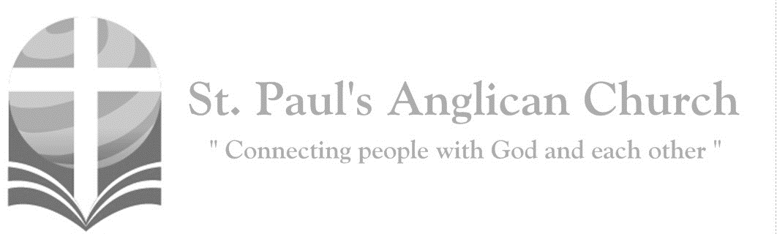

Sunday, August 4, 2019: 8th Sunday After Pentecost

*Blessed are the poor in spirit, for theirs is the kingdom of heaven.*

*(Matthew 5:3)*

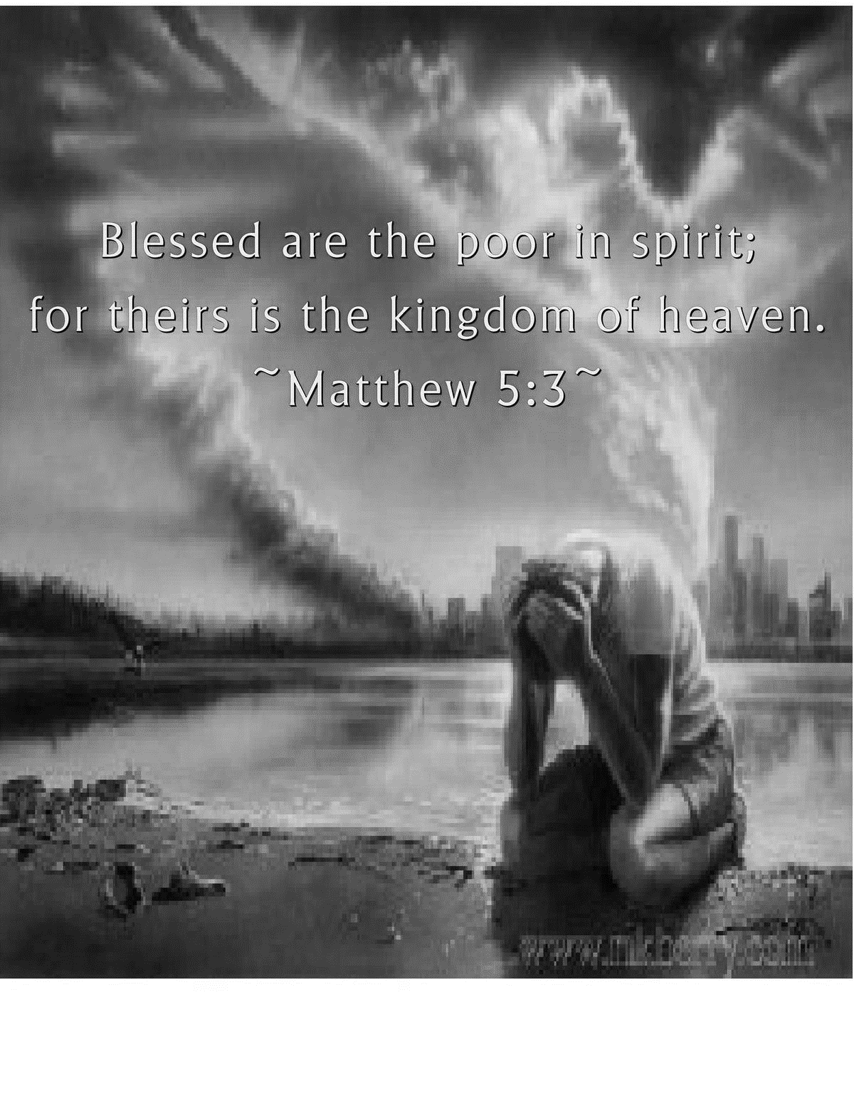

SUNDAYS AT ST. PAUL’S

**REGULAR SERVICES**

* Weekly services held Sundays at 10:00AM
* Interface services - Art based services throughout the year
* Sermons available on our website

**SUNDAY PRAYER**

* Prayer for the service at 9:30AM in the Luke Room
* Individual Prayer in the Chapel during the Sunday service

**SERVING AT ST. PAUL’S**

* Join a Ministry Team (Sunday service team, music team, children’s ministry, Altar guild, or many others)
* Regular or One-Time Giving (cash, cheque, automatic debit, and credit options available)

**LARGE PRINT MATERIALS** Large print Bibles and   
 Books of Alternative   
 Services (BAS) are availableat each Sanctuary door.

Page numbers will not be the same as those listed in the bulletin.

**VISITING TODAY?**

We want to get to know   
 you! Please join us for

in the Hall for coffee and

fellowship following the service. The greeters are also available to help if you have any questions.

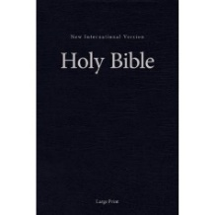



**Assisted listening**

**is available. Please**

**ask a greeter**

**for assistance.**



CONNECT

**St. Paul’s CHILDREN’S MINISTRY**

**KIDS** Chickadees Ages 2-4 / Peacocks Grade K-2 / Falcons Grade 3-5

Sunday School teaching is weekly during the 10:00AM service.

**St. Paul’s YOUTH MINISTRY – September through June**

**YOUTH** Youth Grades 6-12 meet weekly during the 10:00AM service.

Youth also meetbi-weekly for fun events and devotionals.

**St. Paul’s ADULT MINISTRY**

**ADULTS** St. Paul’s has a number of small groups where you can connect with others through Christ. If you are interested in joining a small   
group or starting a small group of your own, please speak with Pat Stretch.

**Opening Song: *Speak, O Lord***

Speak, O Lord, as we come to You

To receive the food of Your Holy Word

Take Your Truth, plant it deep in us

Shape and fashion us in Your likeness

That the light of Christ

Might be seen today

In our acts of love and our deeds of faith

Speak, O Lord, and fulfill in us

All Your purposes for Your glory

Teach us, Lord, full obedience

Holy reverence, true humility

Test our thoughts and our attitudes

In the radiance of Your purity

Cause our faith to rise

Cause our eyes to see

Your majestic love and authority

Words of power that can never fail

Let their truth prevail over unbelief

Speak, O Lord and renew our minds

Help us grasp the heights

Of Your plans for us

Truths unchanged

From the dawn of time

That will echo down through eternity

And by grace we’ll stand

On Your promises

And by faith we’ll walk

As You walk with us

Speak, O Lord, till Your church is built

And the earth is filled with Your glory

**The Gathering of the Community**

Celebrant: *(BAS pg. 185)* The grace of our Lord Jesus Christ, and the love of God, and the fellowship of the Holy Spirit, be with you all.

**People: And also with you.**

Celebrant:Almighty God,

**All:to you all hearts are open, all desires known, and from you no secrets are hidden. Cleanse the thoughts of our hearts by the inspiration of your Holy Spirit that we may perfectly love you, and worthily magnify your holy name; through Christ our Lord. Amen.**

Celebrant: *(pg. 371)* Almighty God, your Son Jesus Christ fed the hungry with the bread of his life and the word of his kingdom. Renew your people with your heavenly grace, and in all weakness sustain us by your true and living bread, who lives and reigns with you and the Holy Spirit, one God, now and for ever.

**People:** **Amen**.

**Children Dismissal**

**The Reading of Scripture**

First Reading: Hosea 11:1-11 (pg. 642 in the red pew Bible)

Reader: The Word of the Lord.

**People:** **Thanks be to God.**

Psalm Reading: Psalm 107:1-9, 43 (pg. 852 in the BAS)

Second Reading: Colossians 3:1-11 (pg. 834 in the red pew Bible)

Reader: The Word of the Lord.

**People:** **Thanks be to God.**

**Worship Through Song**

***Change My Heart, O God***

Change my heart, oh God

Make it ever true

Change my heart, oh God

May I be like You

You are the Potter, I am the clay

Mould me and make me

This is what I pray (*Repeat all*)

Change my heart, oh God

Make it ever true

Change my heart, oh God

May I be like You

***Faithful One***

Faithful One so unchanging

Ageless One You’re my rock of peace

Lord of all I depend on You

I call out to You again and again

I call out to You again and again

You are my rock in times of trouble

You lift me up when I fall down

All through the storm

Your love is the anchor

My hope is in You alone

**Listening Time**

**The Gospel Reading**

Celebrant: The Lord be with you.

**People: And also with you.**

Celebrant: The Holy Gospel of our Lord Jesus Christ according to St. Luke.

**People: Glory to you, Lord Jesus Christ.**

Gospel Reading: Luke 12:13-21 (pg. 737 in the red pew Bible)

Celebrant: The Gospel of Christ.

**People: Praise to you, Lord Jesus Christ.**

Sermon: Dr. Stephen Martin

**Sermon Notes**

________________________________________________________________________________________________________________________________________________________________________________________________________________________________________________________________________________________________________________________________________________________________________________________________________________________________________________________________________________________________________________________

________________________________________________________________________________________________________________________________________________

________________________________________________________________________________________________________________________________________________________________________________________________________________________________________________________________________________________________________________________________________________________________________________________________________________________________________________________________________________________________________________________________________________________________________________________________

________________________________________________________________________

**Affirmation of Faith – The Apostle’s Creed**

**All: I believe in God, the Father almighty, Creator of heaven and earth. I believe in Jesus Christ, his only Son, our Lord. He was conceived by the power of the Holy Spirit and born of the Virgin Mary. He suffered under Pontius Pilate, was crucified, died and was buried. He descended to the dead. On the third day, he rose again. He ascended into heaven and is seated at the right hand of the Father. He will come again to judge the living and the dead. I believe in the Holy Spirit, the holy catholic Church, the communion of saints, the forgiveness of sins, the resurrection of the body, and the life everlasting. Amen.**

**Prayers of the People**

**Confession of Sin**

Celebrant: *(pg. 191)* Dear friends in Christ, God is steadfast in love and infinite in mercy; he welcomes sinners and invites them to his table. Let us confess our sins, confident in God’s forgiveness.

*Silent Confession*

Celebrant:Most merciful God,

**All: we confess that we have sinned against you in thought, word, and deed, by what we have done and by what we have left undone. We have not loved you with our whole heart; we have not loved our neighbours as ourselves. We are truly sorry and we humbly repent. For the sake of your Son Jesus Christ, have mercy on us and forgive us, that we may delight in your will, and walk in your ways, to the glory of your name. Amen.**

Celebrant: Almighty God have mercy upon you, pardon and deliver you from all your sins, confirm and strengthen you in all goodness and keep you in eternal life through Jesus Christ our Lord.

**People:Amen.**

**The Peace**

Celebrant: The peace of the Lord be always with you.

**People: And also with you.**

**Offertory Song: *Be Thou My Vision***

Be Thou my vision, O Lord of my heart

Naught be all else to me

Save that Thou art

Thou my best thought

By day or by night

Walking or sleeping

Thy presence my light

Be Thou my wisdom

And Thou my true word

I ever with Thee

And Thou with me, Lord

Thou my great Father, I thy true son

Thou in me dwelling and I with Thee one

Riches I heed not

Nor man’s empty praise

Thou mine inheritance, now and always

Thou and Thou only, first in my heart

High King of heaven

My treasure Thou art  
 (*Continued on next page*)

High King of heaven, my victory won

May I reach heaven’s joys

O bright heaven’s Sun

Heart of my own heart, whatever befall

Still be my vision, O Ruler of all

**Prayer Over the Gifts**

Celebrant: *(pg. 372)* God our sustainer,

**All: accept all we offer you this day, and feed us continually with that bread which satisfies all hunger, your Son our Saviour Jesus Christ. Amen.**

Celebrant: The Church of Christ, of which we are members, has taken this bread and wine and given thanks according to the Lord’s command. We now share in the communion of his body and blood.

Gracious God, loving all your family with a mother’s tender care: As you sent the angel to feed Elijah with heavenly bread, assist those who set forth to share your word and sacrament with those who are present here. In your love and care, nourish and strengthen those who will receive this sacrament, and give us all the comfort of your abiding presence through the body and blood of your Son, Jesus Christ, our Lord.

**All:** **Amen.**

Celebrant: *(pg. 211)* As our Saviour taught us, let us pray,

**All: *(Sung)* Our Father in heaven, hallowed be your name. Your kingdom come, your will be done, on earth as in heaven. Give us today our daily bread. Forgive us our sins as we forgive those who sin against us. Save us from the time of trial, and deliver us from evil. For the kingdom, the power, and the glory are yours, now and for ever. Amen.**

Celebrant: *(pg. 212)* “I am the bread which has come down from heaven,” says the Lord.

**All: Give us this bread for ever.**

Celebrant: “I am the vine, you are the branches.”

**All: May we dwell in him, as he lives in us.**

Celebrant: *(pg. 213)* The gifts of God for the People of God.

**People: Thanks be to God.**

**The Communion**

*You are welcome to receive communion or come forward for a blessing. If you prefer to receive a blessing, please fold your arms over your chest. There is de-alcoholized wine available in the centre and gluten-free wafers available upon request.*

**Lamb of God**

*(Sung)* Lamb of God, you take away the sin of the world. Lamb of God, you take away the sin of the world. Lord have mercy, Christ have mercy, Lord have mercy on me.

Lord have mercy, Christ have mercy and grant us thy peace.

**Communion Music *Compassion Hymn***

***Behold, What Manner of Love***

Behold, what manner of love

The Father has given unto us

Behold, what manner of love

The Father has given unto us,

That we should be called

The sons of God

That we should be called

The sons of God (*Repeat*)

***I Come to the Cross***

I come to the cross

Seeking mercy and grace

I come to the cross

Where You died in my place

Out of my weakness

And into Your strength

Humbly, I come to the cross

Your arms are open

You call me my name

You welcome this child that was lost

You paid the price

For my guilt and my shame

Jesus I come, Jesus I come

Jesus I come to the cross

There is an everlasting kindness

You lavished on us

When the Radiance of heaven

Came to rescue the lost

You called the sheep without

A shepherd to leave their distress

For Your streams of forgiveness

And the shade of Your rest

And with compassion for the hurting

You reached out Your hand

As the lame ran to meet You

And the dead breathed again

You saw behind the eyes of sorrow

And shared in our tears

Heard the sigh of the weary

Let the children draw near

(*Chorus*) What boundless love

What fathomless grace

You have shown us

O God of compassion!

Each day we live, an offering of praise

As we show to the world

Your compassion (*cont. next page*)

We stood beneath the cross of Calvary

And gazed on Your face

At the thorns of oppression

And the wounds of disgrace

For surely You have borne our suffering

And carried our grief

As You pardoned the scoffer

And showed grace to the thief

(*Chorus*) What boundless love

What fathomless grace

You have shown us

O God of compassion!

Each day we live, an offering of praise

As we show to the world

Your compassion

How beautiful the feet

That carry this gospel of peace

To the fields of injustice

And valleys of need

To be a voice of hope and healing

To answer the cries

Of the hungry and helpless

With the mercy of Christ

(*To Chorus*)

**Prayer After Communion**

Celebrant: *(pg. 371)* God of grace,

**All: we have shared in the mystery of the body and blood of Christ. May we who have tasted the bread of life live with you for ever. We ask this in the name of Jesus Christ our Lord.** **Amen.**

Celebrant: *(pg. 214)* Glory to God,

**All:whose power, working in us, can do infinitely more than we can ask or imagine. Glory to God from generation to generation, in the Church and in Christ Jesus, for ever and ever. Amen.**

**Blessing**

**Congregational Announcements *(Carol R.)***

**Closing Song: *Benediction***

May the peace of God

Our Heavenly Father

And the grace of Christ the Risen Son

And the fellowship of God the Spirit

Keep our hearts

And minds within His love

(*Chorus*)

And to Him be praise

For His glorious reign

From the depths of earth

To the heights of heaven

We declare the name

Of the Lamb once slain

Christ eternal

The King of Kings

May this peace

Which passes understanding

And this grace

Which makes us what we are

And this fellowship of His communion

Make us one in spirit and in heart

(*To Chorus*)

**The Dismissal**Celebrant: *(pg. 215)* Go forth into the world, rejoicing in the power of the Spirit.

**All: Thanks be to God. Amen.**

*Please join us in the Hall for coffee following the service.*

**Myron Away – August 3-21**

Please pray for Myron as he travels to Bolivia and reconnects with a number of ministries that he has been involved with in the past. Please pray that his travel would be smooth and that the Spirit would work through Myron as he ministers while away.

**St. Paul’s Hymn Sing and Ice Cream Social – August 21, 7:00PM**

Please join us on Wednesday, August 21 at 7:00PM for a hymn sing in the Hall followed by ice cream!! Ice cream will be provided but please bring your favourite topping/s to share. If you would like to help with this event, please speak with Jodi Penner.

**The Pas Mission Team Presentation Sunday, August 18**

Please join us during our regular service time on August 18 for a presentation and update from The Pas Missions team!

**Sunday School Summer Schedule**

Sunday School will be offered throughout the summer for the weeks we have children in the congregation. All of the Sunday School age children will be together (rather than in age specific classes). Our summer leaders are:

August 4: Carol R.

August 11: Margot B.

August 18: Renée J.

August 25: Gay G.

**Check us out online!!**

Please visit our new website at www.stpauls-anglican.ca. Content continues to be added to the website so please continue to check back for more information. Also, please check out the events page and mark your calendars.

**St. Paul’s Church-Wide Retreat**

**November 15-17 - Camp Nakamun**

As we have been discussing over the last couple of months, we are going ahead with a St. Paul’s retreat this fall. The retreat will be held at Camp Nakamun on November 15-17, 2019. This event is for everyone (singles, couples, families, friends) and will feature a wagon ride, board games, swimming, and whatever else you want to do! If you would like to register, please fill out a registration form (found at each door).

If you would like to attend the retreat but finances do not allow, please speak with Rev. Myron or any member of Vestry.

**St. Paul’s Small Group in Fall**

Please be thinking ahead to the fall, and think about becoming part of a new Small Group at St. Paul’s. As this would be a new group, it could be set up as the members wanted regarding what to study, the time, and place. There are many options – men, ladies, mixed, etc. Please contact Pat Stretch ([stretchg@telus.net](mailto:stretchg@telus.net) or 780-453-3339) or the office if you are interested.



@StEdmonton

facebook.com/stpachurchedmonton

**St. Paul’s Vestry:**

Peter Jackson, *Rector’s Warden*

Pat Stretch, *People’s Warden*

David Heritage, *Treasurer*

Margot Byer, *Vestry Member*

John Green, *Vestry Member*

Deanna Kalles, *Vestry Member*

David Parker, *Vestry Member*

Carol Rudat, *Vestry Member*

**St. Paul’s Staff:**

*Rector:*

The Reverend Myron Bradley Penner  
*Office Administrator:*

RJ Chambers

*Youth Leader:* Victoria Eeles

**For prayer requests** **email**:

office@stpauls-anglican.ca

**For urgent prayer requests call**

the church office: (780) 455-0771

**For pastoral emergencies call:**

(587) 334-2130

**Office Hours:**

Monday-Thursday: 9:00AM-12:00PM

Closed: Fri/Sat/Sun and Stat Holidays

**St. Paul’s Anglican Church**

10127 145 Street, Edmonton T5N 2X6

Phone: (780) 455-0771; Email: office@stpauls-anglican.ca

Website: www.stpauls-anglican.ca

**This Week’s Readings:**

Hosea 11:1-11 (pg. 642)

Psalm 107:1-9, 43 (BAS, pg. 852)

Colossians 3:1-11 (pg. 834)

Luke 12:13-21 (pg. 737)

**This Week’s Ministry Teams:**

Music/Sound: Pat’s Team/Chandra S.

Service Team: Parker Team

Prayers: Kjeryn or Jennifer

Chapel Prayer: Dudley B. and Pat H-B.

Vestry on Duty: Carol R.

**St. Paul’s Cycle of Prayer:**

James Parker and Olga Elizarova

and Sophia;

Connie Pistawka; Pamela Smith

**Anglican Cycle of Prayer:**

Diocese of Athabasca; the Rt. Rev. Fraser Lawton, Bishop. St. Stephen the Martyr, Edmonton: Armand Mercier (s. Carol Anne), Rector. Chaplain at Buyé High School: Audace Kwizera. Whitefish Lake First Nation.

**Next Week’s Ministry Teams**

Music/Sound: Adele’s Team/Scott M.

Service Team: Tilburn Team

Prayers of the People: Deanna K.

Chapel Prayer: Laurier B. and Pat S.

Vestry on Duty: Deanna K.