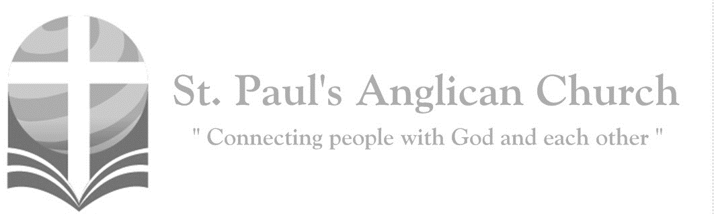
Sunday, November 22, 2020: The Reign of Christ
Blessed is he who comes in the name of the Lord! Blessed is the kingdom of our father David that is coming! (Mark 11:9-10)

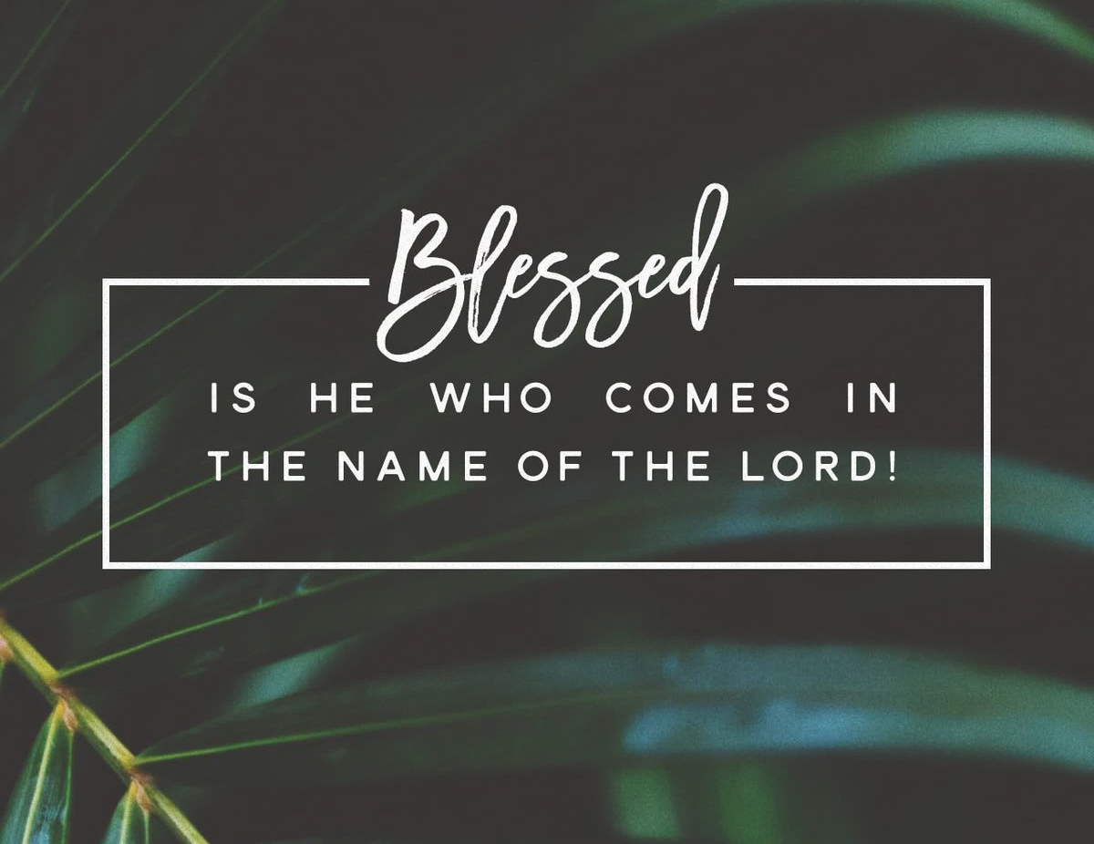

Welcome!! During this unique time in history, services will look a bit different than normal and will likely be different for quite a while. We want to care for the whole parish during this time and one way to care for one another is keeping each other safe. As such, we ask you to follow these guidelines if worshiping in-person with us:
- Experiencing Cough, Fever, or Other Symptom/s? Go home immediately and please stay home for fourteen days following the end of your symptoms.
- Wear a Mask. All parishioners must wear a mask to all services (as per City of Edmonton bylaw 19408). Exceptions to this include children under the age of two and those with a medical condition where wearing a mask is not possible. Masks may be removed when taking communion but must be replaced immediately following. If you do not have a mask, we have cloth masks available in the foyer.
- Maintain Physical Distance. At all times, please remain a minimum of six feet (three seat spaces) from all other individuals not part of your family unit. You will find tape on the floor six feet apart in multiple locations to help you maintain this distance. Please also maintain physical distance outside.
- Listen to the Ushers. There will be ushers inside and outside to help direct these new procedures. Please heed their direction as they are trying to keep everyone safe and healthy.
- Sign-In Upon Arrival. Please sign-in with the designated usher when you arrive onsite. This will help us track who is in attendance just in case we do have to notify the parish if someone tests Covid positive following a service.
- Sanitize Hands Frequently. Please sanitize your hands upon entry and before taking communion. You may also sanitize as often as you would like during the service. Please also try to refrain from touching surfaces and your face.
- Refrain from Singing. At this time, congregational singing is not allowed by the government of Alberta. Please listen to the lyrics being sung by the leader/s and meditate upon them. You may also hum along to the music as long as your mouth remains closed.
- Recycle Bulletins. Please do not leave bulletins in the pews. A recycle bin is available at the exit door. You may also take the bulletin home.
- Use of Washroom. The only washroom available at this time is located at the back of the Sanctuary (just North of the Main Entry doors). Please wipe down all surfaces (including toilet and handle, counter, and faucet) following use.
- Parts of Building Closed. At this time, the only accessible parts of the building are the Sanctuary, Sanctuary washroom, and alley foyer. All other rooms are closed for use including the main washrooms, hall, basement, and chapel. Please do not access any closed section of the building without permission.

ST. PAUL’S COVID-19 RESPONSE
Opening Song: Forever
Give thanks to the Lord
Our God and King
His love endures forever
For He is good, He is above all things
His love endures forever
Sing praise, sing praise

With a mighty hand
And an outstretched arm
His love endures forever
For the life that's been reborn
His love endures forever
Sing praise, sing praise
Sing praise, sing praise
(Chorus) Forever God is faithful
Forever God is strong
Forever God is with us
Forever, forever

From the rising to the setting sun
His love endures forever
And by the grace of God
We will carry on
His love endures forever
Sing praise, sing praise
Sing praise, sing praise
(To Chorus)

Penitential Rite
Leader: Dear friends in Christ, as we prepare to worship almighty God, let us with penitent and obedient hearts confess our sins, that we may obtain forgiveness by his infinite goodness and mercy.
Silence is Kept
All: Most merciful God, we confess that we have sinned against you in thought, word, and deed, by what we have done and by what we have left undone. We have not loved you with our whole heart; we have not loved our neighbours as ourselves. We are truly sorry and we humbly repent. For the sake of your Son Jesus Christ, have mercy on us and forgive us, that we may delight in your will, and walk in your ways, to the glory of your name. Amen.
Leader: Almighty God have mercy upon you, pardon and deliver you from all your sins, confirm and strengthen you in all goodness, and keep you in eternal life; through Jesus Christ our Lord.
All: Amen.

Morning Prayer
Leader: Lord, open our lips,
All: And our mouth shall proclaim your praise.
Leader: O God, make speed to save us.
All: O Lord, make haste to help us. Glory to the Father, and to the Son, and to the Holy Spirit: as it was in the beginning, is now, and will be for ever. Amen. Alleluia!

Leader: The Lord is our light and our life: O come, let us worship.
All: Come, let us sing to the Lord; let us shout for joy to the rock of our salvation. Let us come before his presence with thanksgiving and raise a loud shout to him with psalms. For the Lord is a great God, and a great king above all gods. In his hand are the caverns of the earth, and the heights of the hills are his also. The sea is his for he made it, and his hands have moulded the dry land. Come, let us bow down, and bend the knee, and kneel before the Lord our maker. For he is our God, and we are the people of his pasture and the sheep of his hand. Oh, that today you would hearken to his voice!

The Reading of Scripture
First Reading: Ezekiel 34:11-16, 20-24
For thus says the Lord GOD: I myself will search for my sheep, and will seek them out. As shepherds seek out their flocks when they are among their scattered sheep, so I will seek out my sheep. I will rescue them from all the places to which they have been scattered on a day of clouds and thick darkness. I will bring them out from the peoples and gather them from the countries, and will bring them into their own land; and I will feed them on the mountains of Israel, by the watercourses, and in all the inhabited parts of the land. I will feed them with good pasture, and the mountain heights of Israel shall be their pasture; there they shall lie down in good grazing land, and they shall feed on rich pasture on the mountains of Israel. I myself will be the shepherd of my sheep, and I will make them lie down, says the Lord GOD. I will seek the lost, and I will bring back the strayed, and I will bind up the injured, and I will strengthen the weak, but the fat and the strong I will destroy. I will feed them with justice. Therefore, thus says the Lord GOD to them: I myself will judge between the fat sheep and the lean sheep. Because you pushed with flank and shoulder, and butted at all the weak animals with your horns until you scattered them far and wide, I will save my flock, and they shall no longer be ravaged; and I will judge between sheep and sheep. I will set up over them one shepherd, my servant David, and he shall feed them: he shall feed them and be their shepherd. And I, the LORD, will be their God, and my servant David shall be prince among them; I, the LORD, have spoken.
Reader: The Word of the Lord.
People: Thanks be to God.

Canticle: Psalm 100
1 Be joyful in the Lord, all you lands; *
serve the Lord with gladness and come before his presence with a song.
2 Know this: The Lord himself is God; *
he himself has made us, and we are his; we are his people and the sheep of his pasture.
3 Enter his gates with thanksgiving; go into his courts with praise; *
give thanks to him and call upon his name.
4 For the Lord is good; his mercy is everlasting; *
and his faithfulness endures from age to age.
Prayer: God our Father, you have created us as your people, and you sustain us with your hand. Help us always to give you thanks, for you alone are worthy of thanksgiving and praise and honour, now and for ever.

Second Reading: Ephesians 1:15-23
I have heard of your faith in the Lord Jesus and your love toward all the saints, and for this reason I do not cease to give thanks for you as I remember you in my prayers. I pray that the God of our Lord Jesus Christ, the Father of glory, may give you a spirit of wisdom and revelation as you come to know him, so that, with the eyes of your heart enlightened, you may know what is the hope to which he has called you, what are the riches of his glorious inheritance among the saints, and what is the immeasurable greatness of his power for us who believe, according to the working of his great power. God put this power to work in Christ when he raised him from the dead and seated him at his right hand in the heavenly places, far above all rule and authority and power and dominion, and above every name that is named, not only in this age but also in the age to come. And he has put all things under his feet and has made him the head over all things for the church, which is his body, the fullness of him who fills all in all.
Reader: The Word of the Lord.
People: Thanks be to God.

Processional Chorus – Good and Gracious King

You deserve the greater glory
Overcome I lift my voice
To the King in need of nothing
Empty handed I rejoice
You deserve the greater glory
Overcome with joy I sing
By Your love I am accepted
You're a good and gracious King

The Gospel Reading
Leader: The Lord be with you.
People: And also with you.
Leader: The Holy Gospel of our Lord Jesus Christ according to St. Matthew.
People: Glory to you, Lord Jesus Christ.
Gospel Reading: Matthew 25:31-46
"When the Son of Man comes in his glory, and all the angels with him, then he will sit on the throne of his glory. All the nations will be gathered before him, and he will separate people one from another as a shepherd separates the sheep from the goats, and he will put the sheep at his right hand and the goats at the left. Then the king will say to those at his right hand, 'Come, you that are blessed by my Father, inherit the kingdom prepared for you from the foundation of the world; for I was hungry and you gave me food, I was thirsty and you gave me something to drink, I was a stranger and you welcomed me, I was naked and you gave me clothing, I was sick and you took care of me, I was in prison and you visited me.' Then the righteous will answer him, 'Lord, when was it that we saw you hungry and gave you food, or thirsty and gave you something to drink? And when was it that we saw you a stranger and welcomed you, or naked and gave you clothing? And when was it that we saw you sick or in prison and visited you?' And the king will answer them, 'Truly I tell you, just as you did it to one of the least of these who are members of my family, you did it to me.' Then he will say to those at his left hand, 'You that are accursed, depart from me into the eternal fire prepared for the devil and his angels; for I was hungry and you gave me no food, I was thirsty and you gave me nothing to drink, I was a stranger and you did not welcome me, naked and you did not give me clothing, sick and in prison and you did not visit me.' Then they also will answer, 'Lord, when was it that we saw you hungry or thirsty or a stranger or naked or sick or in prison, and did not take care of you?' Then he will answer them, 'Truly I tell you, just as you did not do it to one of the least of these, you did not do it to me.' And these will go away into eternal punishment, but the righteous into eternal life."
Leader: The Gospel of Christ.
People: Praise to you, Lord Jesus Christ.
Worship Through Song

Good and Gracious King
I approach the throne of glory
Nothing in my hands I bring
But the promise of acceptance
From a good and gracious King

I will give to You my burden
As You give to me Your strength
Come and fill me with Your Spirit
As I sing to You this praise

(Chorus) You deserve the greater glory
Overcome I lift my voice
To the King in need of nothing
Empty handed I rejoice
You deserve the greater glory
Overcome with joy I sing
By Your love I am accepted
You're a good and gracious King

O what grace that You would see me
As Your child and as Your friend
Safe, secure in You forever
I pour out my praise again (To Chorus)

Holy, holy Lord Almighty
Good and gracious
Good and gracious
Holy, holy Lord Almighty
Good and gracious King (To Chorus)

Reckless Love
Before I spoke a word
You were singing over me
You have been so, so good to me
Before I took a breath
You breathed Your life in me
You have been so, so kind to me

(Chorus)
O, the overwhelming, never-ending Reckless love of God
O, it chases me down
Fights 'til I'm found
Leaves the ninety-nine
I couldn't earn it, I don't deserve it
Still You give Yourself away
O, the overwhelming never-ending
Reckless love of God

When I was Your foe
Still Your love fought for me
You have been so, so good to me
When I felt no worth
You paid it all for me
You have been so, so kind to me
(To Chorus)

There's no shadow You won't light up
Mountain You won't climb up
Coming after me
There's no wall You won't kick down
Lie You won't tear down
Coming after me (To Chorus)

Listening Time

Sermon by the Rev. Dr. Myron Penner – Sermon Notes:
________________________________________________________________________________________________________________________________________________________________________________________________________________________________________________________________________________________________________________________________________________________________________________________________________________________________________________________________________________________________________________________
________________________________________________________________________________________________________________________________________________
________________________________________________________________________________________________________________________________________________
________________________________________________________________________________________________________________________________________________
________________________________________________________________________
________________________________________________________________________________________________________________________________________________

Affirmation of Faith – The Apostle’s Creed
All: I believe in God, the Father almighty, Creator of heaven and earth. I believe in Jesus Christ, his only Son, our Lord. He was conceived by the power of the Holy Spirit and born of the Virgin Mary. He suffered under Pontius Pilate, was crucified, died and was buried. He descended to the dead. On the third day, he rose again. He ascended into heaven and is seated at the right hand of the Father. He will come again to judge the living and the dead. I believe in the Holy Spirit, the holy catholic Church, the communion of saints, the forgiveness of sins, the resurrection of the body, and the life everlasting. Amen.

Prayers of the People
Leader: In peace let us pray to the Lord, saying, “Lord, have mercy.” For peace from on high and for our salvation, let us pray to the Lord.
All: Lord, have mercy.
Leader: For the peace of the whole world, for the welfare of the holy Church of God, including those in the St. Paul’s Cycle of Prayer: Peter and Renée Jackson; Wendell and Nora James; Barb Dixon; and Ranji Samuel; as well as all of those in the Anglican Cycle of Prayer; and for the unity of all, let us pray to the Lord.
All: Lord, have mercy.
Leader: For our bishops, and for all the clergy and people, let us pray to the Lord.
All: Lord, have mercy.
Leader: For Elizabeth our Queen, for the leaders of the nations, and for all in authority, let us pray to the Lord.
All: Lord, have mercy.
Leader: For this the city of Edmonton and for every city and community, including our community of Grovenor, and for those who live in them in faith, let us pray to the Lord.
All: Lord, have mercy.
Leader: For good weather, and for abundant harvests for all to share, let us pray to the Lord.
All: Lord, have mercy.
Leader: For those who travel by land, water, or air, for the sick and the suffering, for prisoners and captives, and for their safety, health, and salvation, let us pray to the Lord.
All: Lord, have mercy.
Leader: For our deliverance from all affliction, strife, and need, let us pray to the Lord.
All: Lord, have mercy.
Leader: For the absolution and remission of our sins and offences, let us pray to the Lord.
All: Lord, have mercy.
Leader: For all who have died, let us pray to the Lord.
All: Lord, have mercy.
Leader: Remembering all the saints, we commit ourselves, one another, and our whole life to Christ our God.
All: To you, O Lord.
Leader: Almighty God, you have given us grace at this time with one accord to make our common supplications to you, and you have promised through your well-beloved Son that when two or three are gathered together you will hear their requests. Fulfil now our desires and petitions, as may be best for us, granting us in this world knowledge of your truth, and in the age to come eternal life; for you, Father, are good and loving, and we glorify you through your Son Jesus Christ our Lord, in the Holy Spirit, now and for ever.
All: Amen.

The Collect
Leader: Almighty and everlasting God, whose will it is to restore all things in your well-beloved Son, our Lord and King, grant that the peoples of the earth, now divided and enslaved by sin, may be freed and brought together under his gentle and loving rule; who lives and reigns with you and the Holy Spirit, one God, now and for ever.
All: Amen.

The Lord’s Prayer
Leader: And now, as our Saviour Christ has taught us, we are bold to say,
All: Our Father, who art in heaven, hallowed be thy name, thy kingdom come, thy will be done, on earth as it is in heaven. Give us this day our daily bread. And forgive us our trespasses, as we forgive those who trespass against us. And lead us not into temptation, but deliver us from evil. For thine is the kingdom, the power, and the glory, for ever and ever. Amen.

Closing Song: Blessed Be Your Name

Blessed be Your name
In the land that is plentiful
Where Your streams of abundance flow
Blessed be Your name

Blessed be Your name
When I'm found in the desert place
Though I walk through the wilderness
Blessed be Your name

(Pre-Chorus) Every blessing
You pour out I’ll turn back to praise
When the darkness closes in Lord
Still I will say

(Chorus)
Blessed be the name of the Lord
Blessed be Your name
Blessed be the name of the Lord
Blessed be Your glorious name
(continued on next page)
Blessed be Your name
When the sun's shining down on me
When the world's all as it should be
Blessed be Your name

Blessed be Your name
On the road marked with suffering
Though there's pain in the offering
Blessed be Your name (To Pre-Chorus)

You give and take away
You give and take away
My heart will choose to say
Lord blessed be Your name
(To Chorus)

The Dismissal
Celebrant: Go forth into the world, rejoicing in the power of the Spirit.
All: Thanks be to God. Amen.
Community Corner for November 22

Michelle’s Office Hours – Not sure when to contact Michelle? She is in the office during regular office hours (only by appointment during the current temporary office closure), and can be reached via email at michelle@stpauls-anglican.ca.
Seniors meals – West End Seniors Centre offers a meal service to everyone (you do not have to be a senior to use the service). This service continues during the new COVID restrictions. To sign up for the menu, please visit https://www.weseniors.ca/. Orders can be picked up or they have a delivery service within Edmonton on Thursdays.
Grovenor Elementary School Christmas Hampers – In December we will be collecting donations towards hampers for a few families in need at Grovenor Elementary School. Please keep this in mind as you plan your advent season, and watch here for more information in December.

Virtual Gingerbread House Making – November 27, 6-8PM
Gingerbread houses via ZOOM on November 27, 6-8 pm! Today is the last day to register! Register by emailing RJ or Michelle - cost is $10/house. Please also provide your address so we where to deliver. Zoom link will be sent out to everyone who has registered.

Advent Wreath Delivery
As many parishioners are worshipping from home due to Covid concerns (and there being a possibility the current temporary closure could be extended), St. Paul's wants to provide Advent Wreaths so that everyone is able to participate together in the Advent season from home. If you do not already have an Advent Wreath and would like to be delivered one, please contact the Office at office@stpauls-anglican.ca no later than Monday, Nov. 23.

Anglican Cycle of Prayer:
Diocese of British Columbia: the Very Rev. M. Ansley Tucker, Dean and Administrator; episcopal election held September 26. St. Paul, Edmonton: Myron Penner (s. Jodi), Rector; RJ Chambers (s. Janette), Office Administrator. Buyé Diocese, Canika Parish: Evariste Nsabimana, Rector. Ermineskin Cree Nation.

Next Week’s Ministry Teams:
Music: Jodi and Team
Service Team: Parker and Heritage Teams
Reader/Prayers: Rick and Barb M.

This Week’s Ministry Teams:
Music: Asher and Team
Service Team: None
Reader/Prayers: Asher and Team

St. Paul’s Cycle of Prayer:
Peter and Renée Jackson;
Wendell and Nora James;
Barb Dixon;
Ranji Samuel

For Care/Concern Team
or other prayer requests, email:
office@stpauls-anglican.ca
For urgent prayer requests call
the church office: (780) 455-0771
For pastoral emergencies call:
(587) 334-2130

@StEdmonton
facebook.com/stpachurchedmonton
St. Paul’s Vestry:
Paul Dowie, Rector’s Warden
Margot Byer, People’s Warden
David Heritage, Treasurer
Barb Dixon, Vestry Member
John Green, Vestry Member
Deanna Kalles, Vestry Member
David Parker, Vestry Member
Carol Rudat, Vestry Member

Office Hours:
Monday-Thursday: 9:00AM-12:00PM
Closed: Fri/Sat/Sun and Stat Holidays
St. Paul’s Anglican Church
10127 145 Street, Edmonton T5N 2X6
Phone: (780) 455-0771; Email: office@stpauls-anglican.ca
Website: www.stpauls-anglican.ca

St. Paul’s Staff:
Rector: The Rev. Myron B. Penner
Community Outreach: Michelle Schurek
Youth Leader: Abigail Harding
Office Administrator: RJ Chambers

