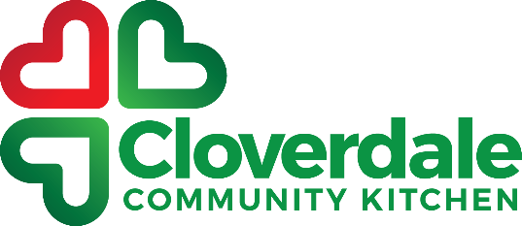 2020 Report

The year 2020 can be summarized as a year of growth and blessing for the Cloverdale Community Kitchen. CCK’s mission since its founding in 2014 has been to alleviate poverty in our community. To alleviate poverty, CCK has partnered with the whole community including churches, businesses, community groups, schools, sports teams, associations, and individuals. All of these partnerships uniquely positioned CCK to serve our community.

When COVID hit our province in March 2020, CCK had to make the decision, ‘Do we circle the wagons to protect ourselves, or do we press into the crisis and serve the community?’

The individuals we serve weekly needed CCK more than ever when COVID19 hit so we made the decision to do what was required to serve those in need during the spring. We quickly updated our safety protocols, trained our volunteers, and recruited new volunteers so we could provide services in a safe manner.

We had been working on a Food Pantry/Food Store/Food Bank for a few years. Before we knew the pandemic was hitting, we had already planned to publicly launch our Food Bank on March 7th, 2020. It was only a week later, and the province was shutting down. It was amazing how the timing and how we were able to serve the community. During this same time the Surrey Food Bank shut down its Cloverdale Food Bank due to COVID, so we were the only Food Bank serving Cloverdale (they have since reopened their depot in September 2020).

Thank-you to all our volunteers and our new volunteers who stepped up to serve during this time. We were blessed during this time with people who wanted to serve. We were also blessed with donations and grants which helped provide the finances during the spring. CCK is especially thankful to the churches of Cloverdale which donated over $30,000 to CCK during this time. Thank-you to Horizon Church, Hillside Church, Coast Hills Church, Sonrise Church, Hope Community Church, Westwinds Church, Surrey Covenant Reformed Church, Mercy Hill Church, and Cross Ridge Church.

During the beginning of the pandemic the local Meals on Wheels programs stopped taking new clients as they could not increase capacity. In response to this with a grant from the Surrey Cares Foundation we launched our Mobile Meals program.

Many of the church-based community meals programs in the area also shut down during the first few weeks of COVID19. We made the decision to move our meals outside and received permission from Fraser Health to serve this way, rather than shut them down.

Through this season CCK has been blessed as it has served the community.

Matthew Campbell
CCK Director

CCK Programs

Community Meals
The community meals program is the original CCK program. We currently serve meals on Monday, Wednesday, and Friday evenings. Just before COVID19 we were serving an average of 100 people per night. With COVID19 and our meals outside during the summer we were serving an average of 60-70 people. We have 5 church partners including PCC to provide this program.

Fraser Valley Regional Food Bank
A full-service Food Bank serving the Surrey, White Rock, Langley, and beyond. We have 300 families registered for the Food Bank. We also serve many churches, ministries, recovery houses with food for their work.
Since March 2020 we have distributed almost 1,000,000 lbs of food.

MObile Meals
This program was launched in response to the needs of seniors during COVID19. During the height of the program we were delivering 90 meals a night. This program servings 5 meals a week.

CHRISTMAS Hamper Program
Our 2019 Cloverdale Christmas Hamper Program was our largest and best hamper program to date. On the pickup day we have live music, hot food, a free store, extra food for the hampers, and the toy store. We served about 550 households in 2019.

Extreme Weather Shelter
In the winter of 2019, we opened our doors over 100 nights to allow people to sleep inside, out of the cold, snow, and rain. On some nights we had up to 25 people inside. The total people time the number of nights, means over 2,000 sleeps were inside our building.

Cloverdale Community Cycles
We launched this bike shop in response to a need from our homeless friends. We are also serving single moms and those who cannot afford a bike repair. We then repair bikes for the public to pay for the shop. The shop is also now a place people can get work experience.

FOOD Bank Hampers
Since the beginning of COVID19 we have been delivering weekly Food Hampers to seniors and those effect COVID19.

clothing cupboard
CCK has a clothing cupboard to give out cloths to those in need. It has been especially helpful to those who are coming to the emergency weather shelter without warm clothing.

