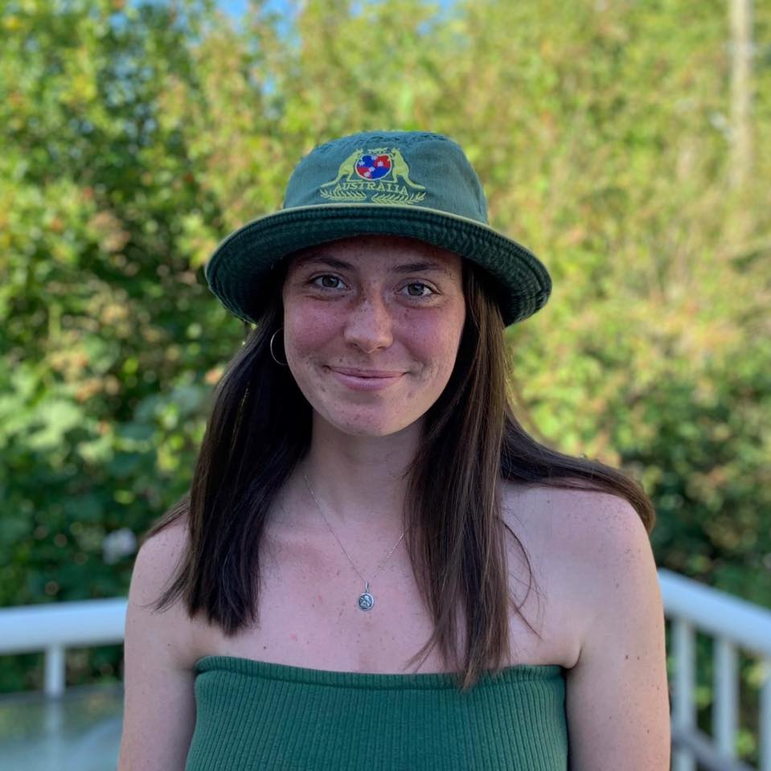
SCOTT
TIME:
What he is wearing:

CHASE
TIME:
What he is wearing:

GLEN
TIME:
What he is wearing:

KYLE
TIME:
What he is wearing:

NIKI
TIME:
What is she wearing:

AMANDA
TIME:
What is she wearing:

MALL HUNT RULES
- No running
- Stay socially distanced
- Be respectful of shops and shoppers.
- Wear your masks
- Only need to write down what the person is wearing do not need to approach anyone.
- When you find me remind me (Glen) to give you a gift card for a snack.
- Text me a pic of your sheet when your done.
778-677-4536

GOOD LUCK!

