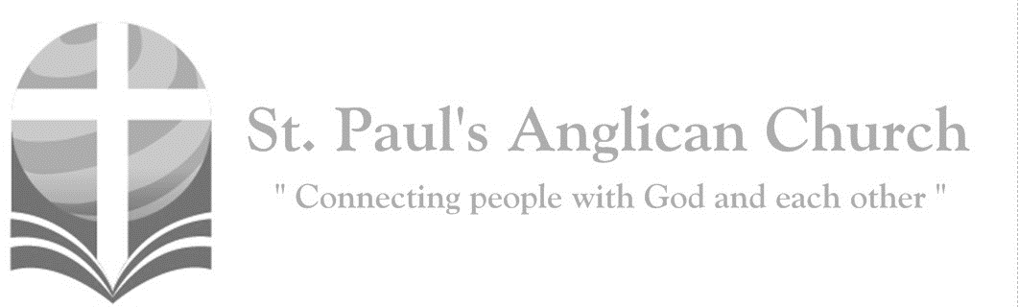
I am the servant of the Lord; let it be to me according to his word. (Luke 1:38)
Sunday, December 20, 2020: Advent 4 – Love

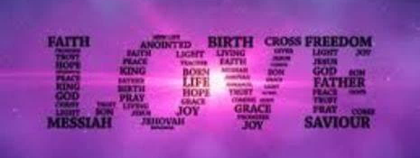
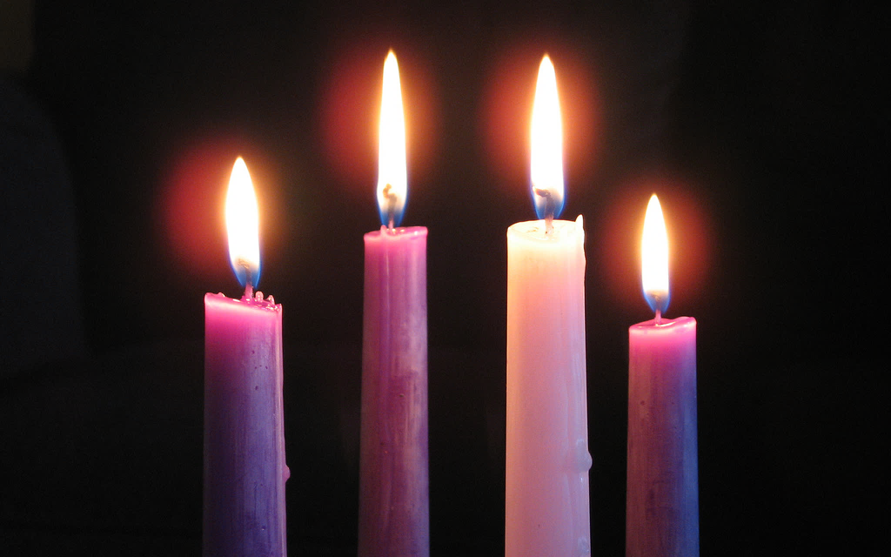

Opening Song: Once in Royal David’s City
Once in royal David's city
Stood a lowly cattle shed
Where a mother laid her baby
In a manger for His bed
Mary was that mother mild
Jesus Christ her little child

He came down to earth from heaven
Who is God and Lord of all
And His shelter was a stable
And His cradle was a stall
With the poor and mean and lowly
Lived on earth our Saviour holy

Not in that poor lowly stable
With the oxen standing by
We shall see him, but in heaven
Set at God’s right hand on high
When, like stars, his children crowned
All in white shall gather round

Lighting of the Fourth Advent Candle: LOVE
All: In a world filled with loneliness and isolation, we are called to share God’s love, a love that is not dependant on our feelings and likes.
Reader One: The Psalmist received a vision from God, who said, I have put a crown on the head of a new king, a mighty one chosen and anointed with oil.
Reader Two: My hand will always be with him; my arm will strengthen him.
Reader One: My faithfulness and steadfast love will be with the one I have chosen.
Reader Two: We wait for God’s love coming to us. The day of God’s joy is soon coming. We live in God’s peace and hope as we light these candles.
Please pause as we light the four candles, then respond:
All: Loving God, come and shine your light in the world! Grant us the courage to love others as God loves us, as we prepare the way for love-made-known, God-with-us, Emmanuel.

Celebrant: Dear friends in Christ, as we finish the Advent Season and look forward to the Birth of our Lord, may it be our care and delight to prepare ourselves to hear again the message of the angels; in heart and mind to go even unto Bethlehem and see this thing which is come to pass, and the Babe lying in a manger.

Let us read and mark in Holy Scripture the story of the loving purposes of God, from the first days of our disobedience unto the glorious Redemption brought us by this Holy Child; and let us make this Church, dedicated to St. Paul, his apostle, glad with our songs of praise.
But first let us pray for the needs of his whole world; for peace and goodwill over all the earth; for unity and brotherhood within the Church he came to build, and especially in our nation of Canada, within this City of Edmonton, and the Anglican Parish of St. Paul’s: And because this of all things would rejoice his heart, let us at this time remember in the name of Jesus the poor and the helpless, the cold, the hungry, and the oppressed; the sick in body and in mind, and those who mourn; the lonely and the unloved; the aged and the little children; all who know not the Lord Jesus, or who love him not, or who by sin have grieved his heart of love. Lastly, let us remember before God all those who rejoice with us, but upon another shore and in a greater light, that multitude which no man can number, whose hope was in the Word made flesh, and with whom, in this Lord Jesus, we for evermore are one.
All: Amen.

The Lord’s Prayer
Leader: As our Saviour Christ has taught us, we are bold to say,
All: Our Father, who art in heaven, hallowed be thy name, thy kingdom come, thy will be done, on earth as it is in heaven. Give us this day our daily bread. And forgive us our trespasses, as we forgive those who trespass against us. And lead us not into temptation, but deliver us from evil. For thine is the kingdom, the power, and the glory, for ever and ever. Amen.

Opening Collect
Celebrant: Almighty God bless us with his grace: Christ give us the joys of everlasting life: and unto the fellowship of the citizens above may the King of Angels bring us all.
People: Amen.

Service of Lessons and Carols

Song: Creator of the Stars of Night
Creator of the stars of night
Thy people's everlasting light
Jesus, redeemer of us all
Hear thou thy servants when they call

Thou, sorrowing at the helpless cry
Of all creation doomed to die
Didst save our lost and guilty race
By healing gifts of heavenly grace

When earth was near its evening hour
Thou didst in love’s redeeming power
Like bridegroom from his chamber come
Forth from a maidens mother’s womb

At thy great name exalted now
All knees in lowly homage bow
All things in heaven and earth adore
And own thee King for evermore

To God the Father, God the Son
And God the Spirit, Three-in-One
Praise, honour, might, and glory be
From age to age eternally

First Lesson: Genesis 3:8-15, 17-19 – God tells sinful Adam that he has lost the life of Paradise and that his seed will bruise the serpent’s head.
They heard the sound of the Lord God walking in the garden at the time of the evening breeze, and the man and his wife hid themselves from the presence of the Lord God among the trees of the garden. But the Lord God called to the man, and said to him, “Where are you?” He said, “I heard the sound of you in the garden, and I was afraid, because I was naked; and I hid myself.” He said, “Who told you that you were naked? Have you eaten from the tree of which I commanded you not to eat?” The man said, “The woman whom you gave to be with me, she gave me fruit from the tree, and I ate.” Then the Lord God said to the woman, “What is this that you have done?” The woman said, “The serpent tricked me, and I ate.” The Lord God said to the serpent, “Because you have done this, cursed are you among all animals and among all wild creatures; upon your belly you shall go, and dust you shall eat all the days of your life. I will put enmity between you and the woman, and between your offspring and hers; he will strike your head, and you will strike his heel.” And to the man he said, “Because you have listened to the voice of your wife, and have eaten of the tree about which I commanded you, ‘You shall not eat of it,’ cursed is the ground because of you; in toil you shall eat of it all the days of your life; thorns and thistles it shall bring forth for you; and you shall eat the plants of the field. By the sweat of your face you shall eat bread until you return to the ground, for out of it you were taken; you are dust, and to dust you shall return.”

Song: In the Bleak Midwinter
In the bleak midwinter
Frosty wind made moan
Earth stood hard as iron
Water like a stone
Snow had fallen, snow on snow
Snow on snow
In the bleak midwinter, long ago

Our God, heaven cannot hold Him
Nor earth sustain
Heaven and earth shall flee away
When He comes to reign
In the bleak midwinter
A stable place sufficed
The Lord God Almighty, Jesus Christ
Angels and archangels
May have gathered there
Cherubim and seraphim
Thronged the air
But His mother only
In her maiden bliss
Worshipped the Beloved with a kiss

What can I give Him
Poor as I am
If I were a shepherd
I would bring a lamb
If I were a wise man
I would do my part
Yet what I can, I give him - give my heart

Second Lesson: Genesis 22:15-18 – God promises to faithful Abraham that in his seed shall all the nations of the earth be blessed.
The angel of the Lord called to Abraham a second time from heaven, and said, “By myself I have sworn, says the Lord: Because you have done this, and have not withheld your son, your only son, I will indeed bless you, and I will make your offspring as numerous as the stars of heaven and as the sand that is on the seashore. And your offspring shall possess the gate of their enemies, and by your offspring shall all the nations of the earth gain blessing for themselves, because you have obeyed my voice.”

Song: Lo, How a Rose E’er Blooming

Lo, how a rose e'er blooming
From tender stem hath sprung
Of Jesse's lineage coming
As those of old have sung
It came a blossom bright
Amid the cold of winter
When half spent was the night

Isaiah 'twas foretold it
The rose I have in mind
With Mary we behold it
The virgin mother kind
To show God's love aright
She bore to us a Saviour
When half spent was the night
(continued on next page)

O Flower whose fragrance tender
With sweetness fills the air
Dispel in glorious splendour
The darkness everywhere
True man, yet very God
From sin and death now save us
And share our every load

Third Lesson: Isaiah 9:2, 6-7 – The prophet foretells the coming of the Saviour.
The people who walked in darkness have seen a great light; those who lived in a land of deep darkness – on them light has shined. For a child has been born for us, a son given to us; authority rests upon his shoulders; and he is named Wonderful Counselor, Mighty God, Everlasting Father, Prince of Peace. His authority shall grow continually, and there shall be endless peace for the throne of David and his kingdom. He will establish and uphold it with justice and with righteousness from this time onward and forevermore. The zeal of the Lord of hosts will do this.

Song: It Came Upon the Midnight Clear

It came upon the midnight clear
That glorious song of old
From angels bending near the earth
To touch their harps of gold
Peace on the earth, to all good will
From heaven's most gracious King
The world in solemn stillness lay
To hear the angels sing

Still through the cloven skies they come
With peaceful wings unfurled
And still their heavenly music floats
O'er all the weary world
Above its sad and lowly plains
They bend on hovering wing
And ever o'er its Babel sounds
The blessed angels sing

Yet with the woes of sin and strife
The world has suffered long
Beneath the angel strain have rolled
Two thousand years of wrong
And we amid our wars hear not
The words of peace they bring
O listen now and still your strife
To hear the angels sing

And you beneath life's crushing load
Whose forms are bending low
Who toil along the climbing way
With painful steps and slow
Look now for glad and golden hours
Come swiftly on the wing
O rest beside the weary road
And hear the angels sing

For lo the days are hastening on
By prophet seen of old
When with the ever-circling years
Shall come the time foretold
(continued on next page)
When the new heaven
And earth shall own
The Prince of Peace their King
And the whole world send back the song
Which now the angels sing

Fourth Lesson: Isaiah 11:1-4a, 6-9 – The peace that Christ will bring is foreshown.
A shoot shall come out from the stump of Jesse, and a branch shall grow out of his roots. The spirit of the Lord shall rest on him, the spirit of wisdom and understanding, the spirit of counsel and might, the spirit of knowledge and the fear of the Lord. His delight shall be in the fear of the Lord. He shall not judge by what his eyes see, or decide by what his ears hear; but with righteousness he shall judge the poor, and decide with equity for the meek of the earth. The wolf shall live with the lamb, the leopard shall lie down with the kid, the calf and the lion and the fatling together, and a little child shall lead them. The cow and the bear shall graze, their young shall lie down together; and the lion shall eat straw like the ox. The nursing child shall play over the hole of the asp, and the weaned child shall put its hand on the adder’s den. They will not hurt or destroy on all my holy mountain; for the earth will be full of the knowledge of the Lord as the waters cover the sea.

Song: O Little Town of Bethlehem

O little town of Bethlehem
How still we see thee lie
Above thy deep and dreamless sleep
The silent stars go by
Yet in thy dark streets shineth
The everlasting Light
The hopes and fears of all the years
Are met in thee tonight

For Christ is born of Mary
And gathered all above
While mortals sleep the angels keep
Their watch of wondering love
O morning stars together
Proclaim the holy birth
And praises sing to God the King
And peace to all the earth
How silently, how silently
The wondrous gift is given
As love imparts to human hearts
The blessings of God’s heaven
No ear may hear His coming
But in this world of sin
Where meek souls will receive Him still
The dear Christ enters in

O holy Child of Bethlehem
Descend to us we pray
Cast out our sin and enter in
Be born in us today
We hear the Christmas angels
The great glad tidings tell
O come to us, abide with us
Our Lord Emmanuel

Fifth Lesson: Luke 1:26-35, 38 – The angel Gabriel salutes the Blessed Virgin Mary.
In the sixth month the angel Gabriel was sent by God to a town in Galilee called Nazareth, to a virgin engaged to a man whose name was Joseph, of the house of David. The virgin’s name was Mary. And he came to her and said, “Greetings, favoured one! The Lord is with you.” But she was much perplexed by his words and pondered what sort of greeting this might be. The angel said to her, “Do not be afraid, Mary, for you have found favour with God. And now, you will conceive in your womb and bear a son, and you will name him Jesus. He will be great, and will be called the Son of the Most High, and the Lord God will give to him the throne of his ancestor David. He will reign over the house of Jacob forever, and of his kingdom there will be no end.” Mary said to the angel, “How can this be, since I am a virgin?” The angel said to her, “The Holy Spirit will come upon you, and the power of the Most High will overshadow you; therefore, the child to be born will be holy; he will be called Son of God. Then Mary said, “Here am I, the servant of the Lord; let it be with me according to your word.” Then the angel departed from her.

Song: What Songs Were Sung

We cannot tell, we do not know
What stars shone down so long ago
When Mary birthed her own sweet Son
And peace and love became as one

The Son of God, as scriptures said
Was virgin born in a tiny shed
Where simple shepherds stood hard by
While heavenly sound filled up the sky

Now let us stand, uncovered all
Before this crèche in lowly stall
Where kings and angels dignify
God’s gift, His Son, in humility

We do not know, we cannot tell
What songs were sung
What starlight fell
Or why the holy mystery stands
For so many years
In so many lands

We cannot tell, we do not know
What stars shone down so long ago
When Mary birthed her own sweet Son
And peace and love became as one

Sixth Lesson: Luke 2:1, 3-7 – St. Luke tells of the birth of Jesus.
In those days a decree went out from Emperor Augustus that all the world should be registered. All went to their own towns to be registered. Joseph also went from the town of Nazareth in Galilee to Judea, to the city of David called Bethlehem, because he was descended from the house and family of David. He went to be registered with Mary, to whom he was engaged and who was expecting a child. While they were there, the time came for her to deliver her child. And she gave birth to her firstborn son and wrapped him in bands of cloth, and laid him in a manger, because there was no place for them in the inn.

Song: Hark! The Herald Angels Sing

Hark! The herald angels sing
Glory to the newborn King
Peace on earth and mercy mild
God and sinners reconciled
Joyful all ye nations rise
Join the triumph of the skies
With the angelic host proclaim
Christ is born in Bethlehem
Hark! The herald angels sing
Glory to the newborn King

Christ by highest heaven adored
Christ the everlasting Lord
Late in time behold Him come
Offspring of a virgin's womb
Veiled in flesh the Godhead see
Hail the incarnate deity
Pleased as one of us to dwell
Jesus our Emmanuel
Hark! The herald angels sing
Glory to the newborn King

Hail the heaven-born Prince of Peace
Hail the Sun of Righteousness
Light and life to all he brings
Risen with healing in his wings
Mild he lays his glory by
Born that we no more may die
Born to raise each child of earth
Born to give us second birth
Hark! The herald angels sing
Glory to the newborn King

Seventh Lesson: Luke 2:8-16 – The shepherds go to the manger.
In that region there were shepherds living in the fields, keeping watch over their flock by night. Then an angel of the Lord stood before them, and the glory of the Lord shone around them, and they were terrified. But the angel said to them, “Do not be afraid; for see—I am bringing you good news of great joy for all the people: to you is born this day in the city of David a Saviour, who is the Messiah, the Lord. This will be a sign for you: you will find a child wrapped in bands of cloth and lying in a manger.” And suddenly there was with the angel a multitude of the heavenly host, praising God and saying, “Glory to God in the highest heaven, and on earth peace among those whom he favors!” When the angels had left them and gone into heaven, the shepherds said to one another, “Let us go now to Bethlehem and see this thing that has taken place, which the Lord has made known to us.” So they went with haste and found Mary and Joseph, and the child lying in the manger.

Song: Shepherds in the Fields Abiding

Shepherds in the field abiding
Tell us, when the seraph bright
Greeted you with wondrous tiding
What you saw and heard that night
Gloria in excelsis Deo!
We beheld (it is no fable)
God incarnate, King of bliss
Swathed and cradled in a stable
And the angel strain was this:
Gloria in excelsis Deo!
Choristers on high were singing
Jesus and his virgin birth
Heavenly bells the while a-ringing
"Peace, good will to men on earth"
Gloria in excelsis Deo!

Eighth Lesson: Matthew 2:1-12 – The wise men are led by the star to Jesus.
In the time of King Herod, after Jesus was born in Bethlehem of Judea, wise men from the East came to Jerusalem, asking, “Where is the child who has been born king of the Jews? For we observed his star at its rising, and have come to pay him homage.” When King Herod heard this, he was frightened, and all Jerusalem with him; and calling together all the chief priests and scribes of the people, he inquired of them where the Messiah was to be born. They told him, “In Bethlehem of Judea; for so it has been written by the prophet: ‘And you, Bethlehem, in the land of Judah, are by no means least among the rulers of Judah; for from you shall come a ruler who is to shepherd my people Israel.’” Then Herod secretly called for the wise men and learned from them the exact time when the star had appeared. Then he sent them to Bethlehem, saying, “Go and search diligently for the child; and when you have found him, bring me word so that I may also go and pay him homage.” When they had heard the king, they set out; and there, ahead of them, went the star that they had seen at its rising, until it stopped over the place where the child was. When they saw that the star had stopped, they were overwhelmed with joy. On entering the house, they saw the child with Mary his mother; and they knelt down and paid him homage. Then, opening their treasure chests, they offered him gifts of gold, frankincense, and myrrh. And having been warned in a dream not to return to Herod, they left for their own country by another road.

Song: The First Noel

The first Noel the angel did say
Was to certain poor shepherds
In fields as they lay
In fields where they
Lay keeping their sheep
On a cold winter's night
That was so deep
(continued on next page)

(Chorus) Noel, Noel, Noel, Noel
Born is the King of Israel

They looked up and saw a star
Shining in the east beyond them far
And to the earth it gave great light
And so it continued both day and night
(To Chorus)

And by the light of that same star
Three wise men came from country far
To seek for a king was their intent
And to follow the star wherever it went
(To Chorus)

This star drew nigh to the northwest
O'er Bethlehem it took its rest
And there it did both stop and stay
Right over the place where Jesus lay
(To Chorus)

Ninth Lesson: John 1:1-14 – St. John unfolds the great mystery of the Incarnation.
In the beginning was the Word, and the Word was with God, and the Word was God. He was in the beginning with God. All things came into being through him, and without him not one thing came into being. What has come into being in him was life, and the life was the light of all people. The light shines in the darkness, and the darkness did not overcome it. There was a man sent from God, whose name was John. He came as a witness to testify to the light, so that all might believe through him. He himself was not the light, but he came to testify to the light. The true light, which enlightens everyone, was coming into the world. He was in the world, and the world came into being through him; yet the world did not know him. He came to what was his own, and his own people did not accept him. But to all who received him, who believed in his name, he gave power to become children of God, who were born, not of blood or of the will of the flesh or of the will of man, but of God. And the Word became flesh and lived among us, and we have seen his glory, the glory as of a father’s only son, full of grace and truth.

Closing Collect
Celebrant: Almighty God, you make us glad each year as we remember the birth of thy only son, Jesus Christ: Grant that, as we joyfully receive him for our redeemer, we may with sure confidence behold him when he comes to be our judge; who is alive and reigns with you and the Holy Spirit, one God, world without end.
All: Amen.

Blessing

The Dismissal
Celebrant: Go forth in the name of Christ.
All: Thanks be to God. Amen.
Christmas Services at St. Paul’s
All Christmas services at St. Paul’s will be available on our YouTube Channel (search “St. Paul’s Anglican – Edmonton”). Please plan to join us!!
- December 24: Christmas Eve Live Streamed service at 7:00PM
- December 25: Christmas Day service available starting at 9:00AM
- December 27: Diocesan service available starting at 9:00AM

Community Corner for December 20

This week we partnered with Grovenor Elementary School to provide grocery gift cards to five families in need for the holidays. Contributions are still being accepted to cover the cost of these gifts. Please contact Michelle if you would like to help. Thank you to everyone who donated on such short notice!

Boyle Street Community Services runs an employment program for their clients, and you can hire their services. https://www.hiregood.ca/ is the website to visit to see what work they do, and you can feel good knowing you have hired hard working individuals with accountable supervision and considerations of COVID restrictions.

St. Paul’s Staff:
Rector: The Rev. Myron B. Penner
Community Outreach:
Michelle Schurek
Youth Leader:
Abigail Harding
Office Administrator:
RJ Chambers
St. Paul’s Anglican Church
10127 145 Street, Edmonton T5N 2X6
Phone: (780) 455-0771; Email: office@stpauls-anglican.ca
Website: www.stpauls-anglican.ca
Office Hours:
By appointment only due to Covid-19
For prayer requests email:
office@stpauls-anglican.ca
For urgent prayer requests call
the church office: (780) 455-0771
For pastoral emergencies call:
(587) 334-2130

