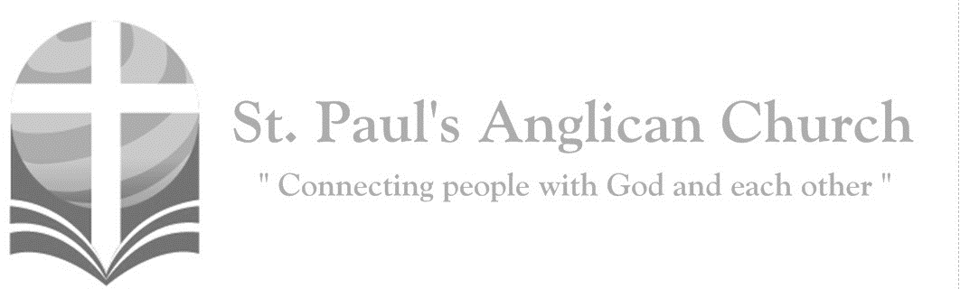
Friday, December 25, 2020: Christmas Day Service
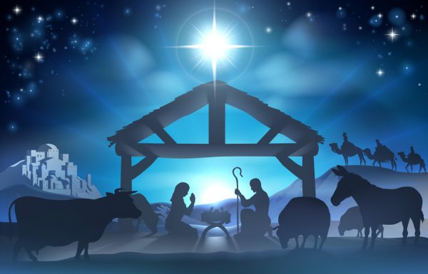
I bring you good news of a great joy which will come to all the people; for to you is born this day a Saviour, Christ the Lord.
(Luke 2:10-11)

Prelude

Opening Song: Hymn for Christmas Day/O Come All Ye Faithful
See amid the winter’s snow
Born for us on earth below
See the tender Lamb appears
Promised from eternal years

Hail, thou ever blessed morn
Hail, redemption’s happy dawn
Sing through all Jerusalem
Christ is born in Bethlehem

O come, all ye faithful
Joyful and triumphant
O come ye
O come ye to Bethlehem
Come and behold him
Born the kings of angels

O come, let us adore him
O come, let us adore him
O come, let us adore him
Christ the Lord (continued on next page)
God of God, Light of Light
Lo, he abhors not the virgin’s womb
Very God, begotten not created

(Chorus) O come, let us adore him
O come, let us adore him
O come, let us adore him
Christ the Lord

Sing choirs of angels
Sing in exultation
Sing all ye citizens of heaven above
Glory to God in the highest (To Chorus)

Yea Lord, we greet thee
Born this happy morning
Jesus, to thee be glory given
Word of the Father
Now in flesh appearing
(To Chorus)

The Service of Light
Leader: Jesus Christ is the light of the world.
All: A light no darkness can extinguish.
O gracious Light, pure brightness of the everliving Father in heaven, O Jesus Christ, holy and blessed! Now as we come to the setting of the sun, and our eyes behold the vesper light, we sing your praises, O God: Father, Son, and Holy Spirit. You are worthy at all times to be sung by happy voices, O Son of God, O Giver of life, and to be glorified through all the worlds.
Leader: Let us give thanks to the Lord our God.
All: It is right to give our thanks and praise.
Leader: Blessed are you, Lord our God, our eternal Father and David’s king. You have made our gladness greater and increased our joy by sending to dwell among us the Wonderful Counsellor, the Prince of Peace. Born of Mary, proclaimed to the shepherds, and acknowledged to the ends of the earth, your unconquered Sun of righteousness destroys our darkness and establishes us in freedom. All glory in the highest be to you, through Christ, the Son of your favour, in the anointing love of his Spirit, this day and for ever and ever.
All: Amen.

Morning Prayer
Leader: Lord, open our lips,
All: And our mouth shall proclaim your praise.
Leader: O God, make speed to save us.
All: O Lord, make haste to help us. Glory to the Father, and to the Son, and to the Holy Spirit: as it was in the beginning, is now, and will be for ever. Amen. Alleluia!

Leader: The Word was made flesh and dwelt among us: O come, let us worship.
All: May God be merciful to us and bless us, show us the light of his countenance and come to us. Let your ways be known upon earth, your saving health among all nations. Let the peoples praise you, O God; let all the peoples praise you. Let the nations be glad and sing for joy, for you judge the peoples with equity and guide all the nations upon earth. Let the peoples praise you, O God; let all the peoples praise you. The earth has brought forth her increase; may God, our own God, give us his blessing. May God give us his blessing, and may all the ends of the earth stand in awe of him.

Song: Immanuel

A sign shall be given
A virgin will conceive
A human baby
Bearing undiminished Deity
The glory of the nations
A light for all to see
And hope for all who will embrace
His warm reality

(Chorus) Immanuel, our God is with us
And if God is with us
Who could stand against us
Our God is with us, Immanuel

For all those who live
In the shadow of death
A glorious light has dawned
For all those who stumble
In the darkness
Behold Your light has come (To Chorus)

So what shall be your answer
Oh, will you hear the call
Of Him who did not spare His Son
But gave Him for us all
On earth there is no power
There is no depth or height
Could ever separate us
From the love of God in Christ
(To Chorus)

The Reading of Scripture
First Reading: Isaiah 52:7-10
How beautiful upon the mountains are the feet of the messenger who announces peace, who brings good news, who announces salvation, who says to Zion, "Your God reigns." Listen! Your sentinels lift up their voices, together they sing for joy; for in plain sight they see the return of the LORD to Zion. Break forth together into singing, you ruins of Jerusalem; for the LORD has comforted his people, he has redeemed Jerusalem. The LORD has bared his holy arm before the eyes of all the nations; and all the ends of the earth shall see the salvation of our God.
Reader: The Word of the Lord.
People: Thanks be to God.

Psalm/Canticle: Psalm 98
O sing to the LORD a new song, for he has done marvelous things. His right hand and his holy arm have gotten him victory. The LORD has made known his victory; he has revealed his vindication in the sight of the nations. He has remembered his steadfast love and faithfulness to the house of Israel. All the ends of the earth have seen the victory of our God. Make a joyful noise to the LORD, all the earth; break forth into joyous song and sing praises. Sing praises to the LORD with the lyre, with the lyre and the sound of melody. With trumpets and the sound of the horn make a joyful noise before the King, the LORD. Let the sea roar, and all that fills it; the world and those who live in it. Let the floods clap their hands; let the hills sing together for joy at the presence of the LORD, for he is coming to judge the earth. He will judge the world with righteousness, and the peoples with equity.

Second Reading: Hebrews 1:1-4
Long ago God spoke to our ancestors in many and various ways by the prophets, but in these last days he has spoken to us by a Son, whom he appointed heir of all things, through whom he also created the worlds. He is the reflection of God's glory and the exact imprint of God's very being, and he sustains all things by his powerful word. When he had made purification for sins, he sat down at the right hand of the Majesty on high, having become as much superior to angels as the name he has inherited is more excellent than theirs.
Reader: The Word of the Lord.
People: Thanks be to God.

The Gospel Reading
Leader: The Lord be with you.
People: And also with you.

Leader: The Holy Gospel of our Lord Jesus Christ according to St. John.
People: Glory to you, Lord Jesus Christ.
Gospel Reading: John 1:1-14
In the beginning was the Word, and the Word was with God, and the Word was God. He was in the beginning with God. All things came into being through him, and without him not one thing came into being. What has come into being in him was life, and the life was the light of all people. The light shines in the darkness, and the darkness did not overcome it. There was a man sent from God, whose name was John. He came as a witness to testify to the light, so that all might believe through him. He himself was not the light, but he came to testify to the light. The true light, which enlightens everyone, was coming into the world. He was in the world, and the world came into being through him; yet the world did not know him. He came to what was his own, and his own people did not accept him. But to all who received him, who believed in his name, he gave power to become children of God, who were born, not of blood or of the will of the flesh or of the will of man, but of God. And the Word became flesh and lived among us, and we have seen his glory, the glory as of a father's only son, full of grace and truth.
Leader: The Gospel of Christ.
People: Praise to you, Lord Jesus Christ.

Song: Angels From the Realms of Glory / Emmanuel
Angels from the realms of glory
Wing your flight o'er all the earth
You who sang creation's story
Now proclaim Messiah's birth

(Chorus 1) Come and worship
Come and worship
Worship Christ the newborn King

Shepherds in the field abiding
Watching o'er your flocks by night
God with man is now residing
Yonder shines the infant light
(To Chorus 1)
(Chorus 2) Emmanuel, Emmanuel
You are the God who saves us
Worthy of all our praises
Emmanuel, Emmanuel
Come have your way among us
We welcome you here, Lord Jesus
Come have your way among us
We welcome you here, Lord Jesus

Come and worship
Worship Christ the newborn King
God is with us
Even now his love is here (repeat)
His love is here (To Chorus 2)

Sermon by the Rev. Dr. Myron Penner – Sermon Notes:
________________________________________________________________________________________________________________________________________________________________________________________________________________________________________________________________________________________________________________________________________________________________________________________________________________________________________________________________________________________________________________________
________________________________________________________________________________________________________________________________________________
________________________________________________________________________________________________________________________________________________

Song: What Child is This
What Child is this who laid to rest
On Mary's lap is sleeping
Whom angels greet with anthems sweet
While shepherds watch are keeping
(Chorus) This, this is Christ the King
Whom shepherds guard and angels sing
Haste, haste to bring Him laud
The Babe the Son of Mary
Why lies He in such mean estate
Where ox and ass are feeding
Good Christians fear for sinners here
The silent Word is pleading (To Chorus)
So bring Him incense, gold, and myrrh
Come peasant king to own Him
The King of kings salvation brings
Let loving hearts enthrone Him
(To Chorus)

Affirmation of Faith – The Apostle’s Creed
All: I believe in God, the Father almighty, Creator of heaven and earth. I believe in Jesus Christ, his only Son, our Lord. He was conceived by the power of the Holy Spirit and born of the Virgin Mary. He suffered under Pontius Pilate, was crucified, died and was buried. He descended to the dead. On the third day, he rose again. He ascended into heaven and is seated at the right hand of the Father. He will come again to judge the living and the dead. I believe in the Holy Spirit, the holy catholic Church, the communion of saints, the forgiveness of sins, the resurrection of the body, and the life everlasting. Amen.

Prayers of the People
Leader: In joy and humility let us pray to the creator of the universe, saying, “Lord, grant us peace.” By the good news of our salvation brought to Mary by the angel, hear us, O Lord.
All: Lord, grant us peace.
Leader: By the mystery of the Word made flesh, hear us, O Lord. Lord, grant us peace. By the birth in time of the timeless Son of God, hear us, O Lord.
All: Lord, grant us peace.
Leader: By the manifestation of the King of glory to the shepherds and magi, hear us, O Lord.
All: Lord, grant us peace.
Leader: By the submission of the maker of the world to Mary and Joseph of Nazareth, hear us, O Lord.
All: Lord, grant us peace.
Leader: By the baptism of the Son of God in the river Jordan, hear us, O Lord.
All: Lord, grant us peace.
Leader: Grant that the kingdoms of this world may become the kingdom of our Lord and Saviour Jesus Christ; hear us, O Lord.
All: Lord, grant us peace. Amen.

The Collect
Leader: O God our Father, whose Word has come among us in the Holy Child of Bethlehem, may the light of faith illumine our hearts and shine in our words and deeds; through him who is Christ our Lord, who lives and reigns with you and the Holy Spirit, one God, now and for ever.
All: Amen.

The Lord’s Prayer
Leader: And now, as our Saviour Christ has taught us, we are bold to say,
All: Our Father, who art in heaven, hallowed be thy name, thy kingdom come, thy will be done, on earth as it is in heaven. Give us this day our daily bread. And forgive us our trespasses, as we forgive those who trespass against us. And lead us not into temptation, but deliver us from evil. For thine is the kingdom, the power, and the glory, for ever and ever. Amen.

Congregational Announcements (Rev. Myron)

Closing Song: Joy to the World

Joy to the world, the Lord is come
Let earth receive her King
Let every heart prepare Him room
And heaven and nature sing
And heaven and nature sing
And heaven
And heaven and nature sing

Joy to the earth, the Saviour reigns
Let men their songs employ
While fields and floods
Rocks, hills, and plains
Repeat the sounding joy
Repeat the sounding joy
Repeat, repeat the sounding joy

He rules the world with truth and grace
And makes the nations prove
The glories of His righteousness
And wonders of His love
And wonders of His love
And wonders, wonders of His love

The Dismissal
Celebrant: Let us bless the Lord
All: Thanks be to God.
Celebrant: May the God of peace enable us to do his will in every kind of goodness, working in us what pleases him, through Jesus Christ, to whom be the glory for ever and ever.
All: Amen.

Postlude

Please join us for Sunday live streamed services at 10:00AM Sunday mornings. Live streams can be viewed from our YouTube Channel (St. Paul’s Anglican – Edmonton).

May you see the GOD of
HOPE, PEACE, JOY, and LOVE
at work in your neighborhoods and communities this Christmas season!
God’s blessing to you and your families!

St. Paul’s Anglican Church
10127 145 Street, Edmonton T5N 2X6
Phone: (780) 455-0771; Email: office@stpauls-anglican.ca
Website: www.stpauls-anglican.ca

