AMDG. Thanksgiving Sunday Texts: Psalm 8
October 8th, 2017 Matthew 6

Reflecting On Thanksgiving
Thanks A Lot!

Introduction:

This morning, instead of a traditional Thanksgiving sermon, I
would like to invite you to join me in creating some intentional space for giving thanks.

Sometimes Thanksgiving can become almost a token time for saying thank you. We may pause for a moment – but often our minds are already racing ahead and thinking about our turkey dinner, and what needs to be done, or about things that are coming up next week. So I wanted to do something a bit different this year and create some space where we can really pause, intentionally breathe in the Spirit, and do some reflecting on what Thanksgiving and giving thanks really means – to give ourselves fully to saying thank you:

-2-
Thanks a lot, God, for our world;
Thanks a lot, God, for our lives;
Thanks a lot God, for our blessings;
Thanks a lot, God – for all of it!

This morning, there will be some reflecting – interspersed with scripture, some singing, some guided thoughts, and some silence. If you find your mind wandering a bit – still thinking about that turkey dinner – don’t worry about it – just take a deep breath and silently say ‘Thanks a lot, God’ to refocus your attention.

Let’s begin by doing just that – closing our eyes for a moment; settling in our seats, and taking some deep breaths…. (end with ‘Thanks a lot, God’)

We’re going to reflect on Thanksgiving from four different aspects:

-3-
The first is that: We are part of something bigger … Sometimes, despite the fact that with the internet and social media the world is at our fingertips – our lives can become very inwardly focussed and small - with all our concerns, our worries and stresses, our busyness, our pains and struggles. And it’s good to be reminded that we are not the centre of the universe – but part of something Bigger. I invite you to watch this video with me – and reflect on our place in this universe. As you watch – allow your heart to simply be in awe of God – Creator of the
heavens and the earth. video: Earth to Universe zoom

Take a moment now in silence:
* Think about the grandeur of creation;
* Think about the earth in all its infinite diversity, beauty and complexity;
* What does it mean to be part of something bigger?

♪ ‘How Great Thou Art’ (vs. 1) VU 238

-4-
2. Giving thanks that God created us …
We move now from the vastness of the universe and reflecting on being part of something bigger - to the intimate microcosm of our own selves – and giving thanks that God created each of us:

Let me share with you this paraphrase from Psalm 8:
All of creation beckons me to worship You.
The grandeur of the universe echoes Your Glory!
More than spectacular is the work of Your hands!
Who can match Your brilliance and authority?
You set boundaries for the ocean,
You raise majestic mountains to touch the sky
Sunrise and sunset happens on Your watch
Who is humankind that You are mindful of us,
the frail sons and daughters that You would
entrust us to oversee all that You’ve made?
Who are the peoples of the earth that we get to bear Your image?
Who am I that You even notice me?
How can it be that my tears and dreams matter to You?
Eternal God – beyond time and space,
Who am I that You lean in when I draw near?
Wind and sea obey at Your command,
yet You invite me to follow You with a whisper.
Thank You for creating me and giving me life.

-5-
I invite you to take a moment to reflect on what it means for you that the One who created the billions of galaxies and stars and planets – the vast expanse of the universe – created you – putting together your DNA – the molecules, the atoms, the genes, the physical characteristics, your personality, your talents and gifts – everything that makes you YOU. Psalm 139 says: “For it was You who formed my inward parts; You knit me together in my mother’s womb. I praise You, God, that I am fearfully and wonderfully made!”
Take a moment now to appreciate the unique things about yourself that make you You. Include everything – even the parts of you that you might consider flaws. And thank God that you exist – just as you are. (silence)

♪ ‘For The Beauty Of The Earth’ (vs.1 & 3) VU 226

-6-
3. Putting our thanksgiving into perspective …
If you’re like me – we often take things for granted: health, friends, family, food on the table, education, freedom, living in a relatively safe environment, enjoying small luxuries …. And yet, again if you are like me – I often find myself complaining about inconveniences and annoyances – traffic, weather, small imagined slights for example - and worrying about trivial things. But as small as these may be – they can consume a lot of our time and energy. What we need, perhaps, is a change of perspective – a reframing of the way we look at life.

Jesus has some wisdom to share with us in this regard. Let’s hear his words again, found in this paraphrase from Matthew’s gospel, chapter 6:

-7-
²⁵⁻²⁶ “If you decide for God, living a life of God-worship, it follows that you don’t fuss about what’s on the table at mealtimes or whether the clothes in your closet are in fashion. There is far more to your life than the food you put in your stomach, more to your outer appearance than the clothes you hang on your body. Look at the birds, free and unfettered, not tied down to a job description, careless in the care of God. And you count far more to God than birds.
²⁷⁻²⁹ “Has anyone by fussing in front of the mirror ever gotten taller by so much as an inch? All this time and money wasted on fashion—do you think it makes that much difference? Instead of looking at the fashions, walk out into the fields and look at the wildflowers. They never primp or shop, but have you ever seen color and design quite like it? The ten best-dressed men and women in the country look shabby alongside them.
³⁰⁻³³ “If God gives such attention to the appearance of wildflowers—most of which are never even seen—don’t you think God will attend to you, take pride in you, do God’s best for you? What I’m trying to do here is to get you to relax, to not be so preoccupied with getting, so you can respond to God’s giving. People who don’t know God and the way God works fuss over these things, but you know both God and how God works. So, steep your life in God-reality, God-initiative, God-provisions. Don’t worry about missing out. And you’ll find all your everyday human concerns will be met.

-8-
As a way of helping us put our lives into perspective this Thanksgiving, I invite you to share the following short video with me – comparing our First World lives to those in the Third World. video

It gives us pause to readjust our perspective, doesn’t it?! And to count our blessings!

♪ Sing ‘Count Your Blessings’ (vs. 1) SG.133

-9-

4. Savouring our blessings …
Many scientific studies over the last few decades have shown the difference that having an ‘attitude of gratitude’ can have in all these difference areas of our lives:

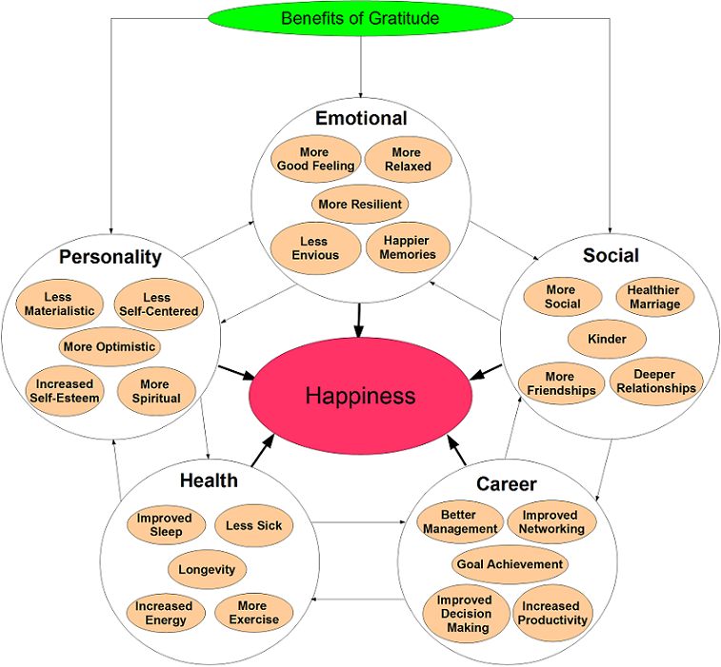

-10-

Intentionally focussing on the things we are grateful for can have a huge impact. But its not so much just listing all the things we are thankful for – as savouring the blessings that come to us from God’s hand.

I am going to invite you to do a guided reflection with me for a few minutes. But first, I invite you once again to get comfortable in your seat, and take a few deep breaths. You can close your eyes if you like – or leave them open – whichever is most comfortable for you. Then I want you to hold out your hands in front of you in a fist (face up) and in silence, slowly count off ten things that come to mind – one after another – for which you are thankful – taking a moment to savour each one. After naming ten things, just sit with your open hands resting on your lap ……

-11-

* Who are the people whom you love and who love you?
Let their faces smile in front of you …..

* What are your talents and gifts – Maybe you’re a good listener,
maybe its patience or compassion; perhaps you have a passion
for justice and making the world a better place for all ….

* What has happened in the last week or so for which you are
especially grateful?

* Make sure you use all ten fingers as you count off and savour
your blessings …..

* When you are finished, just let your open hands rest on your lap ….

-12-

Let us pray together: With open hands God, we hold these blessings we have received from Your hand , and we give You thanks. May the gratitude of our hearts overflow into the living of our lives – blessed to be blessings in the world. Amen

Now let’s gather all of our reflections together in song:
♪ Thanks a lot (thanks a lot) Thanks for the wondering me
Thanks a lot (thanks a lot) Thanks for the way I feel
Thanks for the animals, Thanks for the land
Thanks for the people everywhere
Thanks a lot (thanks a lot) Thanks for all I've got
Thanks for all I've got.

