Faith Evangelical Lutheran Church, Washington, IL
Second Sunday of Christmas
January 3, 2021

Prelude
Welcome

Hymn: “What Child Is This” Red Book # 296
Public Domain

Confession and Forgiveness

P: In the name of the Father, and of the + Son, and of the Holy Spirit.
C: Amen.
You may dip your finger in water and make the sign of the cross on your forehead as a reminder of your baptism.
P: Almighty God, to whom all hearts are open, all desires known, and from whom no secrets are hid: cleanse the thoughts of our hearts by the inspiration of your Holy Spirit, that we may perfectly love you and worthily magnify your holy name, through Jesus Christ our Lord.
C: Amen.
P: Let us confess our sin in the presence of God and of one another.
Please keep silence for reflection
P: Most merciful God,
C: we confess that we are captive to sin and cannot free ourselves. We have sinned against you in thought, word, and deed, by what we have done and by what we have left undone. We have not loved you with our whole heart; we have not loved our neighbors as ourselves. For the sake of your Son, Jesus Christ, have mercy on us. Forgive us, renew us, and lead us, so that we may delight in your will and walk in your ways, to the glory of your holy name. Amen.

P: In the mercy of almighty God, Jesus Christ was given to die for us, and for his sake God forgives us all our sins. As a called and ordained minister of the church of Christ, and by his authority, I therefore declare to you the entire forgiveness of all your sins, in the name of the Father, and of the + Son, and of the Holy Spirit.
C: Amen.
Peace:
P As forgiven people, we have peace with God, and peace with one another.
The peace of the Lord be with you always.
C And also with you.
P Let us share that peace with one another. Please take a moment to share God’s peace with those near to you, and say a prayer of peace for those at a distance.
P The grace of our Lord Jesus Christ, the love of God,
and the communion of the Holy Spirit be with you all.
C And also with you.
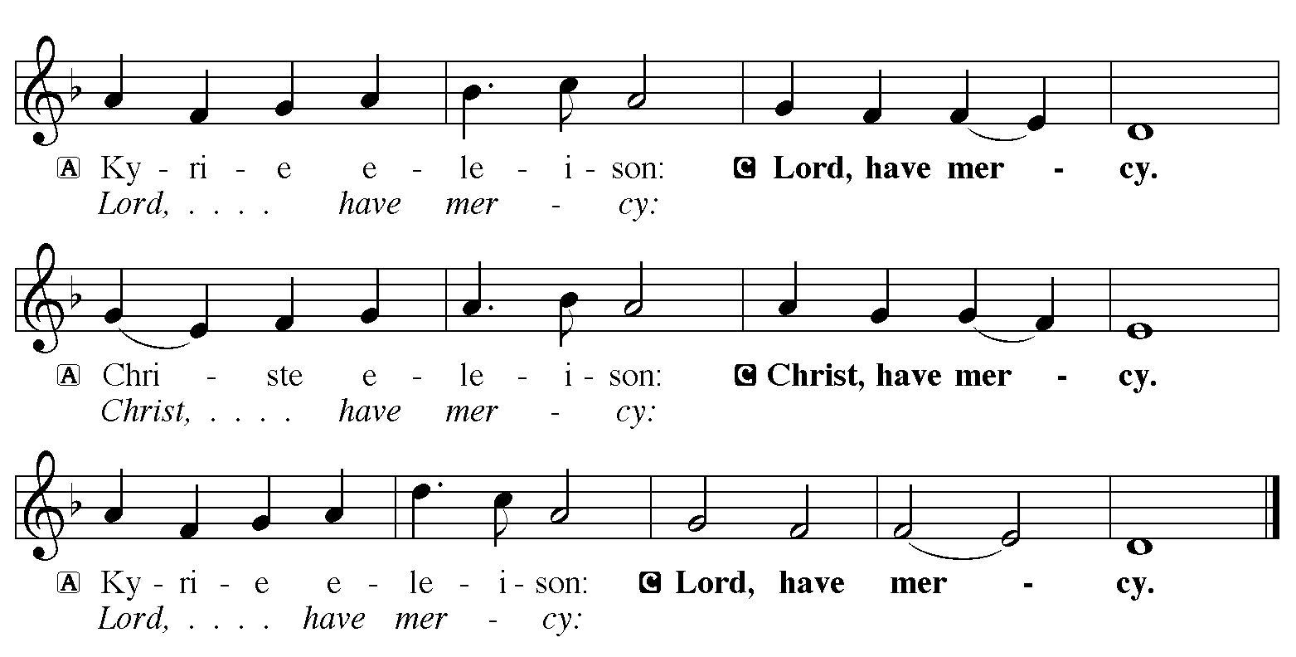

Hymn of Praise: “Of the Father’s Love Begotten” Red Book # 295
All rights reserved. Used by permission. Reprinted under OneLicense.net #A-711151

P The Lord be with you
C And also with you
Let us pray together the Prayer of the Day
O God our redeemer, you created light that we might live, and you illumine our world with your beloved Son. By your Spirit comfort us in all darkness, and turn us toward the light of Jesus Christ our Savior, who lives and reigns with you and the Holy Spirit, one God, now and forever. Amen.
Children’s Message

Canticle: “Listen! You Nations” Green Book 14

Refrain
Listen! you nations of the world:
listen to the Word of the Lord.
Announce it from coast to coast;
declare it to distant islands.

1 The Lord who scattered Israel
will gather his people again;
and he will keep watch over them
as a shepherd watches his flock. Refrain

2 With shouts of joy they will come,
their faces radiantly happy,
for the Lord is so gen’rous to them;
he showers his people with gifts. Refrain

3 Young women will dance for joy,
and men young and old will make merry.
Like a garden refreshed by the rain,
they will never be in want again.
Break into shouts of great joy:
Jacob is free again!
Teach nations to sing the song:
“The Lord has saved his people!”

Text: John W. Arthur, b. 1922
Music: J. Bert Carlson, b. 1937
Text and Music © 1972 Contemporary Worship 5: Services of the Word, admin. Augsburg Fortress
All rights reserved. Used by permission. Reprinted under OneLicense.net #A-711151

Reading: Ephesians 1:3-14
³Blessed be the God and Father of our Lord Jesus Christ, who has blessed us in Christ with every spiritual blessing in the heavenly places, ⁴just as he chose us in Christ before the foundation of the world to be holy and blameless before him in love. ⁵He destined us for adoption as his children through Jesus Christ, according to the good pleasure of his will, ⁶to the praise of his glorious grace that he freely bestowed on us in the Beloved. ⁷In him we have redemption through his blood, the forgiveness of our trespasses, according to the riches of his grace ⁸that he lavished on us. With all wisdom and insight ⁹he has made known to us the mystery of his will, according to his good pleasure that he set forth in Christ, ¹⁰as a plan for the fullness of time, to gather up all things in him, things in heaven and things on earth. ¹¹In Christ we have also obtained an inheritance, having been destined according to the purpose of him who accomplishes all things according to his counsel and will, ¹²so that we, who were the first to set our hope on Christ, might live for the praise of his glory. ¹³In him you also, when you had heard the word of truth, the gospel of your salvation, and had believed in him, were marked with the seal of the promised Holy Spirit; ¹⁴this is the pledge of our inheritance toward redemption as God’s own people, to the praise of his glory.
The Word of the Lord
C Thanks be to God

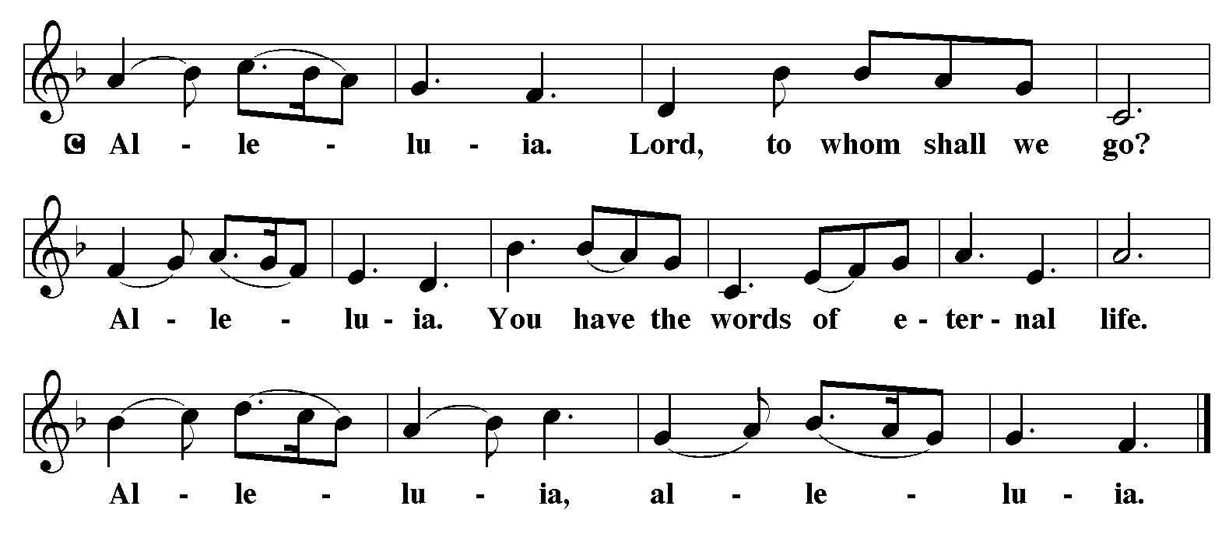

Holy Gospel: John 1:1-18
C Glory to you, O Lord
¹In the beginning was the Word, and the Word was with God, and the Word was God. ²He was in the beginning with God. ³All things came into being through him, and without him not one thing came into being. What has come into being ⁴in him was life, and the life was the light of all people. ⁵The light shines in the darkness, and the darkness did not overcome it.
⁶There was a man sent from God, whose name was John. ⁷He came as a witness to testify to the light, so that all might believe through him. ⁸He himself was not the light, but he came to testify to the light. ⁹The true light, which enlightens everyone, was coming into the world.
¹⁰He was in the world, and the world came into being through him; yet the world did not know him. ¹¹He came to what was his own, and his own people did not accept him. ¹²But to all who received him, who believed in his name, he gave power to become children of God, ¹³who were born, not of blood or of the will of the flesh or of the will of man, but of God.
¹⁴And the Word became flesh and lived among us, and we have seen his glory, the glory as of a father’s only son, full of grace and truth. ¹⁵(John testified to him and cried out, “This was he of whom I said, ‘He who comes after me ranks ahead of me because he was before me.’ ”) ¹⁶From his fullness we have all received, grace upon grace. ¹⁷The law indeed was given through Moses; grace and truth came through Jesus Christ. ¹⁸No one has ever seen God. It is God the only Son, who is close to the Father’s heart, who has made him known.

The Gospel of the Lord
C Praise to you, O Christ
Sermon by Pastor John Rothfusz
Sermon Hymn: “’Twas In the Moon of Wintertime” Red book # 284
Used by permission. Reprinted under OneLicense.net #A-711151

Apostles’ Creed
C: I believe in God, the Father almighty,
creator of heaven and earth.
I believe in Jesus Christ, God's only Son, our Lord,
who was conceived by the Holy Spirit,
born of the virgin Mary,
suffered under Pontius Pilate,
was crucified, died, and was buried;
he descended to the dead.
On the third day he rose again;
he ascended into heaven,
he is seated at the right hand of the Father,
and he will come to judge the living and the dead.
I believe in the Holy Spirit,
the holy catholic church, the communion of saints,
the forgiveness of sins, the resurrection of the body,
and the life everlasting. Amen.

Offering: God gives himself to us at Christmas, coming as the Word made flesh who dwells among us. Let us offer ourselves to God with thanks as we lift our tithes and offerings to the Lord. Please take a moment now to make an electronic offering to the church on the website, with the Tithe.ly app or write a check and send it in.

Offering Hymn: “The Bells of Christmas” Red Book # 298
Public Domain

Prayers: After each portion of the prayers finishes with “Lord in your mercy,” please respond, “Hear our prayer.”
Lord’s Prayer
Our Father, who art in heaven, hallowed be thy name,
thy kingdom come, thy will be done, on earth as it is in heaven.
Give us this day our daily bread; and forgive us our trespasses,
as we forgive those who trespass against us;
and lead us not into temptation, but deliver us from evil.
For thine is the kingdom, and the power, and the glory,
forever and ever. Amen
Announcements
Benediction: The Lord bless you and keep you. The Lord make his face to shine upon you and be gracious to you. The Lord look on you with favor and give you peace. In the name of the Father, and of the Son, and of the Holy Spirit. Amen.

Hymn: “Holy Child Within the Manger” Blue Book # 638
Used by permission. Reprinted under OneLicense.net #A-711151
*Dismissal
P Go in peace, serve the Lord.
C Thanks be to God!
Postlude

