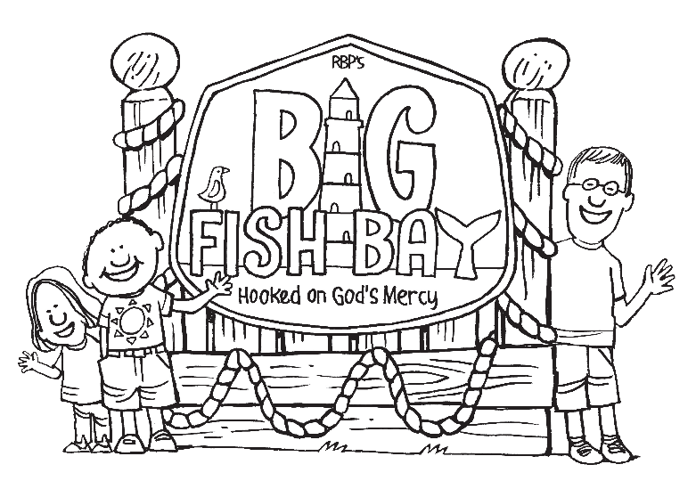

Scripture Memory Verses
2nd to 5th Grade

Scripture | Parent Initials
Be merciful, just as your father also is merciful. ~ Luke 6:36
The Lord is good to all, and his tender mercies are over all his works. All your works shall praise you. ~ Psalm 145:9 -10
You, Lord, are good, and ready to forgive, and abundant in mercy to all those who call upon you. ~ Psalm 86:5
Do not be overcome by evil, but overcome evil with good. ~ Romans 12:21
Not by works of righteousness which we have done, but according to his mercy he saved us. ~ Titus 3:5
Theme Verse: The Lord is merciful and gracious, slow to anger, and abounding in mercy. ~ Psalm 103:8

Please initial in the box when your child has memorized the verse and said it for you several times. You may return this form following VBS on August 21st or during the week of August 24th to 28th to earn a reward.

Some ideas to help with memorization:
- Write the verse in a prominent place where it will be seen every day.
- Sing the verse or put it to music
- Use hand motions or sign language while saying the verse
- Practice the verse while jump roping
- Write each word on a sticky-notes and then remove one sticky note at a time, saying the verse each time until all of the sticky notes have been removed.
- Play catch, saying the next word of the verse each time you catch the ball.
- Talk about the verse, its context and meaning.

