Children’s Page
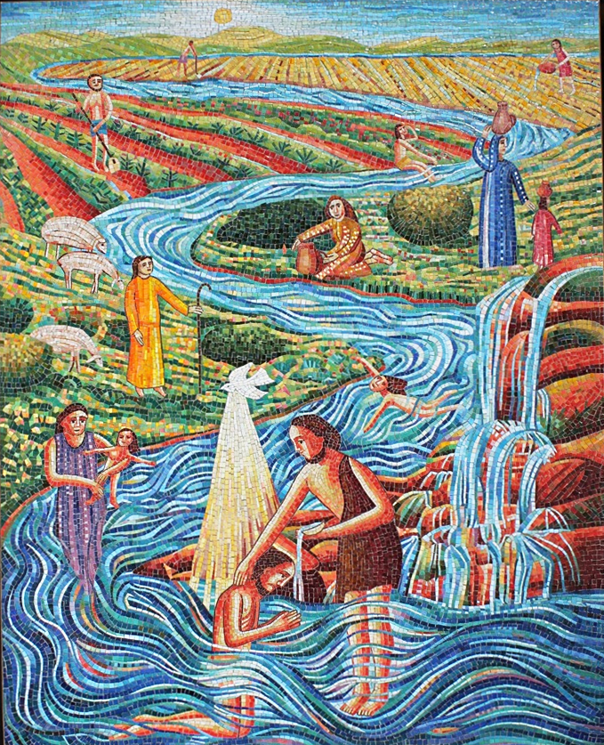
This is a picture by our friend, John Swanson (the guy in the photograph)
. A copy of it hangs over the water fountain at Calvary Evangelical Lutheran Church in San Diego.
- This is the Jordan River in Israel. Just an ordinary river.
- At the bottom of the picture, Jesus is being baptized by His cousin, John.
- What are all the other people doing with the water?

  - Bathing in it?
  - Drinking it?
  - Letting their animals drink?
  - Swimming in it?
  - Taking it back to their homes?
  - Watering crops?
  - Washing clothes?

- What do you do with water?
- The next time you use water, remember that water is a gift from God - ordinary enough to be used for bathing, drinking, washing and watering, AND special enough to baptize Jesus, and you, and me.

