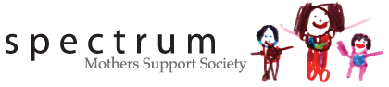

MEMBERSHIP APPLICATION FORM

Name
Professional Designation (if applicable)
Professional Organisation (if applicable)
Mailing Address
Phone
Email Address

Mission Statement
To compassionately support and motivate mothers while demonstrating commitment, excellence, confidentiality, integrity, acceptance and non-judgment in everything we do.

Yearly Individual Membership ($25.00 renewable in February of each year)
I, the undersigned, declare my support of the Vision and Mission Statements of Spectrum Support Group, as found above.

A copy of the Constitution and By Laws is available upon request.

Date

Please submit this form, together with a cheque for $25 made payable to
Spectrum Mothers Support Society
1314 East 29th Street, North Vancouver, BC V7J 1T1.

