Children’s Page
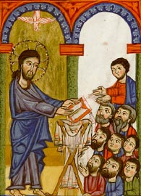
This is an illustration of “Christ Reading in the Synagogue” from the Gladzor Gospels. It was part of a very old book painted by Toros of Taron and two others between 1300 -1307 in one of the most important Armenian monasteries at the time named Gladzor, in Armenia.
If you wanted to see it today, you would find it at the University of California, Los Angeles
Read Luke 4:14-21
- Jesus is reading in a synagogue, which is a church for Jews.
- Jesus is reading from a scroll, because books weren’t invented yet.
- Jesus is reading a passage from Isaiah 61.
- Do you see the dove over Jesus’ head? It reminds us that Jesus is filled with the power of the Holy Spirit.
- Would you like to read the Bible in the church like Jesus?

