Faith Evangelical Lutheran Church, Washington, IL
Second Sunday of Epiphany
January 17, 2021

Prelude
Welcome

Hymn: “Listen, God is Calling” Red Book # 513
All rights reserved. Used by permission. Reprinted under OneLicense.net #A-711151

Confession and Forgiveness

P: In the name of the Father, and of the + Son, and of the Holy Spirit.
C: Amen.
You may dip your finger in water and make the sign of the cross on your forehead as a reminder of your baptism.
P: Almighty God, to whom all hearts are open, all desires known, and from whom no secrets are hid: cleanse the thoughts of our hearts by the inspiration of your Holy Spirit, that we may perfectly love you and worthily magnify your holy name, through Jesus Christ our Lord.
C: Amen.
P: Let us confess our sin in the presence of God and of one another.
Please keep silence for reflection
P: Most merciful God,
C: we confess that we are captive to sin and cannot free ourselves. We have sinned against you in thought, word, and deed, by what we have done and by what we have left undone. We have not loved you with our whole heart; we have not loved our neighbors as ourselves. For the sake of your Son, Jesus Christ, have mercy on us. Forgive us, renew us, and lead us, so that we may delight in your will and walk in your ways, to the glory of your holy name. Amen.

P: In the mercy of almighty God, Jesus Christ was given to die for us, and for his sake God forgives us all our sins. As a called and ordained minister of the church of Christ, and by his authority, I therefore declare to you the entire forgiveness of all your sins, in the name of the Father, and of the + Son, and of the Holy Spirit.
C: Amen.
Peace:
P As forgiven people, we have peace with God, and peace with one another.
The peace of the Lord be with you always.
C And also with you.
P Let us share that peace with one another. Please take a moment to share God’s peace with those near to you, and say a prayer of peace for those at a distance.
P The grace of our Lord Jesus Christ, the love of God,
and the communion of the Holy Spirit be with you all.
C And also with you.
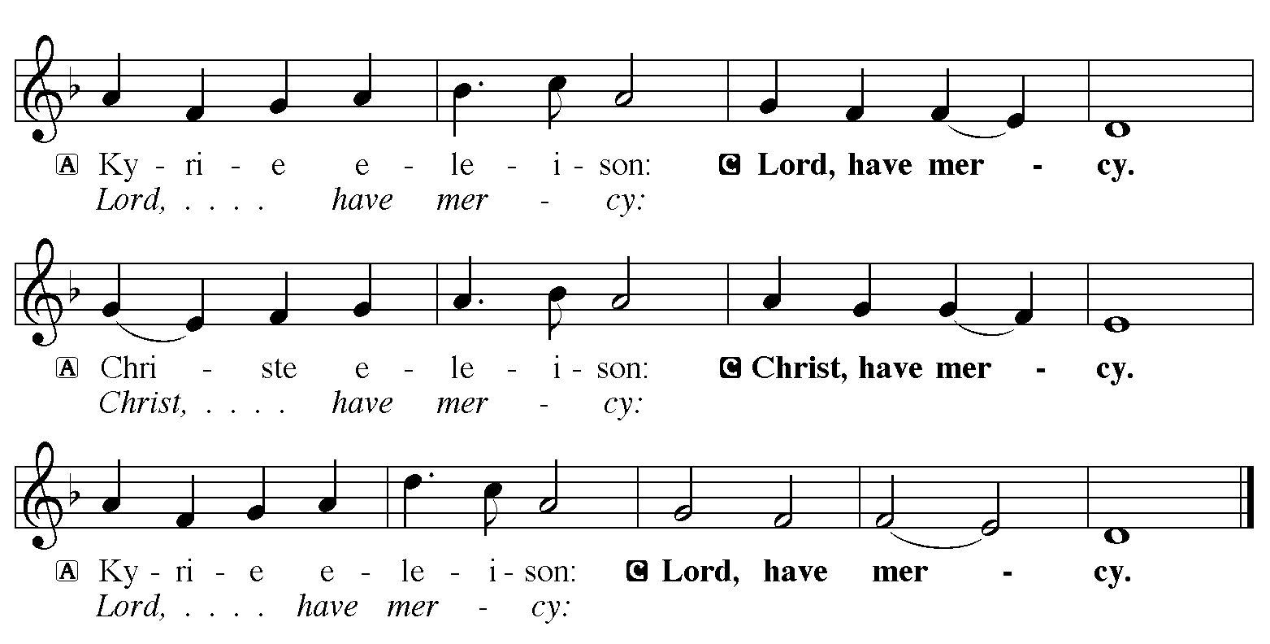

Hymn of Praise: “Songs of Thankfulness and Praise” Red Book # 310
Public Domain

P The Lord be with you
C And also with you
Let us pray together the Prayer of the Day
Thanks be to you, Lord Jesus Christ, most merciful redeemer, for the countless blessings and benefits you give. May we know you more clearly, love you more dearly, and follow you more nearly, day by day praising you, with the Father and the Holy Spirit, one God, now and forever. Amen.
Children’s Message

Reading: 1 Samuel 3:1-10
¹Now the boy Samuel was ministering to the Lord under Eli. The word of the Lord was rare in those days; visions were not widespread.
²At that time Eli, whose eyesight had begun to grow dim so that he could not see, was lying down in his room; ³the lamp of God had not yet gone out, and Samuel was lying down in the temple of the Lord, where the ark of God was. ⁴Then the Lord called, “Samuel! Samuel!” and he said, “Here I am!” ⁵and ran to Eli, and said, “Here I am, for you called me.” But he said, “I did not call; lie down again.” So he went and lay down. ⁶The Lord called again, “Samuel!” Samuel got up and went to Eli, and said, “Here I am, for you called me.” But he said, “I did not call, my son; lie down again.” ⁷Now Samuel did not yet know the Lord, and the word of the Lord had not yet been revealed to him. ⁸The Lord called Samuel again, a third time. And he got up and went to Eli, and said, “Here I am, for you called me.” Then Eli perceived that the Lord was calling the boy. ⁹Therefore Eli said to Samuel, “Go, lie down; and if he calls you, you shall say, ‘Speak, Lord, for your servant is listening.’ ” So Samuel went and lay down in his place.
¹⁰Now the Lord came and stood there, calling as before, “Samuel! Samuel!” And Samuel said, “Speak, for your servant is listening.”
The Word of the Lord
C Thanks be to God

Psalm 139:1-5, 12-17 – Sing in unison
¹Lord, you have searched me | out and known me;
you know my sitting down and my rising up; you discern my thoughts | from afar.
²You trace my journeys and my | resting-places
and are acquainted with | all my ways.
³Indeed, there is not a word | on my lips,
but you, O Lord, know it | altogether.
⁴You press upon me behind | and before
and lay your | hand upon me.
⁵Such knowledge is too wonder- | ful for me;
it is so high that I cannot at- | tain to it.
¹²For you yourself created my | inmost parts;
you knit me together in my | mother’s womb.
¹³I will thank you because I am mar- | velously made;
your works are wonderful, and I | know it well.

¹⁴My body was not hid- | den from you,
while I was being made in secret and woven in the depths | of the earth.
¹⁵Your eyes beheld my limbs, yet unfinished in the womb; all of them were written | in your book;
they were fashioned day by day, when as yet there was | none of them.
¹⁶How deep I find your | thoughts, O God!
How great is the | sum of them!
¹⁷If I were to count them, they would be more in number | than the sand;
to count them all, my life span would need to | be like yours.
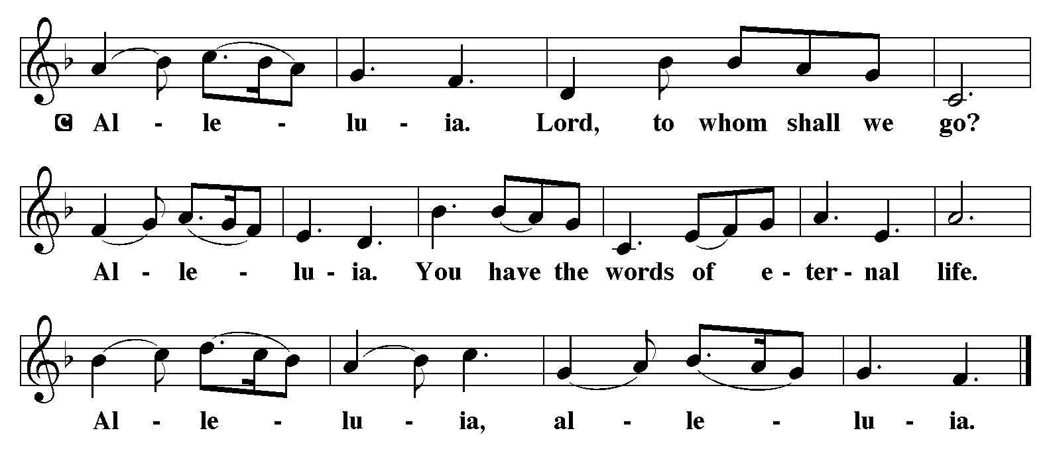

Holy Gospel: John 1:43-51
C Glory to you, O Lord
⁴³The next day Jesus decided to go to Galilee. He found Philip and said to him, “Follow me.” ⁴⁴Now Philip was from Bethsaida, the city of Andrew and Peter. ⁴⁵Philip found Nathanael and said to him, “We have found him about whom Moses in the law and also the prophets wrote, Jesus son of Joseph from Nazareth.” ⁴⁶Nathanael said to him, “Can anything good come out of Nazareth?” Philip said to him, “Come and see.” ⁴⁷When Jesus saw Nathanael coming toward him, he said of him, “Here is truly an Israelite in whom there is no deceit!” ⁴⁸Nathanael asked him, “Where did you get to know me?” Jesus answered, “I saw you under the fig tree before Philip called you.” ⁴⁹Nathanael replied, “Rabbi, you are the Son of God! You are the King of Israel!” ⁵⁰Jesus answered, “Do you believe because I told you that I saw you under the fig tree? You will see greater things than these.” ⁵¹And he said to him, “Very truly, I tell you, you will see heaven opened and the angels of God ascending and descending upon the Son of Man.”
The Gospel of the Lord
C Praise to you, O Christ
Sermon by Pastor Maureen Stein
Sermon Hymn: “Will You Come and Follow Me” Red book # 798
Used by permission. Reprinted under OneLicense.net #A-711151
Apostles’ Creed
C: I believe in God, the Father almighty,
creator of heaven and earth.
I believe in Jesus Christ, God's only Son, our Lord,
who was conceived by the Holy Spirit,
born of the virgin Mary,
suffered under Pontius Pilate,
was crucified, died, and was buried;
he descended to the dead.
On the third day he rose again;
he ascended into heaven,
he is seated at the right hand of the Father,
and he will come to judge the living and the dead.
I believe in the Holy Spirit,
the holy catholic church, the communion of saints,
the forgiveness of sins, the resurrection of the body,
and the life everlasting. Amen.

Offering: Jesus calls us to follow him, to share in his work in the world. Let us offer ourselves to God with thanks as we lift our tithes and offerings to the Lord. Please take a moment now to make an electronic offering to the church on the website, with the Tithe.ly app or write a check and send it in.

Offering Hymn: “Drawn to the Light” Red Book # 593
Used by permission. Reprinted under OneLicense.net #A-711151

Prayers: After each portion of the prayers finishes with “Lord in your mercy,” please respond, “Hear our prayer.”

Lord’s Prayer
Our Father, who art in heaven, hallowed be thy name,
thy kingdom come, thy will be done, on earth as it is in heaven.
Give us this day our daily bread; and forgive us our trespasses,
as we forgive those who trespass against us;
and lead us not into temptation, but deliver us from evil.
For thine is the kingdom, and the power, and the glory,
forever and ever. Amen
Announcements
Benediction: The Lord bless you and keep you. The Lord make his face to shine upon you and be gracious to you. The Lord look on you with favor and give you peace. In the name of the Father, and of the Son, and of the Holy Spirit. Amen.

Hymn: “Here I Am, Lord” Red Book # 574
Used by permission. Reprinted under OneLicense.net #A-711151
*Dismissal
P Go in peace, serve the Lord.
C Thanks be to God!
Postlude

