Reconciliation Matters! Content for Sunday Bulletins at WPGUC
…the collection from Sept. 6, 2020 to January 31, 2021….

Sept. 6, 2020
Reconciliation Matters
How long will true reconciliation take?
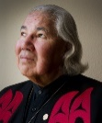
Senator Murray Sinclair:
“Dismantling systemic racism
will be a long fight….”

Listen to him on the Aug. 2, 2020 edition of
“The Sunday Edition” on CBC Radio

https://www.cbc.ca/radio/thesundayedition/the-sunday-edition-for-august-2-2020-1.5665613/senator-murray-sinclair-says-dismantling-systemic-racism-will-be-a-long-fight-1.5665625
All Our Relations!

Sept. 13, 2020
Reconciliation Matters

Shame and Prejudice: A Story of Resilience

Exhibit of Ken Monkman’s work
[Cree artist]

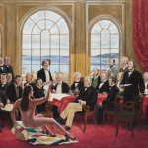

at UBC’s Museum of Anthropology
Aug. 6, 2020 to Jan 3, 2021.

https://moa.ubc.ca/2020/08/restorying-justice-kent-monkmans-shame-and-prejudice-a-story-of-resilience/

All Our Relations!

Sept. 20, 2020
Reconciliation Matters
Orange Shirt Day is coming!
September 30, 2020
We will observe the day on Sept. 27.
We invite everyone to wear an orange shirt
or orange ribbon to our service.
(in-person and online)

Read more details here:
https://www.orangeshirtday.org/

All Our Relations!

Sept. 27, 2020
Reconciliation Matters
Honouring Nisga’a Elder
Hereditary Chief Joe Gosnell
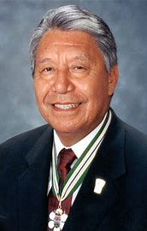
Renowned treaty negotiator, politician,
and leader of the Nisga'a Nation,
who died on Aug. 18 at age 85.

https://www.cbc.ca/news/canada/british-columbia/nisga-a-joe-gosnell-dead-1.5690778
All Our Relations!

Oct. 4, 2020
Reconciliation Matters
Two Former Residential Schools
Designated as National Historic Sites

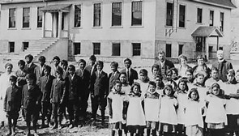

One in Manitoba, one in Nova Scotia

Read more details here:

https://www.ctvnews.ca/canada/two-former-residential-schools-named-national-historic-sites-1.5087347

All Our Relations!

Oct.11, 2020

Reconciliation Matters

Highway of Tears in Northern BC
(Highway 16)

A commemorative pole will honour
Missing and Murdered
Indigenous Women and Girls

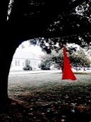

https://www.cbc.ca/news/canada/british-columbia/memorial-totem-pole-highway-of-tears-1.5711324

All Our Relations!

Oct. 18, 2020
Reconciliation Matters

University of Victoria to House
National Indigenous Law Centre
(funds provided by BC and Federal Govts.)

https://www.cbc.ca/news/canada/british-columbia/uvic-national-indigenous-law-centre-announcement-1.5711550
All Our Relations!

Oct. 25, 2020
Reconciliation Matters

Thousands of Children Died

In Canadian Residential Schools

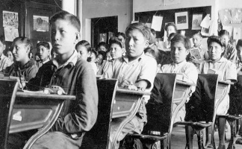

….and we now know some of their names…

Please read this account >>

https://www.thestar.com/edmonton/2019/09/30/thousands-of-indigenous-children-died-in-canadian-residential-schools-now-we-know-some-of-their-names.html

All Our Relations!

Nov. 1, 2020
Reconciliation Matters

Honouring Kimberly C. Baird, O.C.

First Indigenous Woman
to address the BC Legislature
Re: BC Treaty Negotiation Process

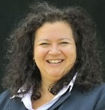

Kim Baird
Member, Tsawwassen First Nation

More details are included in these 3 articles:

https://www.bcibic.ca/council-board-members/councillor/kimberly-c-baird/
http://kimbaird.ca/about/biography/
https://indspire.ca/laureate/kim-baird/

All Our Relations!

Nov. 8, 2020
Reconciliation Matters

Honouring Indigenous Veterans
in Canada

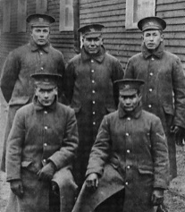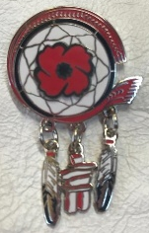

Lest We Forget

https://www.veterans.gc.ca/eng/remembrance/history/historical-sheets/aboriginal-veterans
All Our Relations!

Nov. 15, 2020
Reconciliation Matters

Honouring Yvonne Boyer
Senator of Canada

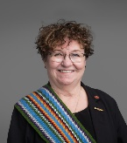

Senator Boyer is a member of the Métis Nation of Ontario; her ancestral roots are the Métis Nation-Saskatchewan, Manitoba, and the Red River.

She began as a nurse and transitioned to practice law for 22 years.

Read about what Yvonne has accomplished >>
https://senatorboyer.ca/about/

All Our Relations!

Nov. 22, 2020
Reconciliation Matters

Empowering Indigenous Student Success

Additional funds have been allocated by the
BC Ministry of Advanced Education,
Skills and Training.

Announced by Minister Melanie Mark

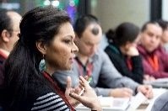

Read the details here:
https://news.gov.bc.ca/releases/2020AEST0033-001111
All Our Relations!

Nov. 29, 2020
Reconciliation Matters

Honouring Sheila Watt-Cloutier
Inuit Human Rights & Climate Activist

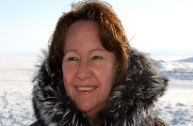

She has previously served as the
International Chair for the Inuit Circumpolar Council (formerly called the Inuit Circumpolar Conference).

Read more details here >>
https://www.thecanadianencyclopedia.ca/en/article/sheila-watt-cloutier

All Our Relations!

Dec. 6, 2020
Reconciliation Matters
Uncovering the Complicated History
of Blankets in Indigenous Communities.

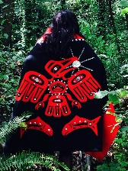
Read more details here >>
https://www.cbc.ca/radio/unreserved/uncovering-the-complicated-history-of-blankets-in-indigenous-communities-1.5264926/a-short-history-of-indigenous-blankets-in-canada-1.5270362
All Our Relations!

Dec. 13, 2020
Reconciliation Matters

Honouring Wendy Grant-John
Member, Musqueam First Nation
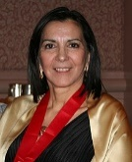
Former Chief Grant-John (nee Sparrow) launched Canada’s first Indigenous commercial fishery in 1990.

Read details of her background life & work:
https://en.wikipedia.org/wiki/Wendy_Grant-John
https://indspire.ca/laureate/wendy-grant-john-2/
https://www.musqueam.bc.ca/councillors/785/

All Our Relations!

Dec. 20, 2020
Reconciliation Matters

The Huron Carol

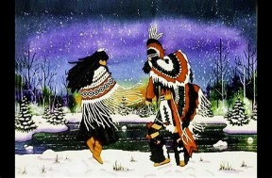

The transformation of the Christmas story
using Indigenous language & themes:

Read the interesting details here >
Huron Carol - Wikipedia
See the link to the music on this page too
and listen.

All Our Relations!

Dec. 27, 2020
Reconciliation Matters

Honouring Daphne Odjig, O.C.
(1919-2016)

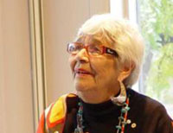

An acclaimed artist, Odjig was the driving force behind the Professional Native Indian Artists Assn. (“Indian Group of Seven”) that brought First Nations art to the forefront of Canada's art world.

https://www.odjig.com/
https://beyondthedash.com/obituary/daphne-odjig-987896411

All Our Relations!

Jan. 3, 2021:
Reconciliation Matters
The Tragic Story of the Pentlatch People
on Vancouver Island:
A Door into a Lost World

Read this account:
https://www.macleans.ca/news/human-remains-found-on-vancouver-island-have-opened-a-door-into-a-lost-world/?utm_source=nl&utm_medium=em&utm_campaign=mme_daily&sfi=37e727b670e3231a783936b3b125b0c0
or
https://www.macleans.ca/author/terry-glavin/

All Our Relations!

Jan. 10, 2021
Reconciliation Matters

Indigenous leadership crucial

to protecting the planet

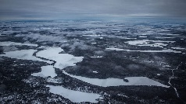

“Canadians can benefit from Indigenous leadership in understanding values and policies based on reciprocity with the natural world. [We] can become an environmental leader by becoming an Indigenous rights leader.”

https://www.macleans.ca/opinion/indigenous-leadership-is-crucial-to-protecting-the-planet/?utm_source=nl&utm_medium=em&utm_campaign=mme_daily&sfi=37e727b670e3231a783936b3b125b0c0

All Our Relations!

Jan. 17, 2021
Reconciliation Matters
Dr; Lorna Williams
Professor Emerita, Faculty of Education
University of Victoria

has been appointed to the Order of Canada.

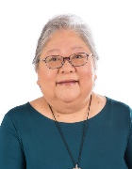

Lorna is a member of the Lil’wat Nation in BC, and has been responsible for initiating and overseeing the development of Indigenous Language Revitalization Programs for teachers, students, and the public.

Read the details of Lorna’s life and work:
Dr. Lorna Wanosts’a7 Williams | Indspire

All Our Relations!

Jan. 24, 2021
Reconciliation Matters
How West Coast First Nations
are coping with the COVID-19 Pandemic

Youtube:
“Our Changing World”
with host Michelle Washington

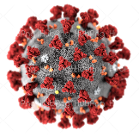
How are West Coast communities responding? What makes them particularly vulnerable? What can we learn about ourselves through this process?

New doc looks at how West Coast First Nations are coping with pandemic | CBC Arts

All Our Relations!

Jan 31, 2021
Reconciliation Matters

Ardith Walkem

First Indigenous Woman

appointed to the BC Supreme Court

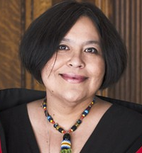

“It’s About Time!” say those who know
Ardith Walkem, member of the Nlaka’pamux First Nation, Vancouver Island. She is described as “calm but powerful, like the ocean.”

https://vancouversun.com/news/local-news/its-about-time-leading-first-nations-law-expert-named-to-b-c-supreme-court

All Our Relations!
Feb. 07, 2021
Reconciliation Matters

Widespread racism and discrimination
against Indigenous people
in BC’s health-care system

Former judge Mary-Ellen Turpel-Lafond leads the investigation:

Investigation finds widespread racism and discrimination against Indigenous peoples in B.C. health-care system | CBC News

All Our Relations!

