Children’s Page
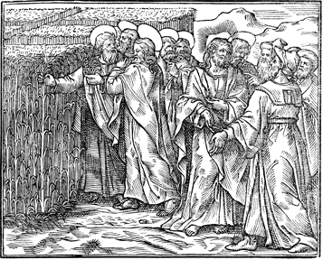
This illustration is from a 16th century book titled,
“The Gospel of Our Lord Written by the Four Holy Evangelists, Matthew, Mark, Luke, and John.”

If you wanted to see it, the book can be found at the Library of Congress in Washington D.C.
and at the Pitts Theology Library in Atlanta, Georgia.

Read Luke 6:1-16

- What are Jesus’ disciples (the men with the small halos) doing?
- Who is Jesus (big halo) talking with?
- “Remember the Sabbath and keep it holy” is one of the Ten Commandments.
  - Which commandment?
  - What is the Sabbath?
  - What day do Jews observe as the Sabbath and what day do Christians observe as the Sabbath?
- What does your family do to remember the Sabbath?

