Faith Evangelical Lutheran Church, Washington, IL
Fifth Sunday after Epiphany
February 7, 2021

Prelude
Welcome

Hymn: “Praise to the Lord, the Almighty” Red Book # 858
Public Domain
Confession and Forgiveness

P: In the name of the Father, and of the + Son, and of the Holy Spirit.
C: Amen.
You may dip your finger in water and make the sign of the cross on your forehead as a reminder of your baptism.
P: Almighty God, to whom all hearts are open, all desires known, and from whom no secrets are hid: cleanse the thoughts of our hearts by the inspiration of your Holy Spirit, that we may perfectly love you and worthily magnify your holy name, through Jesus Christ our Lord.
C: Amen.

P: Let us confess our sin in the presence of God and of one another.
Please keep silence for reflection
P: Most merciful God,
C: we confess that we are captive to sin and cannot free ourselves. We have sinned against you in thought, word, and deed, by what we have done and by what we have left undone. We have not loved you with our whole heart; we have not loved our neighbors as ourselves. For the sake of your Son, Jesus Christ, have mercy on us. Forgive us, renew us, and lead us, so that we may delight in your will and walk in your ways, to the glory of your holy name. Amen.

P: In the mercy of almighty God, Jesus Christ was given to die for us, and for his sake God forgives us all our sins. As a called and ordained minister of the church of Christ, and by his authority, I therefore declare to you the entire forgiveness of all your sins, in the name of the Father, and of the + Son, and of the Holy Spirit.
C: Amen.
Peace:
P As forgiven people, we have peace with God, and peace with one another.
The peace of the Lord be with you always.
C And also with you.
P Let us share that peace with one another. Please take a moment to share God’s peace with those near to you, and say a prayer of peace for those at a distance.
P The grace of our Lord Jesus Christ, the love of God,
and the communion of the Holy Spirit be with you all.
C And also with you.
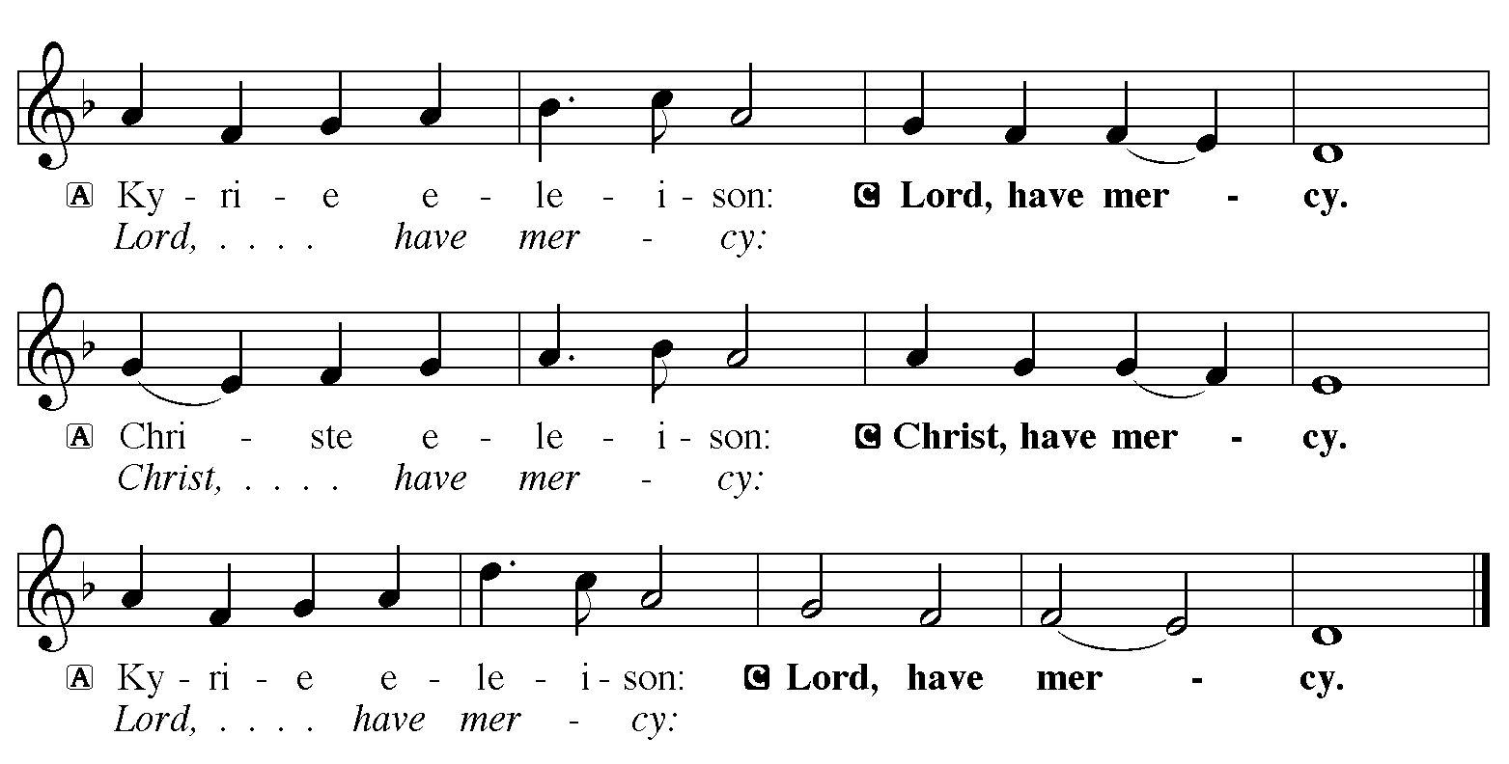

Hymn of Praise: “I’m So Glad, Jesus Lifted Me” Red Book # 860
All rights reserved. Used by permission. Reprinted under OneLicense.net #A-711151

P The Lord be with you
C And also with you
Let us pray together the Prayer of the Day
Everlasting God, you give strength to the weak and power to the faint. Make us agents of your healing and wholeness, that your good news may be made known to the ends of your creation, through Jesus Christ, our Savior and Lord. Amen.

Children’s Message

Psalm: Psalm 147:1-11, 20c Sing in Unison
¹Hallelujah! How good it is to sing praises | to our God!
How pleasant it is to honor | God with praise!
²The Lord re- | builds Jerusalem,
and gathers the ex- | iles of Israel.
³The Lord heals the | brokenhearted
and binds | up their wounds.
⁴The Lord counts the number | of the stars
and calls them all | by their names.
⁵Great is our Lord and might- | y in power;
there is no limit | to God’s wisdom.
⁶The Lord lifts | up the lowly,
but casts the wicked | to the ground.
⁷Sing to the Lord| with thanksgiving;
make music upon the harp | to our God,
⁸who covers the heav- | ens with clouds
and prepares rain for the earth, making grass to grow up- | on the mountains.
⁹God provides food | for the cattle
and for the young ravens | when they cry.
¹⁰God is not impressed by the might | of a horse,
and has no pleasure in the speed | of a runner,
¹¹but finds pleasure in those who | fear the Lord,
in those who await God’s steadfast love. ^{20c}| Hallelujah!

First Reading: Isaiah 40:21-31
²¹Have you not known? Have you not heard?
Has it not been told you from the beginning?
Have you not understood from the foundations of the earth?
²²It is he who sits above the circle of the earth,
and its inhabitants are like grasshoppers;
who stretches out the heavens like a curtain,
and spreads them like a tent to live in;
²³who brings princes to naught, and makes the rulers of the earth as nothing.
²⁴Scarcely are they planted, scarcely sown,
scarcely has their stem taken root in the earth,
when he blows upon them, and they wither,
and the tempest carries them off like stubble.
²⁵To whom then will you compare me, or who is my equal? says the Holy One.
²⁶Lift up your eyes on high and see: Who created these?
He who brings out their host and numbers them, calling them all by name;
because he is great in strength, mighty in power, not one is missing.
²⁷Why do you say, O Jacob, and speak, O Israel,
“My way is hidden from the Lord, and my right is disregarded by my God”?
²⁸Have you not known? Have you not heard?
The Lord is the everlasting God, the Creator of the ends of the earth.
He does not faint or grow weary; his understanding is unsearchable.
²⁹He gives power to the faint, and strengthens the powerless.
³⁰Even youths will faint and be weary, and the young will fall exhausted;
³¹but those who wait for the Lord shall renew their strength,
they shall mount up with wings like eagles,
they shall run and not be weary, they shall walk and not faint.
The Word of the Lord
C Thanks be to God
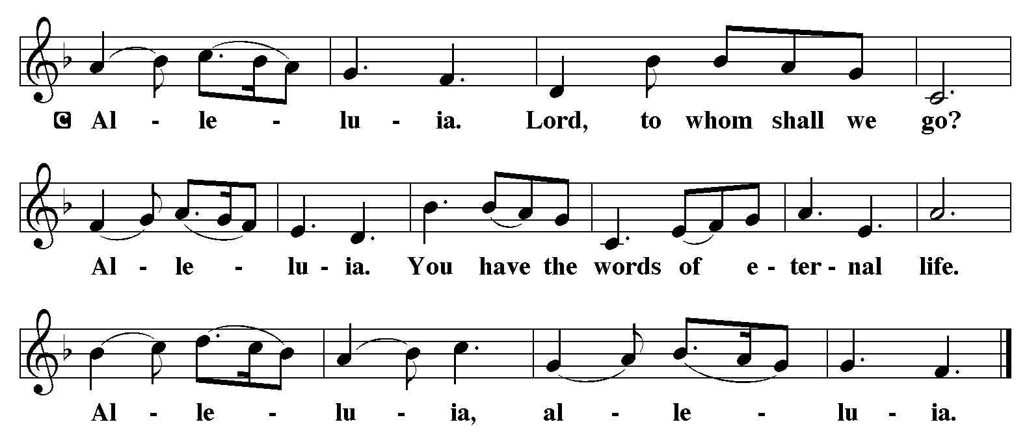

Holy Gospel: Mark 1:29-39
C Glory to you, O Lord
²⁹As soon as [Jesus and the disciples] left the synagogue, they entered the house of Simon and Andrew, with James and John. ³⁰Now Simon’s mother-in-law was in bed with a fever, and they told him about her at once. ³¹He came and took her by the hand and lifted her up. Then the fever left her, and she began to serve them.
³²That evening, at sunset, they brought to him all who were sick or possessed with demons. ³³And the whole city was gathered around the door. ³⁴And he cured many who were sick with various diseases, and cast out many demons; and he would not permit the demons to speak, because they knew him.
³⁵In the morning, while it was still very dark, he got up and went out to a deserted place, and there he prayed. ³⁶And Simon and his companions hunted for him. ³⁷When they found him, they said to him, “Everyone is searching for you.” ³⁸He answered, “Let us go on to the neighboring towns, so that I may proclaim the message there also; for that is what I came out to do.” ³⁹And he went throughout Galilee, proclaiming the message in their synagogues and casting out demons.

The Gospel of the Lord
C Praise to you, O Christ

Sermon by Pastor John Rothfusz

Sermon Hymn: “O Christ the Healer, We Have Come” Red book # 610
Reprinted under OneLicense.net #A-711151

Apostles’ Creed
C: I believe in God, the Father almighty,
creator of heaven and earth.
I believe in Jesus Christ, God's only Son, our Lord,
who was conceived by the Holy Spirit,
born of the virgin Mary,
suffered under Pontius Pilate,
was crucified, died, and was buried;
he descended to the dead.
On the third day he rose again;
he ascended into heaven,
he is seated at the right hand of the Father,
and he will come to judge the living and the dead.
I believe in the Holy Spirit,
the holy catholic church, the communion of saints,
the forgiveness of sins, the resurrection of the body,
and the life everlasting. Amen.

Offering: Jesus calls us to follow him, to share in his work in the world. Let us offer ourselves to God with thanks as we lift our tithes and offerings to the Lord. Please take a moment now to make an electronic offering to the church on the website, with the Tithe.ly app or write a check and send it in.
Offering Hymn: “I Heard the Voice of Jesus Say” Red Book # 611
Arr. © 2006 Augsburg Fortress. All rights reserved. Used by permission. Reprinted under OneLicense.net #A-711151

Prayers: After each portion of the prayers finishes with “Lord in your mercy,” please respond, “Hear our prayer.”
Lord’s Prayer
Our Father, who art in heaven, hallowed be thy name,
thy kingdom come, thy will be done, on earth as it is in heaven.
Give us this day our daily bread; and forgive us our trespasses,
as we forgive those who trespass against us;
and lead us not into temptation, but deliver us from evil.
For thine is the kingdom, and the power, and the glory,
forever and ever. Amen
Announcements
Benediction: The Lord bless you and keep you. The Lord make his face to shine upon you and be gracious to you. The Lord look on you with favor and give you peace. In the name of the Father, and of the Son, and of the Holy Spirit. Amen.

Hymn: “Come, Thou Fount of Every Blessing” Red Book # 807

Public Domain
*Dismissal
P Go in peace, serve the Lord.
C Thanks be to God!
Postlude

