Vestry Report

February 28th, 2021

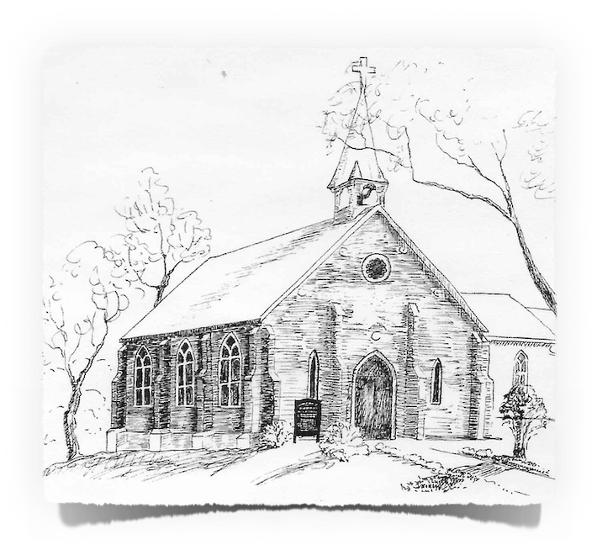

Church of the Ascension

Port Perry, Ontario

Anglican Church of Canada

Agenda

Opening Prayer

Introduction and Housekeeping

Vestry Committee Chairpersons 2

Acceptance of Minutes from Previous Meetings

Annual Vestry February 23rd, 2020 3

Special Vestry November 16th, 2020 11

Bishops’ Letters 12

Incumbent’s Report 16

Warden’s Report 19

Committee Reports 20

Outreach Committee Report 20

Choir Report 21

Property Report 21

Fundraising Report 23

St. John`s Cemetery Report 23

Report on the Buddy System 25

Financial Information 26

Envelope Secretary’s Report - please see spreadsheet following 26

Income Statement and Balance Sheet – following Envelope Secretary’s Report 26

Internal, Trust & GIC Funds Statement Details 30

Motions being brought to Vestry, February 2021 ………………………………………... 31

* The Social Justice Motion
* Motion regarding the removal of pews from the Sanctuary to be replaced by Chairs

Concluding Prayer and Blessings

# Vestry Committee Chairpersons

**Wardens**

Anne Paré - People’s Warden (elected)

Glynnice Avery - Rector’s Warden (appointed)

Gillian Daly - Deputy Rector’s Warden (appointed)

Occo van Tijn - Deputy People’s Warden (elected)

**Treasurer -** Susan Tremayne-Moon

**Lay Delegate to Synod** - Susan van Tijn (elected)

**Alternate Delegate to Synod** -Kathy Sweet(elected)

**Advisory Board and Committee Chairs**

Advisory Board Chairperson - Bev Brown

Advisory Board Secretary - Nora Symington

Music Leadership - Elizabeth Lambert

Choir Liaison - Marion Falconer

Envelope Secretary - Alan Sweet

Chancel - Jan Thompson

Bookkeeping - Bev Muir

Property - Cliff Moon

Anointing & Pastoral Visits - Anne Lane & Elaine Flowers

Outreach & Mission - Anne Paré & Susan van Tijn

Church Historian - Ross Etherington

Servers - Elaine Flowers

Sidespeople - Nora Symington

Intercessors and Lectors - Rev. Ruthanne

St. John’s Blackstock Cemetery -Anne Pare

# Annual Vestry February 23rd, 2020

**of the**

**Church of the Ascension, Port Perry**

**Present:**

Rev. Ruthanne Ward Isabel Arculus Paul Arculus

Glynnice Avery Lucy Black Michael Black

Dan Cappellani Catherine Corden Gillian Daly

George Daly Deb Eden Marian Falconer

Elaine Flowers Eric Flowers Rev. Phil Gearing

Edna Goss Susan Gower John Gower

Tom Greenwood Dorothee Jeffery Aeneas Lane

Lynn Lovekin Lawrence McLaughlin Linda McLaughlin

Cliff Moon Susan Tremayne-Moon Carol Moon

John Moon Bev Muir Anne Paré

Dee Redpath Ian Rowan Morag Rowan

Denis Schmiegelow Lynne Skillen Roy Skillen

Alan Sweet Kathy Sweet Nora Symington

Mort Symington Jack Taylor Lois Taylor

Occo van Tijn Susan van Tijn Angela Wakeford

Mary-Margaret Walters Wynn Walters Angela Weinreb

Daniel Weinreb Ruth Wyman Ron Wyman

Rev. Ruthanne Ward called the Vestry Meeting to order at 11:40 am, and Rev. Phil Gearing led all those present in Prayer.

1. **Introduction**

Rev. Ruthanne reviewed the rules of entitlement for a member to vote at the annual Vestry Meeting.

1. **Minutes of the Vestry Meeting of Parish of the Church of the Ascension held February 24th, 2019**

MOVED by Cliff Moon, SECONDED by Denis Schmiegelow

“THAT the minutes of the Vestry Meeting of the Parish of the Church of the Ascension held on February 24th, 2019 be approved.”

CARRIED

**Minutes of the Special Vestry Meeting held on April 7, 2019;**

MOVED by Elaine Flowers, SECONDED by Susan van Tijn

“THAT the minutes of the Special Vestry Meeting held on April 7, 2019 be approved.”

CARRIED

**Minutes of the Special Vestry Meeting held on November 3rd, 2019**

MOVED by Elaine Flowers, SECONDED by Susan van Tijn

“THAT the minutes of the Special Vestry Meeting held on November 3rd, 2019 be approved.”

CARRIED

**3. Letter from the Rt. Reverend Andrew Asbil, Bishop of Toronto was received and tabled.**

**4. Letter from the Rt. Reverend Riscylla Shaw, Area Bishop of Trent-Durham was received and tabled.**

**5. Report of Rev. Ruthanne Ward, Incumbent**

Rev. Ruthanne presented her report reflecting on the many accomplishments of the past year and talked about her plans for the upcoming year. Rev. Ruthanne indicated that she is hoping to start a new Sunday afternoon service that will speak to the needs of young families and others, starting in in the spring. She also mentioned that the church’s finances are looking in better shape due to the generosity of the parishioners, fundraising and rental income (which we hope to expand on). Rev. Ruthanne gave thanks to the Wardens, the many volunteers, committee leaders, staff and choir director and a special thanks to The Rev. Phil Gearing for his help with Sunday liturgies, leadership of our newly formed Buddy Group, nursing home services and other groups and noted he has been a tremendous resource with parish visitations.

Rev. Ruthanne noted that all Wardens and Committee Chairs had been approached to see if they wish to stand for another year. The following is a listing of all Wardens and Committee Chairs for the year 2020. Rev. Ruthanne also commented that the newly formed Finance Committee has been very beneficial in providing training, increased communication and enhancing the tools for giving.

**Wardens**

Anne Paré, People’s Warden (elected)

Glynnice Avery – Rector’s Warden (appointed)

Gillian Daly – Deputy Rector’s Warden (appointed)

John Moon – Deputy People’s Warden (elected)

**Music Leadership** - Elizabeth Lambert

**Treasurer** – Susan Tremayne-Moon

**Lay Delegate to Synod** – Susan van Tijn

**Alternate Delegate to Synod** – Kathy Sweet

**Advisory Board and Committee Chairs**

Advisory Board Chairperson – Beverly Brown

Advisory Board Secretary and Secretary to Vestry – Nora Symington

Music Leadership – Elizabeth Lambert

Choir Liaison – Marion Falconer

Envelope Secretary - Alan Sweet

Chancel - Jan Thompson

Finance Committee – Glynnice Avery

Bookkeeping – Bev Muir

Property – Cliff Moon

Anointing & Pastoral Visits - Anne Lane & Elaine Flowers

Outreach and Mission – Anne Paré & Susan van Tijn

Thyme –

Church Archives – Ross Etherington

Servers – Elaine Flowers

Sides People – Nora Symington

Intercessors and Lectors – Rev. Phil Gearing

Truth and Reconciliation – Cathy Cooper

St. John’s Blackstock Cemetery - Anne Paré

Fundraising – Gillian Daly

Worship Committee – Rev. Ruthanne Ward

**6. Curate’s Report**

Rev. Phil reflected on his time with the Church of Ascension since June 1st, 2019 and the various projects he has been involved in including the newly formed Buddies Program which he is overseeing. Rev. Phil expressed his gratitude to the people, wardens and Rev. Ruthanne for their support and guidance.

**7. Wardens’ Reports**

The Report of Wardens, Glynnice Avery, Anne Paré, Gillian Daly and John Moon was received and tabled.

**8. Ministry Reports**

Anne Paré, Deputy People’s Warden, read the report from the Outreach Committee which was not included in the Vestry Report.

The following Ministry Reports were received and tabled:

Finance

Property

Outreach

Chancel Guild

Choir

Truth and Reconciliation

St. John’s Anglican Cemetery

Christmas Bazaar

**9. Envelope Secretary**

Alan Sweet, Envelope Secretary reviewed his report and encouraged everyone, if possible, to consider increasing their givings and to participate in the PAG program.

**10. Financial Report for the year ending December 31st, 2019**

Susan Tremayne-Moon, Treasurer reviewed the Financial Statements for the year ending December 31st, 2019.

Susan reviewed the operating results and presented the following highlights:

The Church’s deficit this year or expenditures greater than receipts, was $4,688; however, after transferring that amount from the worship fund, the deficit was adjusted to $0. Under the receipts category, parish offerings were slightly lower compared to budget, fundraising was significantly lower and investment income was significantly higher due to a change in policy that the finance committee approved where dividends from three consolidated trust funds were included in operating income. All categories of expenditures were very close to budget with the exception of Rev Ruthanne’s stipend and benefits which were approximately $6,500 lower due her adjusting her work schedule to 80% commencing August 2019.

Susan noted that she is extremely thankful for the formation of a Finance Committee this past year to oversee the finances of the Church. Susan gave a huge thanks to Bev Muir and Alan Sweet for all their support and hard work again this year.

**11. Presentation and Adoption of the 2020 Budget**

Susan Tremayne-Moon, Treasurer presented the 2020 Budget for the Church of Ascension. The Treasurer projected a deficit of $5,450 and indicated that if this happens, funds will be transferred from worship to cover it. The reason for the deficit is that while many of our expenditures are projected to increase, we have been extremely conservative in budgeting for receipts. Our budget for parish offerings remains the same as last year and our fundraising is lower. With respect to budgeted expenses, even though Rev Ruthanne’s salary is budgeted to be approximately $5,700 lower compared with last year’s actual, we budgeted for an increase of $1,300 in the organist salary, rectory property taxes will increase $600, property insurance increased approximately $1,000 and the Diocese assessment has increased approximately $1,200.

A question arose with regard to the increase in property insurance costs which has increased by $817.46 since last year. Anne Paré read an email she had received from the Insurance Company indicating that insurance is negotiated as a whole by the Diocese of Toronto and unfortunately there is no way they are able to change the amount for one church.

Rev. Ruthanne explained that fundraising was down this year but that a church should not be focused or dependent on fundraising to support its operating budget. Hall rental income remained the same.

MOVED by Dan Cappellani, SECONDED by Carol Moon

“THAT the 2020 Budget as presented be approved.”

CARRIED

**12. New Business**

**a. Social Justice Motion**

Rev. Ruthanne read the following motion from the Diocese of Toronto with regard to taking action on Climate change.

MOVED by Marion Falconer, SECONDED by Susan van Tijn

“THAT We, the Vestry of The Church of the Ascension, in the Diocese of Toronto recognize that there is a global climate emergency. We acknowledge that all sectors of society, including government, business, churches and other non-profit organizations and private individuals, have an obligation to do what they can to minimize their contribution to climate change.

We call on the government of Canada to commit to the following:

* End public financing of the fossil fuel industry (oil, gas, coal)
* Bring Canada’s climate and energy policy into alignment with the Paris Accord emissions targets to do our part to limit the rise in global average temperatures below 1.5 degrees Celsius.
* Support a just transition to a low-carbon economy through investment in renewable energy sources and infrastructure, energy-efficient technologies, and skills development and retraining for high-quality, sustainable jobs in the renewable energy sector.
* Assist Indigenous, northern, and costal communities, and other vulnerable populations, to adapt to and mitigate the impacts of climate change on their local environments.

As Christians, we have a particular obligation to care for the earth as God’s beloved creation (Genesis 1 26-28, 2:15), as well as for the most vulnerable among the human family (Matthew 25). Accordingly, we also commit our Parish to the following goals:

1. Reducing Parish Energy use,
2. Reducing use of single-use plastic products, working towards elimination; and
3. Pursuing education about these issues and alternative resources to be used at church and at home.”

CARRIED

(later in the meeting, see following notes)

Discussion ensued with regard to the above-noted motion. Rev. Phil noted that this a Diocesan motion and we can either support or reject this motion but that we cannot amend it.

A vote was then taken as follows and the motion was CARRIED.

**Yea** 50

**Nay** 5

**b. Other Business**

**Continuing Conversation Update**

Rev. Ruthanne thanked Lucy Black for facilitating the Continuing Conversation discussions. The following comments were summarized resulting from the feedback received during these discussions.

* + Timing of the meetings – It was requested that some of the meetings be held at night rather than all in the day in order to accommodate those who could not attend.
  + Sale of the Rectory – This is not planned for at the present time. It is a decision that the Diocese makes and we can only make a proposal. It was also noted that the proceeds from any sale of the Rectory would go to the Diocese and not to the Church of the Ascension. We would be responsible for providing a housing allowance for any future Priest to come here. Severance of the land has not been investigated, but is likely to be difficult or impossible.
  + Seniors Ministry is a high priority. Suggestions for more socials for seniors and to increase the Pastoral Care Team to be able to meet all the needs of the seniors in the community. We presently conduct 4 Nursing Home services.
  + Chairs vs. Pews to allow for greater comfort and more accessibility. It was noted that if the pews were removed and replaced with chairs, we would be able to provide more rental space for music events, etc. A suggestion was made that only some of the pews be removed rather than the whole church and that 5 pews had already been spoken for. Ruthanne advised that a Committee is being formed to further investigate this matter and that in any event, we would have to hold a Special Vestry Meeting to approve of the expenditure of funds. Rev. Ruthanne asked that if anyone is interested in sitting on this committee to please let her know.

**Leadership and Administration concerns**

* Rev. Ruthanne noted that some concerns have been raised with regard to the amount of time she is in and away from the office. She advised that she has provided the Wardens with a Time Audit of her time spent in the office and her time spent on outside responsibilities required by the Diocese and fulfilling her Pastoral duties.
* A question arose as to whether Rev. Phil would be assigned a new church now that he has been ordained prior to him completing his two- year term. Rev. Phil responded that he has provided Rev. Ruthanne his assurance that he will complete his commitment of the 24-month contract.

**13. Adjournment**

MOVED by Catherine Corden, SECONDED by Eric Flowers

“THAT the Vestry Meeting of the Church of the Ascension be adjourned.”

CARRIED

**The Reverend Ruthanne Ward closed the meeting at 1:00 pm. with the Doxology and Blessing.**

# Special Vestry November 16th, 2020

**of the**

**Church of the Ascension, Port Perry**

**Present:**

Rev. Ruthanne Ward Glynnice Avery Dan Cappellani

Bev Brown Cathy Cooper Catherine Corden

Sallyanne Etherington Ross Etherington Anne Lane

Aeneas Lane Linda McLaughin Lawrence McLaughlin

Ann Miles Anne Paré Kathy Sweet

Alan Sweet Nora Symington Susan vanTijn

Occ vanTijn Mary-Margaret Walters Wynn Walters

Rev. Ruthanne Ward called the Special Vestry Meeting via Zoom to order at 7:30 pm and explained that the meeting was being recorded digitally, along with the taking of minutes by the Clerk, Nora Symington.

An opening prayer was led by Rev. Ruthanne who gave an explanation that the purpose of the Special Vestry Meeting was for the election of Occo vanTijn as a new Deputy People’s Warden and noted that no other nominations had been received.

Rev. Ruthanne also noted that she had received many phone calls endorsing the proposed election of Occo vanTijn from persons who were not able to attend the zoom meeting.

MOVED by Dan Cappellani, SECONDED by Cathy Cooper

“That Occo vanTijn be elected as Deputy People’s Warden.”

**CARRIED UNANIMOUSLY**

A person by person vote was taken and was carried unanimously.

MOVED by Alan Sweet, SECONDED by Dan Cappellini

“THAT the Special Vestry meeting be adjourned.”

CARRIED

The meeting adjourned at 7:44 pm

# Bishops’ Letters

To our Clergy, Churchwardens and Parishioners February 2021

Beloved in Christ, peace and grace be with you.

Grow! You may remember that in my letter to you last year, I invited each community to embrace the essence of our diocesan strategic plan, *Growing in Christ*. The invitation was simple…grow! Well, none of us could have imagined the scope with which we would have to adjust, change, turn, accommodate, and innovate in 2020. Almost every aspect of how we do Church would need to be transformed: from worship to administration, from pastoral care to sacramental ministry, from finance to stewarding buildings and property. On Sunday, March 15th we closed the doors of our buildings and we were jettisoned into another way of gathering and being the Church.

Parishes small and large, rural and urban turned to online worship, telephone ministry, driveway conversations, pre-recording and livestreaming. We thought we would be back in our buildings by Easter. My, how we were wrong about that. Maybe by Pentecost things would be normal again, we thought. Summer turned into fall. A partial opening under strict guidelines would give way to a second wave that would carry us through Advent and Christmas, Epiphany and now into Lent. Through it all we have learned to live outside our comfort zone and grow. Like being tossed into the deep end of the pool we are learning to swim.

The Jubilee offered by the Diocese in 2020 helped to shore up a faltering financial confidence. Many parishes report that online worship and programming is reaching a wider audience. Some parishes tell us that financial support and donations are holding steady. Clergy tell me that there is a growing trust, cooperation, and companionship with colleagues. Many parishes speak of collaborating with neighbouring communities. We have also been wrestling with how to serve those who are falling through the cracks of our social structures and safety nets, particularly those who live in precarious housing, grapple with food insecurity, mental health issues and domestic violence.

The murder of George Floyd on May 25, 2020 thrust us into the depths of confronting anti- black and systemic racism. Each year at vestry we ask you to consider supporting a social justice initiative. In 2021, we invite you to support the motion on [*Committing Ourselves to Anti-Racism*](https://www.toronto.anglican.ca/parish-life/social-justice-and-advocacy/social-justice-vestry-motion/). The initiatives that are outlined give all of us the opportunity to be agents of dismantling racism in all of its forms. We are called to change. Throughout this time of pandemic, we are doing more than just treading water… we are growing. I believe we are growing in trust of one another, and deeper still, in trust that God has this whole situation in hand. And trust calls us to be faithful and to be prepared.

As you gather for your vestry meeting, likely online, I want to say two things. The first is to express my profound gratitude for your faithfulness, hard work, creativity, and innovative ways thus far in this pandemic. I am thankful for the tireless leadership of our clergy; bishops, priests, and deacons. I am moved beyond words by the ministry of our lay leaders who move mountains to keep the church moving. Thank you.

The second thing is, be prepared. We hear this summons often in scripture.*In the wilderness, prepare the way of the Lord*, cries the prophet. *I go to prepare a place for you,* Jesus says to his disciples*. Preach the word, be ready in season and out of season*writes Paul to Timothy. As circumstances begin to change, as the vaccine begins to take a hold for the better, I hope that you will take as much time planning for a return as you did when our doors closed in March of last year. Coming back will take a special kind of care and effort. It will take time to allay fears, it will take energy to coax the community to move forward in new ways. It will take a vision steeped in the Gospel of Jesus Christ to lift the eyes and hearts of a weary people.

*And let us not grow weary of doing good, for in due season we will reap, if we do not give up. So then, as we have opportunity, let us do good to everyone, and especially to those who are of the household of faith. Galatians 6.9-10*

Yours in Christ,  
The Rt. Rev. Andrew J. Asbil  
Bishop of Toronto



# Incumbent’s Report

How does one start a report for a year unlike any year we’ve ever experienced? When we met one year ago, on February 23rd for our Vestry, little did we know that the world would shut down in only three short weeks, changing all of our lives.

Of the 52 Sundays in the year, we were only able to gather in church for 25 of them. Normally we can squeeze about 100 people into our church, and on an average Sunday (at least in 2019) we’d see somewhere between 55 to 70 people at church. In the fall of 2020, with all the restrictions in place, we couldn’t have more than 23 people in the church at one time.

We learned to connect and gather in new ways. When safe, we gathered, at a distance, on the front lawn of the church and got to know each other in new ways, and wave to neighbours as they walked by. We got our Buddy System up and running, doing our best to make sure everyone in the parish was contacted by someone else in the parish from time to time. We learned how to use our website and newsletter more frequently, and began the challenging task of updating our technology at the church to allow for live-streaming (thanks to Rob & Andrew Paré). I learned how to preach to a camera instead of a congregation, something I never anticipated.

There was a headline early on in the pandemic that read, “The Discomfort You’re Feeling Is Grief.” There has been so much to grieve this year, too much. The loss of community and normalcy; the loss of seeing our loved ones and giving them hugs; the loss of public gathering and celebrations; and most profoundly, the loss of too many people, some of them known to us, as casualties of this virus and the impact of this virus. And in the midst of all that grief, we’ve not had the usual ways to process it - together.

We have also had to grieve other losses. We’ve said good-bye to some of the saints who now rest in the light of Christ, remembering Tom Midgley, Don Proutt and Joan Cudlip.

Though we were blessed to celebrate the ordination of The Reverend Phil Gearing early in 2020, and to be blessed by his ministry amongst us, we also had to say good-bye to Reverend Phil (in the frustrating and unsatisfactory way of emails and cards). These were not easy passages.

And yet, as Christians, as people of faith, we hold our grief with hope. Perhaps as we enter the season of Lent this year, less in shock than last year this time, yet deeper in the grief of what we’ve lost, we will find places to hold, express and honour that grief. Yet, as we hold it, we journey, always, towards Easter. Towards life, hope and promise. Towards light returning and life continuing to be lived.

This past year has asked a lot of all of us. I want to say a deeply felt thank you to our leadership at the church. In particular, to our wardens and treasurer. Though John Moon had to step down, we are so grateful for his thoughtful and faith-filled participation on the leadership team. We are grateful that Occo Van Tijn agreed to step into the role of Warden. I believe the corporation met at least twice as much as usual this past year. They’ve worked hard and prayed hard. Thank you!

I would also like to say a very special thank you to Shirley Andrechuk. Shirley has served as the office administrator here at Ascension for many years, and before that at St. John Blackstock (and for awhile, at both parishes). Shirley ran our office with precision and efficiency, always greeting those who dropped by with a big smile and warm conversation. Along with making sure bulletins were done, records kept up and photocopier toner ordered, Shirley very generously gave many beautiful embroidered items to the church, both for our use and for us to sell at our Christmas Bazaar. Though we have had to retire the position of office administrator for financial reasons, we certainly hope that Shirley will continue to be a part of our church community in the years to come. I know she will remain a friend to many of us.

Many people made the church and worship accessible for us in this year of unprecedented change. Our beloved music director, Liz Lambert learned how to record for our online services - first as audio recordings, and now on YouTube. Thank you Liz and Ankelly and others who made music happen, even in lockdown! Thank you to all the cleaners who stayed after church to wipe down the pews and door knobs so that we could feel safe when we did gather. And thank you to our faithful property guy, Cliff Moon, for always being on hand to attend to furnaces and such.

And in the spirit of ‘the first shall be last, that last shall be first’, I want to thank each and everyone of you for your faithfulness and prayerfulness. Despite the challenges and hardships of this past year, despite the ways in which your faith has been challenged, sorely challenged, you went to church on Sundays when you could, often online. You continued to pray. You picked up the phone and called neighbours and fellow parishioners. You made casseroles and dropped them off. You donated to the food bank, and you sent emails of encouragement. You wrote cards and sent notes through the mail. You remained faithful to the body of Christ that God has invited you to be a part of in this place and at this time.

As I have met with various leaders in the church, in the Anglican Church and beyond, there are certain things that are becoming clear, even as we anticipate vaccines and a world (hopefully) similar to what we once knew. We know that some people will access the worshiping community online from now on. We know that we will only survive as the local church if we become more engaged with our local communities - sharing our resources (volunteers, buildings etc.). Very little of what is unfolding is surprising to those who have been watching closely for many years. And, in fact, it is exciting for some. The church was never meant to be a quiet refuge for a few. The church has always been meant to be sanctuary for all. A place to rest, to find healing, to grow, to be nourished and then challenged and always, always, to be sent back out.

The Spirit of God is not stingy when it comes to those who open their hearts. We have, over the past three years together, done some very helpful discernment (The Revitalization Conversations in 2018/2019 and The Continuing Conversations with Lucy Black in early 2020). As we have faced new and unprecedented challenges, we continue to seek God’s guidance and blessing. As we come to this year’s vestry, somewhat limited by current restrictions and only being able to meet virtually, let us attend to our duty as the Body of Christ with faith and hope. I do not say that lightly, because we are weary in the light of all we have to face. So let us, in the straightforward and pragmatic words of St. Paul, “*not lag in zeal, be ardent in spirit, serve the Lord. Rejoice in hope, be patient in suffering, persevere in prayer. Contribute to the needs of the saints; extend hospitality to strangers.”*

In other words, let us love and serve our Lord, with peace and together, whatever this next year may bring our way.

I write in a spirit of gratitude and hope.

Respectfully submitted,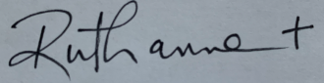

The Reverend Canon Ruthanne Ward

# Warden’s Report

We began the year with happy celebrations. Reverend Ruthanne was appointed Canon Rev. Ruthanne and we attended the installation service at St. James Cathedral in Toronto. In February, we held Curate Phil Gearing’s ordination service at our Church.

Many changes and adjustments unfolded beginning in March. A lockdown prevented us from holding Church services, Bible studies, and renting our Hall for community activities. We quickly learned how to use Zoom and to hold regular Warden meetings via Zoom.

Rev. Phil and one of our parishoner’s, Marion Falconer, had coordinated a Buddy Program. The Buddy program became essential during the pandemic. It was a way in which all parishoners were contacted and connected.

Due to health reasons, Warden John Moon resigned. We miss John’s commitment and expertise, especially in the property management area.

In June, we prepared to hold a Special Vestry meeting to discuss replacing the pews with chairs. Wardens contacted parishoners via telephone, however, the meeting had to be cancelled due to Covid restrictions. A mail slot was installed, thanks to Dan Cappellani. It is another means in which parishioners can drop off donations and correspondence.

Adhering to the Diocese guidelines for reopening, Warden Anne Parế formed a cleaning team and ordered cleaning supplies, masks, proper signage, etc.

Warden Gillian Daly worked with Rev Phil and ordered equipment for live streaming. A huge thank you to Rob and Andrew Parế, who were instrumental in setting us up to successfully offer live stream services. We are very thankful that Ben Cutmore has accepted the technical facilitator position.

During the summer months we met weekly to get everything ready for reopening in September. Property Manager, Cliff Moon and Treasurer Susan Tremayne-Moon, helped to reorganize the administrative office. Wardens Glynnice Avery, Anne Parẻ and Rev Ruthanne met with staff and addressed changes to hours and roles. Church reopened for services September 11th.

A special Vestry meeting via Zoom was held to elect a deputy Warden. We welcomed Occo VanTijn to the Corporation.

Rev Ruthanne, Treasurer Susan and the Wardens prepared a mailing to go out just before Christmas. The mailings were hand delivered and proved to be a welcome read.

The year 2020 ended on a very quiet note; back to Church services available on live streaming only and the building closed. We are grateful that we have met most of the challenges successfully. Thank goodness for Zoom, phone, email, weekly newsletters, live streaming.

Respectfully submitted,

Anne Parế, Occo van Tijn, Gillian Daly, Glynnice Avery

# Committee Reports

## Outreach Committee Report

Not surprisingly this was a very quiet year. We did have a virtual presentation by Christian Harvey in conjunction with North House as a follow up to the interest expressed in forming a Poverty Coalition. Anne Lane once again sold Church calendars to raise money for Operation Scugog. Thank you Anne. and many thanks to Phil and his 1000 km walk as we were able to send $2,646 to Faithworks.

We have received a grant of $300 from the Diocese which will be used in some way in the community towards pandemic relief/support/encouragement, details to follow.

We sincerely hope that we will be able to accomplish more this year. We have been forced into a time of introspection. Let us now turn our attention back to the community.

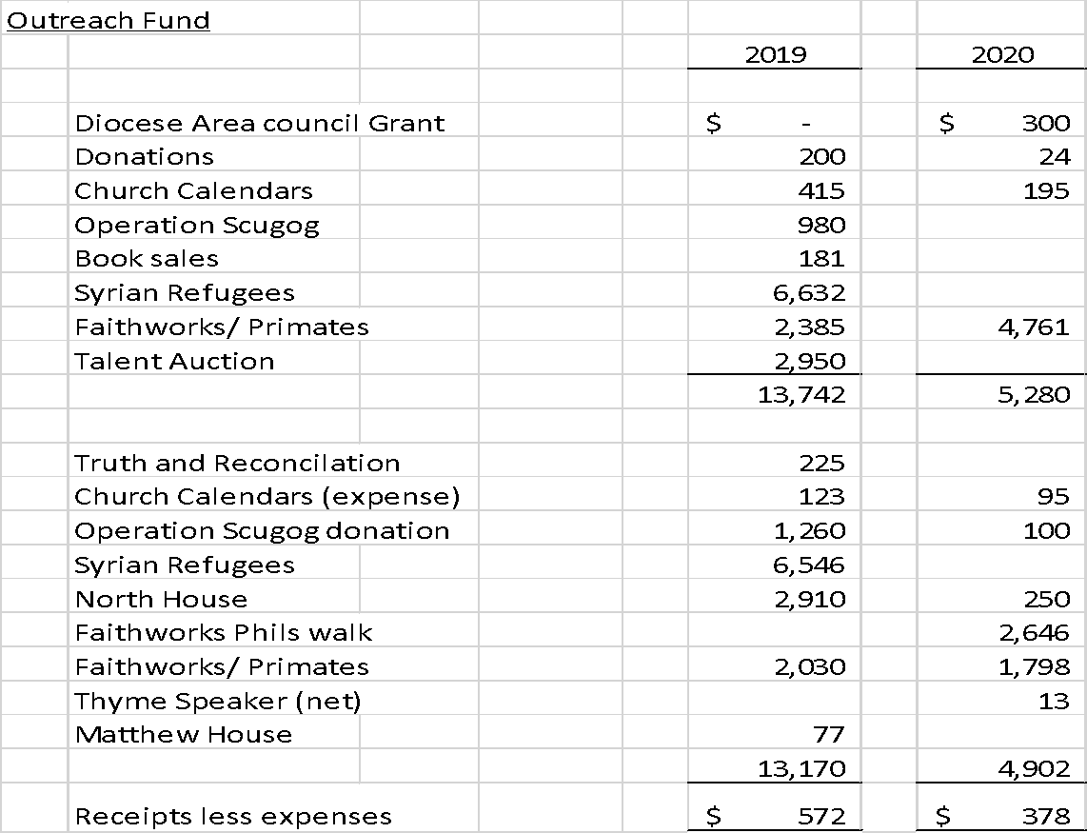

Respectfully Submitted

Susan van Tijn

## Choir Report

 The year 2020 proved to be a great challenge for everyone at the Church of the Ascension.

 On February 9th, the Choir was very pleased to sing Robert Shaw’s With a Voice of Singing at the Ordination of the Reverend Phil Gearing.  This anthem was conducted by Angela Wakeford.

Unfortunately, because of the Covid-19 Pandemic, the Choir has not met or sung together as a group since March.  The church was closed from March to September.  There has been no congregational singing in the church since March.

When in-person services started up again in September, the Parish was blessed to hear numerous prerecorded vocal solos by Ankelly Armstrong, Anne Lane (voice and flute), and Wynn Walters.  Hymns and other music were played by me on the organ and piano.  In December, Ruthanne Ward, Ankelly Armstrong, and I recorded a Virtual Carol Sing for the Advent/Christmas season.

I look forward to the day when the congregation and Choir can sing and praise God together again.  Let us all pray for that day.

Respectfully submitted,

Elizabeth Lambert

## Property Report

A BIG thanks to all members of the property committee and various parishioners who have helped with many property issues this past year. There are too many people to mention and I didn’t want to miss anyone by naming names.

With the ongoing maintenance of the Church, Hall and Rectory, many of the major projects planned, have been put on hold due to the current world situation (pandemic related) we are all dealing with. The flower beds and property surrounding the buildings have received tender loving care and have been admired by many a passerby.

On an annual basis, the Church and Hall heating and security systems are inspected, repaired and upgraded as needed. A major repair had to be completed on the hall roof-top furnace (a cracked heat exchanger) which left the hall and offices without heat for part of December 2020 until the middle of January 2021.

We received a notice, from the Region of Durham, that properties that were grandfathered in the past now have to be inspected by plumbing contractors and have installed, a water backflow valve, on our incoming water supply, for drinking water safety. This is in progress at the moment.

At this point in time, the following projects are still either outstanding or could get underway as 2021 proceeds.

1. Replacement of hall, offices and outdoor lights with LED lights for considerable reliability and cost savings.
2. Addition of more ice jams blades to the steel roof to prevent ice and snow build-up by the hall entrance.
3. Installation of gutter guards on the church and hall eve troughs to prevent leaf clogging.
4. Construction of a garden storage shed for gardening items and general storage.
5. Brick work and repointing of Church buttresses and some concrete repair.
6. A remodel of the Rectory deck for aesthetic and utilization enhancement and continue work on the rectory foundation and basement facilities as per the engineering report completed earlier.

Some items that are still outstanding and have been looked into and discussed are:

* Refreshing the sanctuary with a floor to ceiling paint job as well as refinishing the floor.
* Possible remodelling and re-organization of the hall washroom facilities.
* Repair and refurbishment of the Church Bell and Bell Tower.

Back in 2020 I put forward a plan to re-organize the property responsibilities. Progress has been made along those lines and further discussion will take place as we continue looking after our beautiful Church properties.

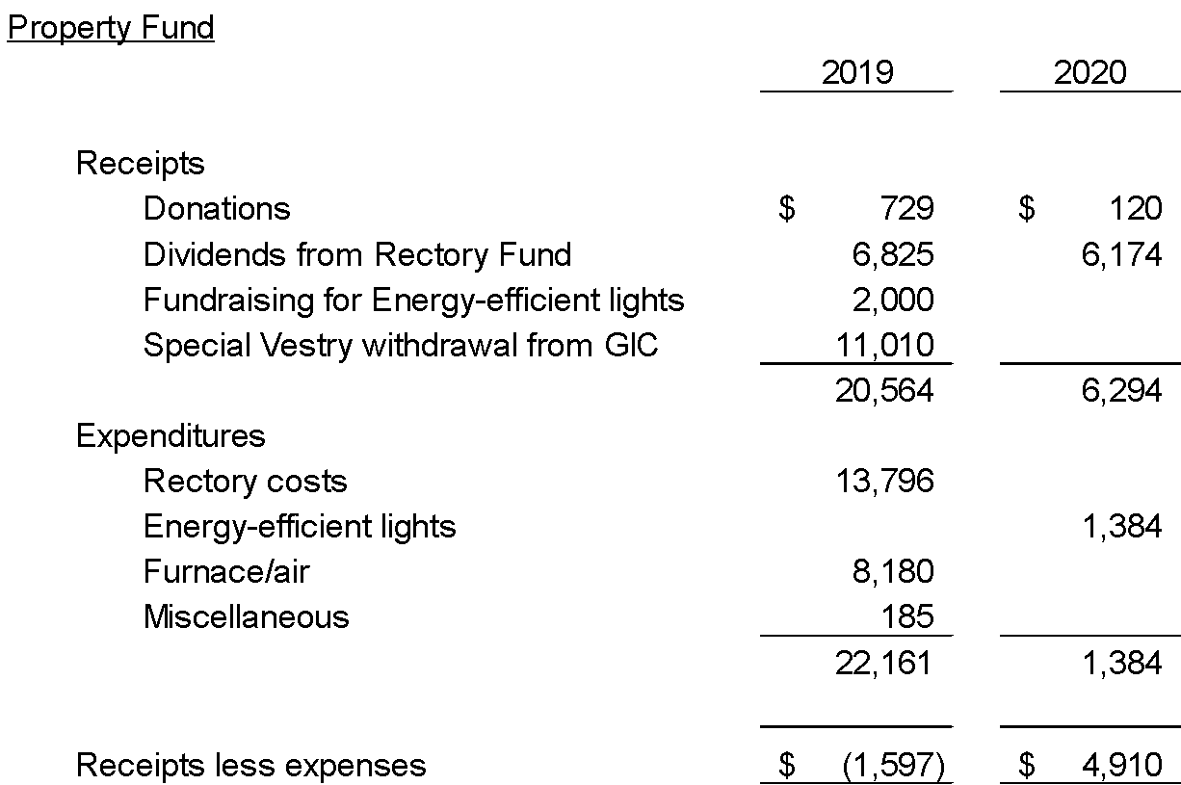

Respectfully submitted, Cliff Moon, Property Chair.

## Fundraising Report

Two fundraising events were held this year. In May, approximately 25 pasta sauce and meatballs orders were delivered.

In November a Virtual Christmas Market was held. Nora Symington and I wish to thank Rev. Canon Ruthanne for her photography and computer skills. Thank you for the many donations we received to make this event successful, and especially to the many shoppers.

Both events were generously supported and approximately $2,300. was raised in total.

Submitted by,

Glynnice Avery

## St. John`s Cemetery Report

2020 has been a year we will all remember, just as 1918 was a year our grandparents remember.

Donald Proutt who was a member of St.John`s congregation and a member of the cemetery board for many years was buried in St.John`s this past summer. Our condolences go to his widow Grace. We also had three cremation burials this year.

We could not meet for our annual meeting in March because of COVID, so we met in the cemetery in June. At that time we decided to have an informal “meet and greet” on the 13th of September. This evolved into several family reunions.

We went through a particularly dry time in June and early July when the grass did not need cutting; however Justin Stone managed to keep the grounds looking good.

We look forward to 2021 with more enthusiasm for projects which could be undertaken.

When we were with St.John`s Blackstock, the cemetery was included in their website. The cemetery should have a comprehensive website of its own so that people doing genealogical research would be able to access information about their ancestors. We already have photographs of the gravestones along with printed information of the inscriptions on them. One of our projects in 2021 will be finding the best way to put all the information online.

Respectfully Submitted,

Lawrence McLaughlin

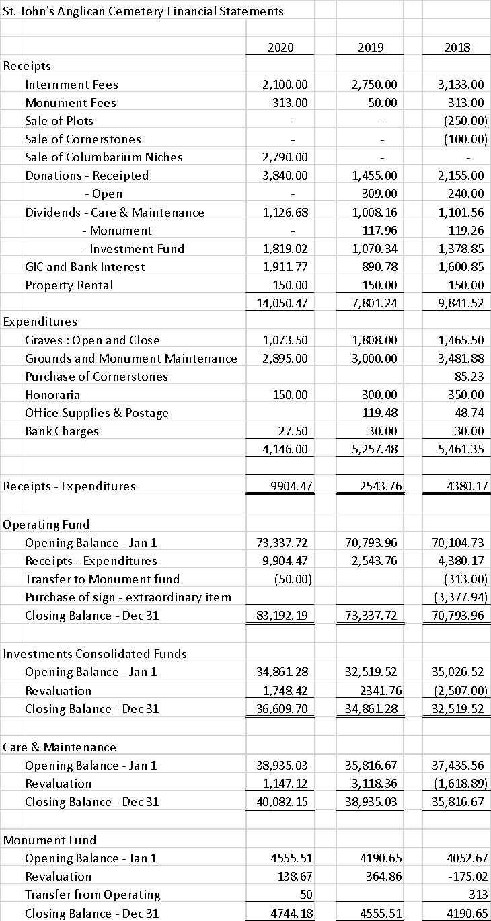

## Report on the Buddy System

One of the things that came out of the revitalization meetings was making sure we cared for each other in the parish. The idea of a buddy system was to have small groups of people who would notice if someone in their group was absent for a couple of Sundays so that a quick phone call could be made to just say, “are you ok?”

However, with Covid, this has taken on a life of its own!! We don’t see each other as we are all absent! Instead, our wonderful coordinators have been either phoning or emailing their buddies to say, “we are here, how are you? Is there anything you need? Does Ruthanne need to get in touch?” This is the way we are all trying to stay connected as a parish during this pandemic.  
I think we are fortunate that we were able to get this started pre-Covid and I think most people are happy to have that contact. We do care about each other and I think this is one way that we do show our love and caring.

Respectfully Submitted,

Marian Falconer

# Financial Information

Due to COVID the finance committee did not formally meet this year; however, more time was spent working with the Diocese on monthly reporting of receipt information.

## Envelope Secretary’s Report - please see spreadsheet following

Alan’s comments - “I have not said this in the written document, but I think we should be encouraging as many people as possible to switch to Pre-Authorized Gifts to help raise the monthly contributions and reduce the deficit.  I believe that now knowing that credit cards are an option at 2.5% more may consider this to accumulate various incentive points.  People should be encouraged to contribute their monthly donation plus the service charge”.

## Income Statement and Balance Sheet – following Envelope Secretary’s Report

*Actual results*:

Actual results for 2020 reflect the following difference due to COVID:

* The Diocese offset lower receipts from parish offerings, fundraising and hall rentals with grants totalling $30,667 that included payment forgiveness in April, May and June of 1) the clergy stipend and benefits and 2) the allotment expense; $1,950 toward rectory costs and $5,000 for virtual recording technology.
* Payments of $2,680 for CEWS (emergency wage supplement) for July, August and September.
* Reduced costs primarily for music and administration.
* The net income of $19,407 is due to COVID, without COVID we had budgeted for a loss. If the Diocese receives CEWS for October, November and December the net income for 2020 will be revised to reflect these payments.

*Budget Notes*:

The budget assumes that lock down will continue throughout 2021. Fixed expenses will continue; however, we do have some control over variable expenses.

We are budgeting for a loss; receipts are lower due to COVID and I recommend that dividends at 4.25% in the Ascension fund be reinvested this year which reduces investment income. Secretarial assumed a volunteer position and organist’s salary temporarily reduced until choir resumes. Repairs to the church higher due to unforeseen maintenance – see property report.

## Fund Statement Details – Page 30.

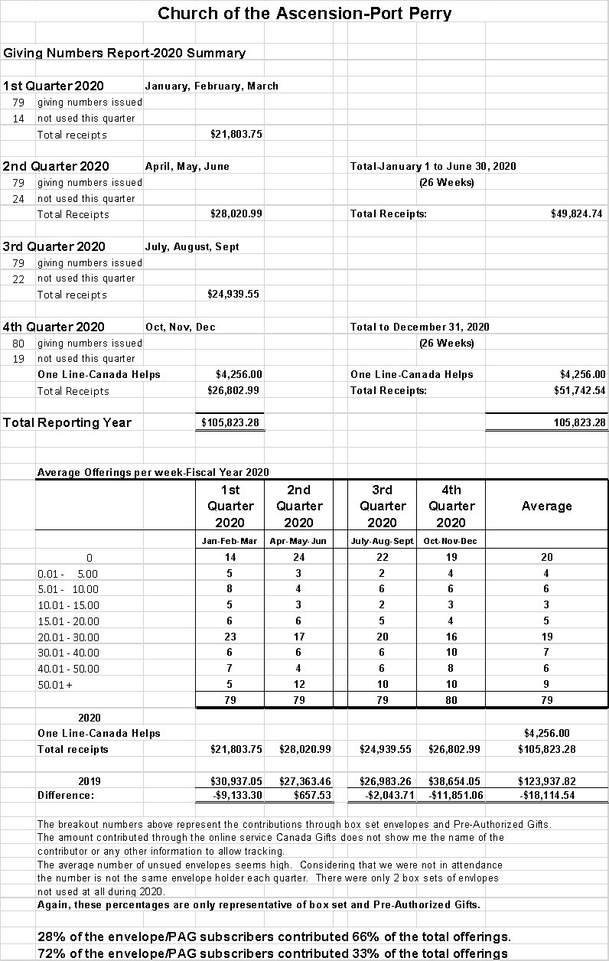

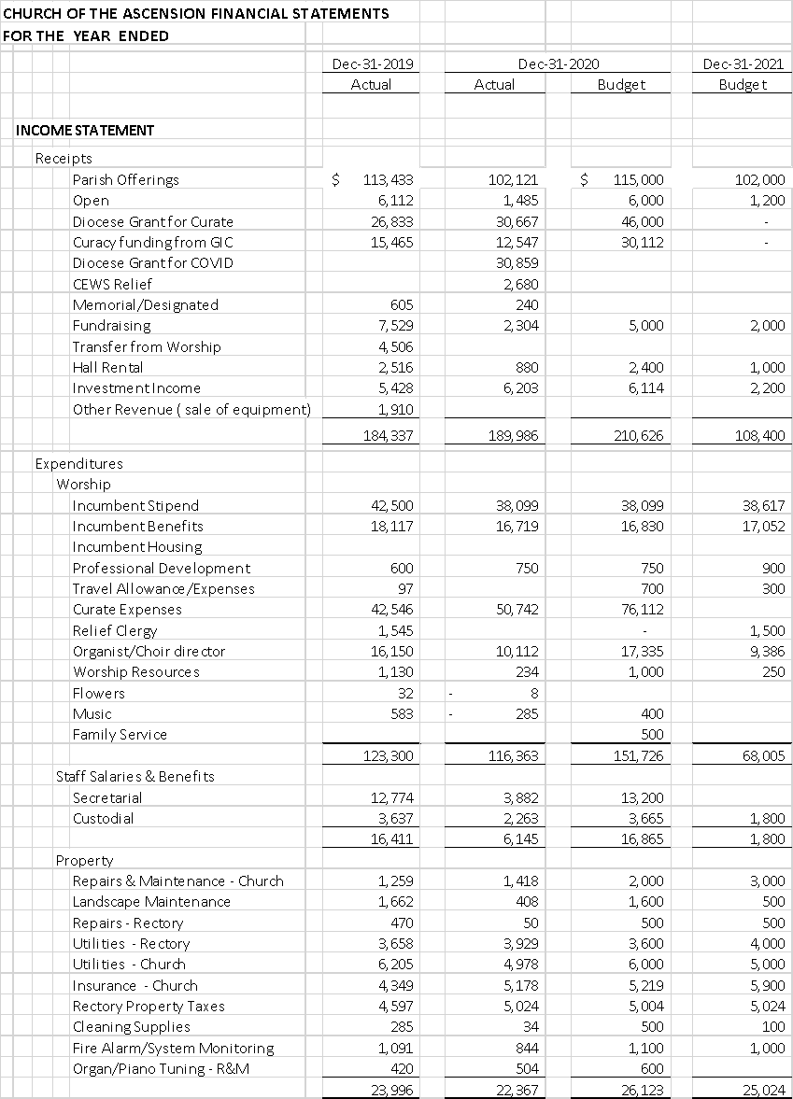

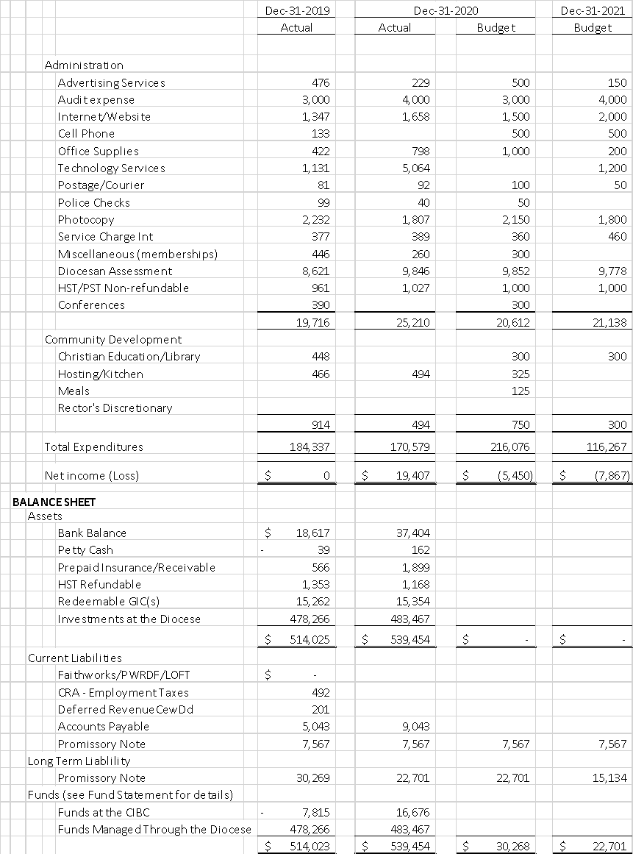



# Motions being brought to Vestry, February 2021

## The Social Justice Motion

The Social Justice Vestry Motion for 2021 is offered by the Bishop’s Committee on Intercultural Ministry with the full support of the Social Justice & Advocacy Committee:

“The parish of Church of the Ascension, Port Perry, acknowledges that Anti-Black racism exists in our society and in our Church, and that it and all forms of racism against Black, Indigenous and other racialized people are a sin against God and against our neighbour. We commit ourselves to the recognition, dismantling, and elimination of Anti-Black and other forms of racism in our secular institutions, in our Church, and in ourselves, and to work for the full inclusion, participation and belongingness of Black, Indigenous and other racialized people in all sectors of our common life.

In light of this acknowledgment, and in keeping with this commitment, our parish undertakes to do the following:

* To pray for healing for racialized communities, for awareness amongst ourselves for how we perpetuate, often unknowingly, systems that oppress others.
* At least one event in the coming year that provides our community with education about these issues in our own community and church.
* To think creatively for ways we can make our own church feel safe and inclusive for those who may not find it so presently.

## Motion regarding the removal of pews from the sanctuary to be replaced by chairs

We the Vestry of The Church of the Ascension approve the allocation of $70,000 to be withdrawn from the funds made available to the church from the proceeds of the sale of St. John’s Blackstock. This money will be used to pay for the removal of pews and installation of moveable sanctuary chairs as per the proposal presented by the Corporation of Ascension. These monies will also cover the cost of refinishing the hardwood floor, painting the sanctuary and re-carpeting the aisle.