Faith Evangelical Lutheran Church, Washington, IL
The First Sunday of Lent
February 21, 2021

Prelude
Welcome

Hymn: “Thy Holy Wings” Red Book #613
All rights reserved. Used by permission. Reprinted under OneLicense.net #A-711151

Confession and Forgiveness

P: In the name of the Father, and of the + Son, and of the Holy Spirit.
C: Amen.
You may dip your finger in water and make the sign of the cross on your forehead as a reminder of your baptism.
God hears us when we cry, and draws us close in Jesus Christ. Let us return to the one who is full of compassion.
You may keep silence for reflection
Fountain of living water,
pour out your mercy over us. Our sin is heavy, and we long to be free.
Rebuild what we have ruined and mend what we have torn.
Wash us in your cleansing flood.
Make us alive in the Spirit to follow in the way of Jesus,
as healers and restorers of the world you so love.
Amen.
Beloved, God’s word never fails. The promise rests on grace:
by the saving love of Jesus Christ, the wisdom and power of God,
your sins are ☩ forgiven, and God remembers them no more.
Journey in the way of Jesus.
Amen.

Peace:
P As forgiven people, we have peace with God, and peace with one another.
The peace of the Lord be with you always.
C And also with you.
P Let us share that peace with one another. Please take a moment to share God’s peace with those near to you, and say a prayer of peace for those at a distance.

P The grace of our Lord Jesus Christ, the love of God,
and the communion of the Holy Spirit be with you all.
C And also with you.
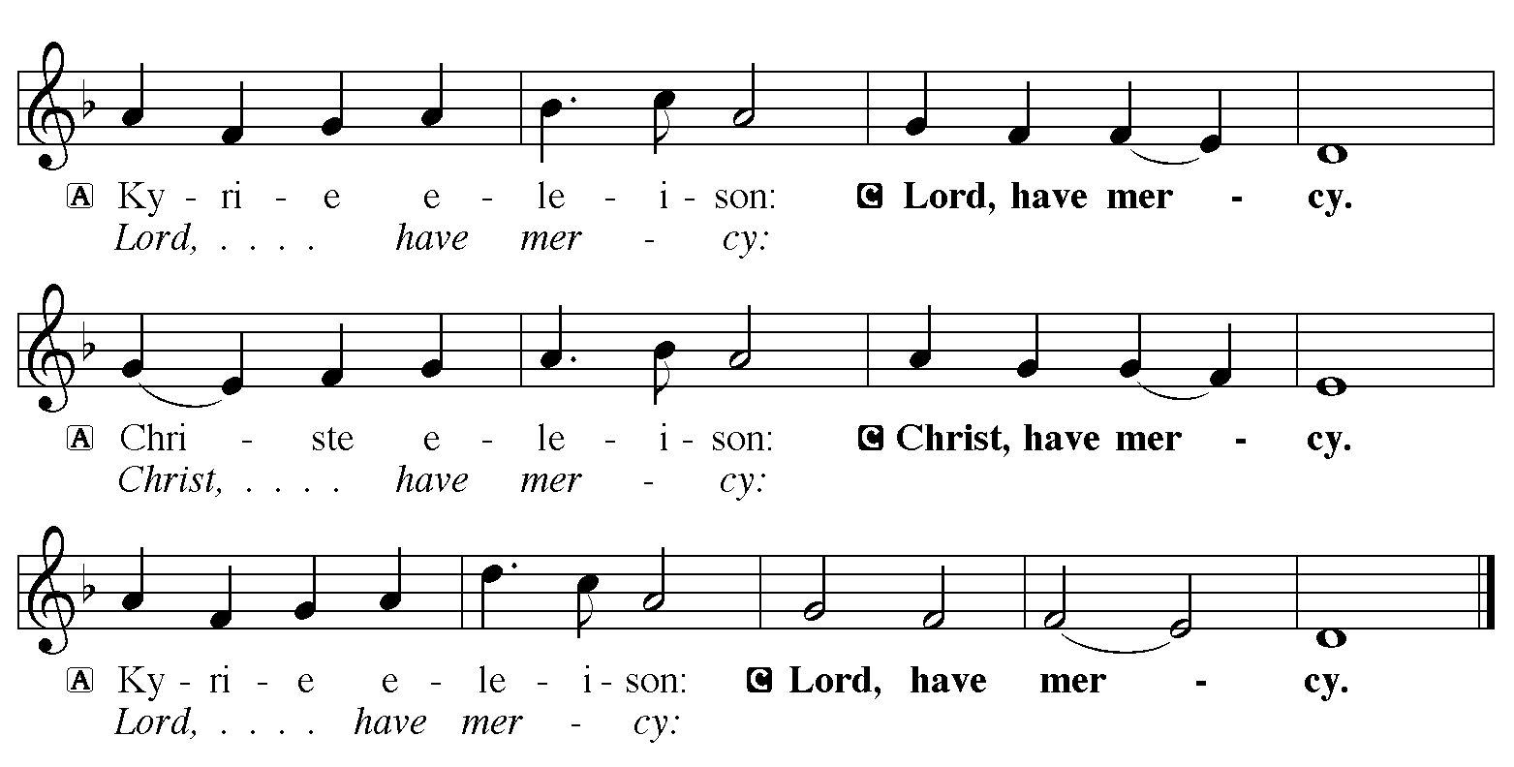

Hymn of Praise: “In the Cross of Christ I Glory” Red Book # 324
Public Domain
P The Lord be with you
C And also with you
Let us pray together the Prayer of the Day
Holy God, heavenly Father, in the waters of the flood you saved the chosen, and in the wilderness of temptation you protected your Son from sin. Renew us in the gift of baptism. May your holy angels be with us, that the wicked foe may have no power over us, through Jesus Christ, our Savior and Lord, who lives and reigns with you and the Holy Spirit, one God, now and forever. Amen.
Children’s Message

First Reading: Genesis 9:8-17
⁸God said to Noah and to his sons with him, ⁹“As for me, I am establishing my covenant with you and your descendants after you, ¹⁰and with every living creature that is with you, the birds, the domestic animals, and every animal of the earth with you, as many as came out of the ark. ¹¹I establish my covenant with you, that never again shall all flesh be cut off by the waters of a flood, and never again shall there be a flood to destroy the earth.” ¹²God said, “This is the sign of the covenant that I make between me and you and every living creature that is with you, for all future generations: ¹³I have set my bow in the clouds, and it shall be a sign of the covenant between me and the earth. ¹⁴When I bring clouds over the earth and the bow is seen in the clouds, ¹⁵I will remember my covenant that is between me and you and every living creature of all flesh; and the waters shall never again become a flood to destroy all flesh. ¹⁶When the bow is in the clouds, I will see it and remember the everlasting covenant between God and every living creature of all flesh that is on the earth.” ¹⁷God said to Noah, “This is the sign of the covenant that I have established between me and all flesh that is on the earth.”
The Word of the Lord
C Thanks be to God

Second Reading: 1 Peter 3:18-22
¹⁸Christ also suffered for sins once for all, the righteous for the unrighteous, in order to bring you to God. He was put to death in the flesh, but made alive in the spirit, ¹⁹in which also he went and made a proclamation to the spirits in prison, ²⁰who in former times did not obey, when God waited patiently in the days of Noah, during the building of the ark, in which a few, that is, eight persons, were saved through water. ²¹And baptism, which this prefigured, now saves you—not as a removal of dirt from the body, but as an appeal to God for a good conscience, through the resurrection of Jesus Christ, ²²who has gone into heaven and is at the right hand of God, with angels, authorities, and powers made subject to him.
The Word of the Lord
C Thanks be to God
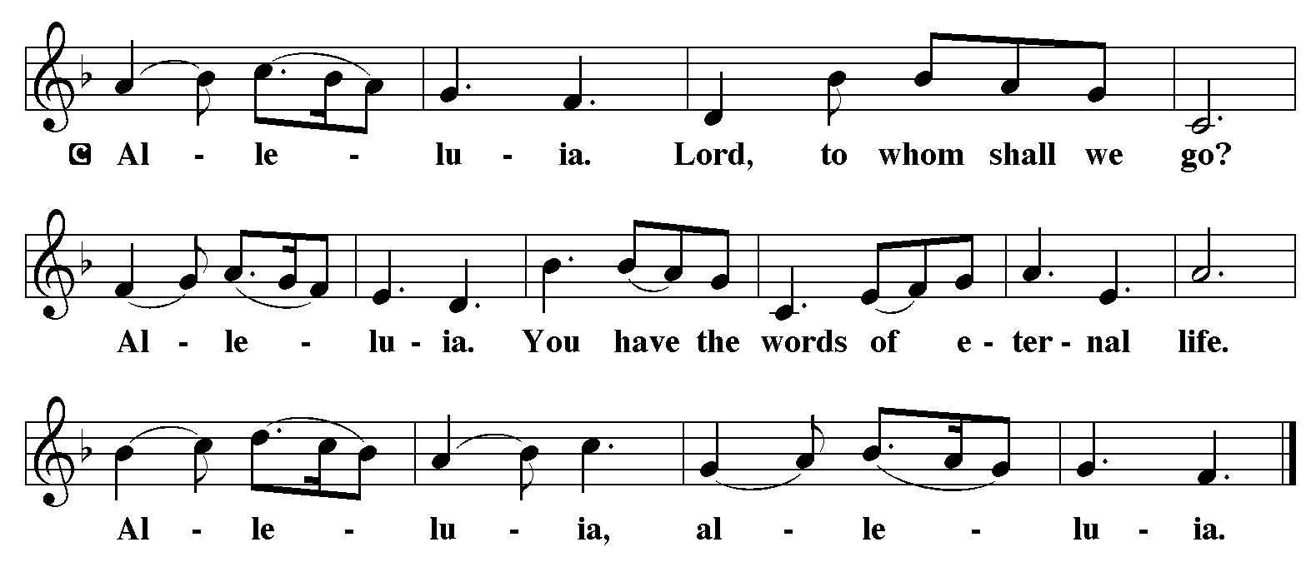

Holy Gospel: Mark 1:9-15
C Glory to you, O Lord
⁹In those days Jesus came from Nazareth of Galilee and was baptized by John in the Jordan. ¹⁰And just as he was coming up out of the water, he saw the heavens torn apart and the Spirit descending like a dove on him. ¹¹And a voice came from heaven, “You are my Son, the Beloved; with you I am well pleased.”
¹²And the Spirit immediately drove him out into the wilderness. ¹³He was in the wilderness forty days, tempted by Satan; and he was with the wild beasts; and the angels waited on him.
¹⁴Now after John was arrested, Jesus came to Galilee, proclaiming the good news of God, ¹⁵and saying, “The time is fulfilled, and the kingdom of God has come near; repent, and believe in the good news.”
The Gospel of the Lord
C Praise to you, O Christ

Sermon by Pastor John Rothfusz

Sermon Hymn: “Lord, Keep us Steadfast in Your Word” Red book # 517
Public Domain

Apostles’ Creed
C: I believe in God, the Father almighty,
creator of heaven and earth.
I believe in Jesus Christ, God's only Son, our Lord,
who was conceived by the Holy Spirit,
born of the virgin Mary,
suffered under Pontius Pilate,
was crucified, died, and was buried;
he descended to the dead.
On the third day he rose again;
he ascended into heaven,
he is seated at the right hand of the Father,
and he will come to judge the living and the dead.
I believe in the Holy Spirit,
the holy catholic church, the communion of saints,
the forgiveness of sins, the resurrection of the body,
and the life everlasting. Amen.

Offering: God is with us to strengthen us in every time of trial. Let us offer ourselves to God with thanks as we lift our tithes and offerings to the Lord. Please take a moment now to make an electronic offering to the church on the website, with the Tithe.ly app or write a check and send it in.

Offering Hymn: “Christ, the Life of All the Living” Red Book # 339
Public Domain

Prayers: After each portion of the prayers finishes with “Lord in your mercy,” please respond, “Hear our prayer.”

Lord’s Prayer
Our Father, who art in heaven, hallowed be thy name,
thy kingdom come, thy will be done, on earth as it is in heaven.
Give us this day our daily bread; and forgive us our trespasses,
as we forgive those who trespass against us;
and lead us not into temptation, but deliver us from evil.
For thine is the kingdom, and the power, and the glory,
forever and ever. Amen
Announcements
Benediction: The Lord bless you and keep you. The Lord make his face to shine upon you and be gracious to you. The Lord look on you with favor and give you peace. In the name of the Father, and of the Son, and of the Holy Spirit. Amen.

Hymn: “I Want Jesus to Walk With Me” Red Book # 325
Arr. © 2006 Augsburg Fortress. All rights reserved. Used by permission. Reprinted under OneLicense.net #A-711151

*Dismissal
P Go in peace, serve the Lord.
C Thanks be to God!
Postlude

