“Blame Nature”

Rev. Stephen Milton
February 7th, 2021
Lawrence Park Community Church

One of the hardships of this pandemic is that time feels like it has lost any structure. It’s become so hard to predict what will happen next that we seem stuck in a sort of aimless time. As one of you put it this week, what we yearn for most is the ability to make plans for the future. So, instead of making each week an unpredictable Bible reading, I thought it might help a bit if we knew exactly where we were going for a while. So, for the next four weeks we will be walking our way through the story of Joseph and his Brothers.

In the passage we heard today, Joseph’s brothers argue over how they should betray their brother. They all resent him for being their father’s favourite, and for his dreams which predict he will rule over them all. So, there’s no question about whether they should get rid of him, the question is how. To my ears, this part of the story seems clunky. First they decide to kill him by dumping him in the well. Then they decide to sell him as a slave to a caravan heading for Egypt. Then they lie to their father, blaming nature for killing him. Destroy, demote, deny. Three strategies for betrayal. It sounds clunky – why don’t they just do one, wouldn’t that make the story flow more smoothly?

Well, the story may seem clunky, but that hasn’t stopped it from being a roaring success.
A few years ago, this church put on a musical retelling of the story, starring adults and kids from the Sunday school program. That production was based on the popular Broadway musical, “Joseph and the Amazing Technicolour Dreamcoat,” which was a big hit in the 1980s and 90s, with Donny Osmond famously playing Joseph when the show came to Toronto. However, I wondered if this story had also been a hit before Broadway.

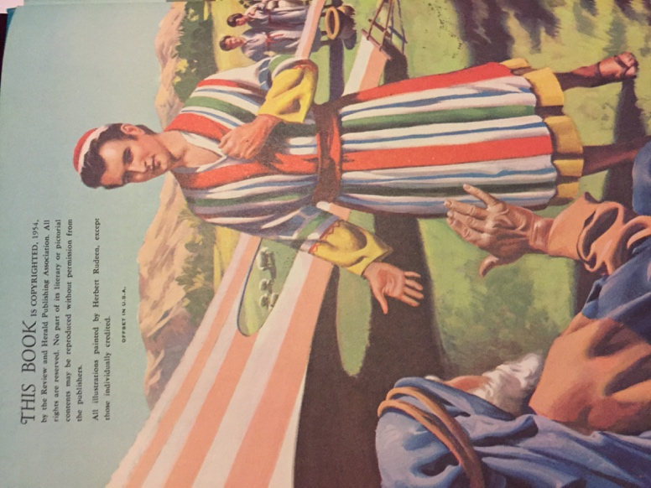
So, this week, I went back to the church for the first time since the lockdown began. I wanted to see if there were any old Sunday school books about Joseph and his brothers. If there were, that would mean that this story had been taught to kids over the years. So, I searched the library and the Sunday school rooms. Here’s what I found. Over a dozen books featuring his story. The oldest one is this one from 1954.

1954 Joseph
On the inside cover there’s a nice picture of Joseph in his special coat.

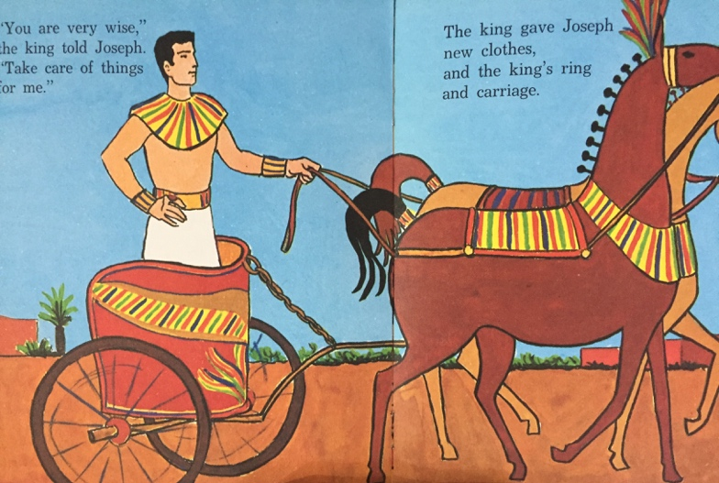

This one is from 1966. The whole book is dedicated to the story.
Here’s a picture of Joseph riding a chariot after his promotion.

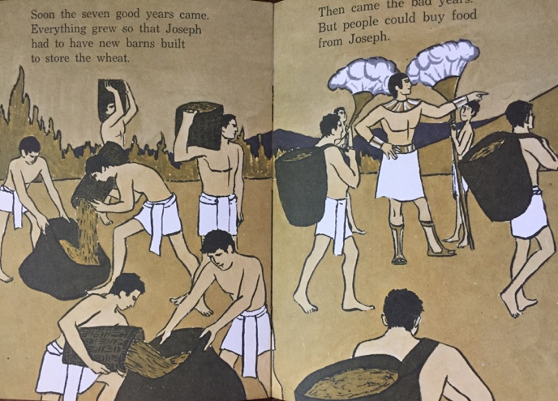
And here’s one from 1985.
There’s Joseph with members of the Pharoah’s court. In all, I found over 10 from the 1960s to the 2000s that told the story.

And there was one thing that was consistent in almost all of them. You may have noticed it already. In virtually every single book, the Egyptians are white people.

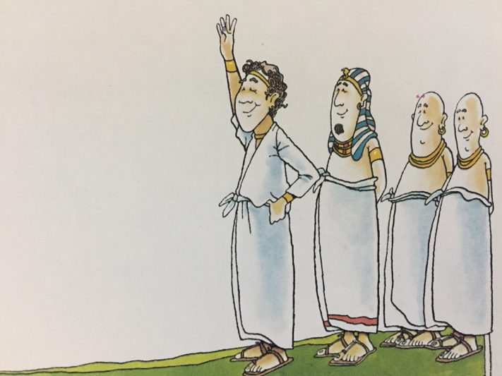
In book after book, a very white Joseph is brought to a very white Egypt.

Sometimes the Egyptians appear to be white people with a bit of a tan, as though Joseph was visiting a Club Med.

Pharoahs, court officials, even the slaves in the fields, are people with white faces and bodies.

Anyone who has visited modern Egypt knows that this simply is not the case now. Egypt is in north Africa, and it looks like it. The people there are a mosaic of the cultures who have made their home in Egypt over the centuries – Black Africans, Arabs, and some white people, among other races. This reflects the history of Egypt. In the 600s, Muslim Arabs invaded Egypt. In 332 BCE, Greeks invaded Egypt under Alexander the Great. But the Joseph story takes place long before Greeks and Arabs invaded. In Joseph’s era, around 1700 BCE, an Egyptian marketplace would have been a sea of brown and Black faces, reflecting the people of North Africa.

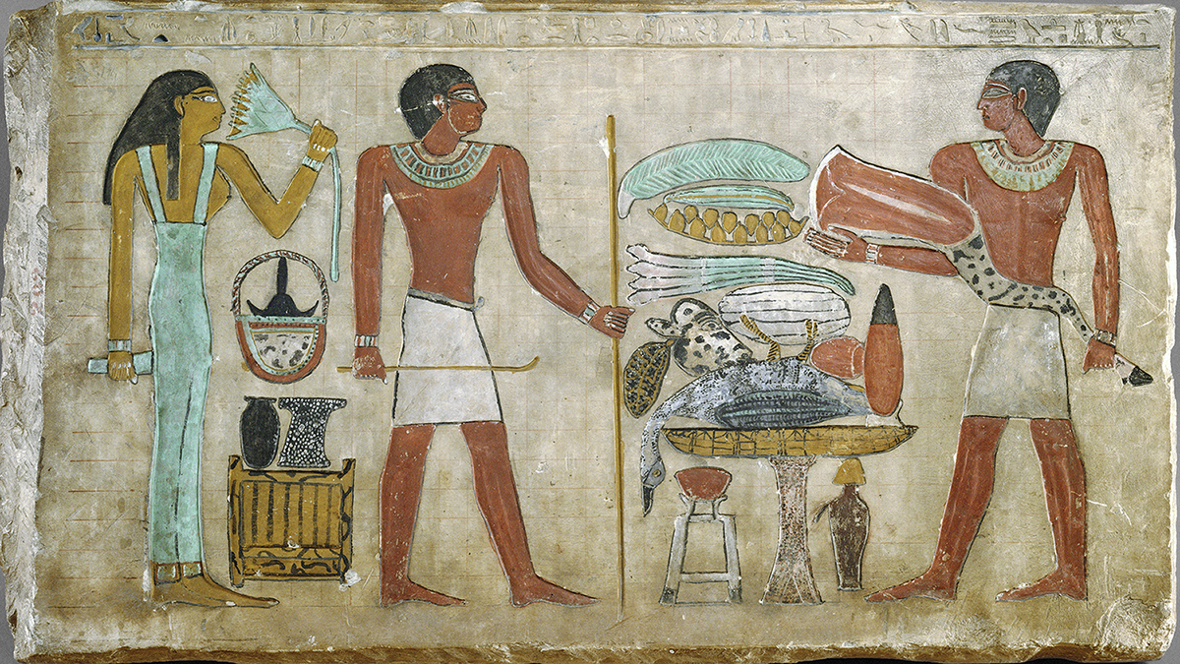

Egyptian paintings from this era show people of multiple shades of brown, and many statues feature people with large lips and Black looking faces. In fact, there were periods when Black tribes from Nubia conquered Egypt and installed their own Black Pharaohs on the throne.

Scholars continue to debate the proportions of black and brown peoples lived in Egypt at any one time, but what is very clear is that Egypt was never a nation of white people.

So if that is so obvious to us now, why do our Sunday school books show white Joseph in white Egypt? Since this is the start of Black History month, I decided to do some digging to find out. One thing should be made clear at beginning: The Bible has people who hate each other because of their tribe and their religion, but racist discrimination just isn’t in there. Racism as we know it is a relatively recent invention, that starts in the 1600s at the same time as the slave trade begins. When Europeans came to the Americas, they ran out of indigenous people to enslave pretty quickly, so they started importing Black people, from West Africa. Those enslaved Africans were brought to the American south by the millions. And since the American colonies were Christian, they looked for a Biblical justification for the mass enslavement of Black people.

They seized on a small detail at the end of the story of the Flood. You may recall that After the waters recede, Noah and his family leave the ark, and let the animals loose. Noah plants some grape vines on the now dry land, and becomes the first person to make wine. He is also the first person in the Bible to get drunk. One of his sons, Ham, sees him lying naked and passed out on the ground. Ham doesn’t cover him up, which to ancient Jews is shameful. Noah’s other two sons notice, and cover up their father. When Noah wakes up, he gets angry at Ham, and tells him that his children, the people of Canaan will be cursed to serve his brother’s children. That’s it. Noah, not God, curses the people of Canaan to be servants. A bit later, Genesis provides a genealogy of Noah’s family, and Ham’s line includes, in addition to Canaan the nations of what are now Egypt and Ethiopia.

However, in the 1600s, white Christians deduced that Ham’s African descendants shared Canaan’s curse, even though the Bible doesn’t say that. Details schmetails. There was a lot of money invested in the slavery system, and one small detail wasn’t going to stand in the way. So they proclaimed that the Bible said The Black people of Ethiopia and Egypt were cursed to be servants, which meant it was ok to enslave Africa. This became known as the curse of Ham. Problem solved, slavery was allowed in God’s eyes.

Now, you may be wondering – if Christians thought Egyptians were Black, then why do our Sunday school books show them as white? There is one more twist in this story.

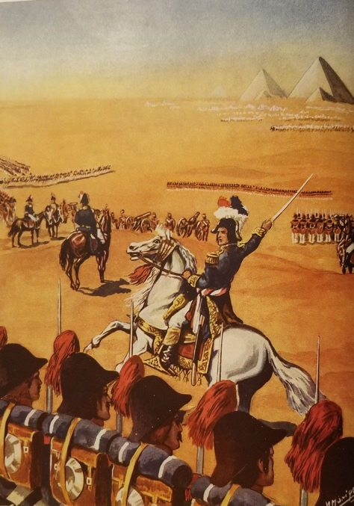
In the early 1800s, Napoleon invaded Egypt. French scientists learnt how to read ancient Egyptian heiroglyphs, they found lots of tombs, dig the Sphynx out of the sand.

As they studied ancient Egypt, it becomes clear that these Africans had a sophisticated civilization that provided many key ideas to Western civilization, from literature to mathematics to engineering. Ancient Egypt was one of the key ancestors to European civilization, ranking right up there with the Greeks and Romans.

But that posed a serious problem. After centuries of enslaving Black Africans and dismissing them as biologically and intellectually inferior, here was proof that they had once ruled a civilization that was highly advanced. It was like doing a family tree and finding out that one whole side of your white family was composed on Black people. Really accomplished Black people. This was embarrassing, and would undermine the whole rationale for slavery.

So, respected white scholars at universities all over Europe and the United States introduced a new theory. They argued that Egypt was founded and ruled by white people. Caucasoids from Europe had come down and settled along the Nile Valley, and had been in charge all along. Egyptians were never Black. Biblical scholars joined in and declared that in fact, Black people had never played any important part in the Bible. The Bible was the story of God’s relationship with white people, and that included Egyptians and Jews alike. That idea became so entrenched that over one hundred years later, Donny Osmond and David Cassidy could play the Jewish Joseph. That idea became so popular that Sunday school books in churches all over North America could depict a white Joseph going to white Egypt as a slave. The message was pretty clear – the Bible is the story of God talking to white people, and that’s what we showed our children in Sunday school, and that’s what adults saw in stained glass windows.

Earlier, I said that the beginning of the Joseph story sounded clunky. The brothers can’t seem to make up their minds how to betray Joseph. Are they going to throw him in a well to destroy him? Or sell him into slavery to demote him? Or deny him to his father by pretending he is dead? Blame nature for his disappearance? It sounds messy. But perhaps what the Bible is doing here is trying to show us how to spot the strategies people use to betray each other. First, try to destroy them. If that doesn’t work, demote them, make seem less than human. And finally, the last step, deny that they even exist. Destroy, demote, deny.

That strategy fits very well with how whites treated Blacks during the slavery era. They demoted them through enslavement. Then they killed them for even the slightest hint of disobedience. And finally, scholars denied that they had ever been civilized, and that they had ever played a role in the Bible stories. Destroy, demote and deny. The Joseph story lays it all out, so we can see the user’s manual for evil, for how people get robbed of their humanity.

Showing us that formula is an act of grace, a gift so we can see the signs of when a group is being betrayed and denied their humanity. It gives us insight into what happened during the slave trade, and it can help us understand what has happened over the past year during this pandemic. Back in March, when the pandemic began, the first outbreaks occurred in long term care homes. The mortality rates were tragically high, and so as a society we mobilized to save the lives of our elderly by going into the first lockdown. Ever since then, this pandemic has been seen as a sort of gray plague that kills the elderly primarily, and makes younger people sick, sometimes seriously.

But among Black people in Canada, the pandemic looked different. In Toronto and Montreal, the majority of staff at long term care homes are people of colour, and often Black. In fact, one third of all Black women in Canada work in health care. To those women, the outbreaks at the long-term care homes were not just about old people getting sick, but about people of colour getting infected, too. In Montreal, the first major outbreaks in the community were in Black neighbourhoods where those health care workers lived. So Black rights advocates started asking the government how many Black and racialized people were getting sick. And the answer from the cities, the province and the federal governments was – we don’t know. We don’t collect that kind of data.

The Joseph story tells us that betrayal takes the form of destruction, demotion and denial. Canada’s governments denied that race was a part of the Covid crisis, suggesting instead that the key risk factor was being very old. But as the months passed, outbreaks started appearing in crowded factories, warehouses and meat packing plants. These are Industries that are staffed by racialized people. By the summer, Toronto finally agreed to start collecting health data including race. The results were shocking – by November, 79% of all covid infections outside of long-term care homes were among racialized people. The group at greatest risk – Blacks, who make up 26% of all infections, despite being just 9% of the population. And yet, even knowing this, for months every day statistics about the pandemic focused on the pandemic’s impact on the elderly, making it seem like the rest of us were all equally at risk.

Today it is known that in the US, the UK and places like Toronto, Black people are much more likely to contract Covid-19 than white people. This has nothing to do with their race. Many Blacks are stuck in risky low wage work, where outbreaks are frequent. Every day you can see on the internet which long term care homes have outbreaks, and track them by name. But the government is vague about the workplaces where hundreds of Black and racialized workers are also suffering from outbreaks. Those workplaces go unnamed. And to this day, no one knows what the death rate from covid-19 is for Black people in Canada or Toronto. We don’t collect or release that kind of data. We know the death rate for people for every age range, but we can’t tell Black people, the group who is most infected, what their death rate is. In the US and the UK it is 3-4 times higher than the white rate. How many Blacks have died here? We don’t know. As if that didn’t matter. Destroy, demote, deny. That’s how people are betrayed, and it is still happening, right now, right here.

In the Joseph story, the brothers who betray him do not win. As we’ll see in the coming weeks, Joseph suffers many mishaps in Egypt, but eventually, he escapes from captivity, and becomes one of the most powerful men in the country. His biggest challenge is what to do about his brothers. The story is clear – just because his brothers gave up on him, God didn’t.

In the Sunday school books I found that tell his story, there are a few that show Joseph in an Egypt populated by Black and brown people.

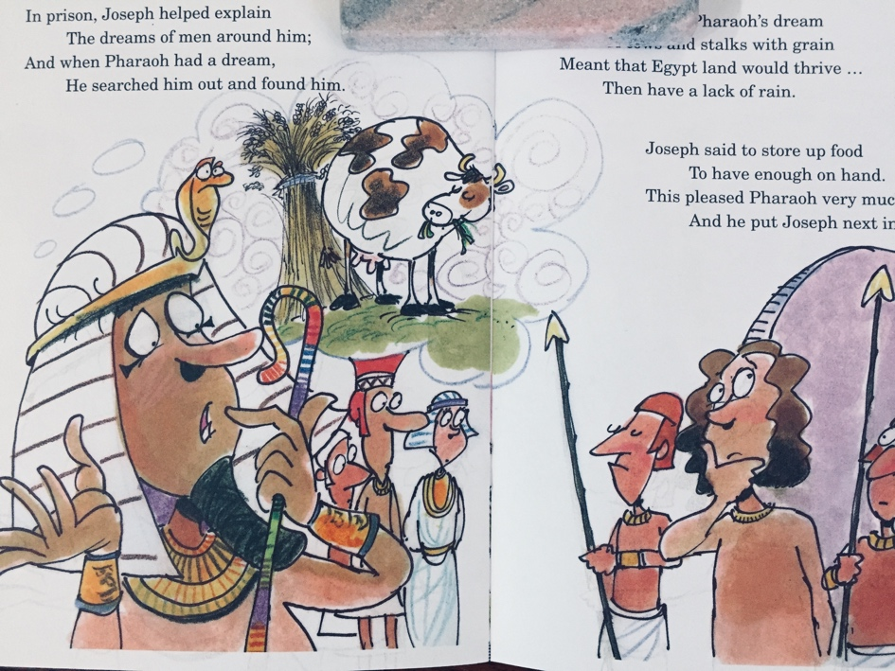
There aren’t many, and they are mostly from the last ten years or so. It took decades for Black scholars to convince white Christians that the Bible had people of colour in it.

The stories look better, as though God cares about lots of different kinds of people, not just one kind. The Joseph story is the same in these books, but it means more because if a brown or Black child sits down to read them, they can see themselves in the story.

People whose ancestors created a great civilization. That’s something that kids of all backgrounds should know. It took a long time for us to colour in the Joseph story, but it happened, and it’s worth it.

Here in Toronto, this week the city announced that it had set up a commission of people from the Black community to study how covid 19 is affecting Black people. There will also be mobile teams to bring vaccines and tests to places where Black people live. This is happening because Black people protested and lobbied to get the government to listen to them. There are still major problems – racialized workers need better protections at work to prevent outbreaks. Queen’s Park needs to pass legislation to give all workers paid sick days so no one has to go to work when they are infected. Most of all, we need to take seriously the idea that we are all one family, and not one of us should ever betrayed by the others as less than everyone else. God made us all. It’s time for us to colour in our society, to see the full story of who we are and who we can be.

Amen.

This is called the curse of Ham. Charles B Copher, Black Biblical Studies, ( Black Light Fellowship, Chicago,1993), chapter 3.
Charles B Copher, Black Biblical Studies, ( Black Light Fellowship, Chicago,1993).23ff.
This is called the curse of Ham. Charles B Copher, Black Biblical Studies, ( Black Light Fellowship, Chicago,1993),chapter 8.
Awad Ibrahim, “Black Immigrants: Oscillating Between Covid-19 And Dead Silence,” Royal Society of Canada, November 12, 2020
“From Risk to Resilience: An Equity Approach to COVID-19”, The Chief Public Health Officer of Canada’s Report on the State of Public Health in Canada 2020
Johanne Jean-Pierre, Ryerson University and Tya Collins, “Covid-19 Effect On Black Communities In Quebec,” Royal Society of Canada, November 12, 2020.
Awad Ibrahim, ibid.
https://www.canada.ca/en/public-health/corporate/publications/chief-public-health-officer-reports-state-public-health-canada/from-risk-resilience-equity-approach-covid-19.html#a2
https://www.toronto.ca/home/covid-19/covid-19-latest-city-of-toronto-news/covid-19-status-of-cases-in-toronto/
Brendan Kennedy, “Toronto announces plan to combat disproportionate impact of COVID-19 on Black communities,” Toronto Star, Feb. 3, 2021
George J. Sefa Dei and Kathy Lewis, Ontario Institute for Studies in Education, University of Toronto|, “Covid-19, Systemic Racism, Racialization And The Lives Of Black People,” Royal Society of Canada, November 12, 2020
Brendan Kennedy, “Toronto announces plan to combat disproportionate impact of COVID-19 on Black communities,” Toronto Star, Feb. 3, 2021

