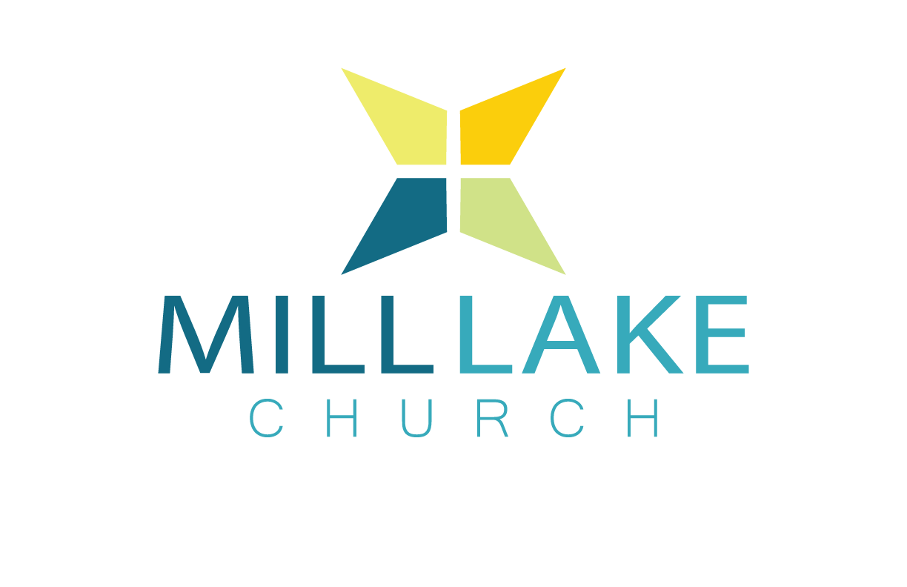

**Child Registration Form 2021**

Mill Lake Church is collecting and retaining this personal information for the purpose of enrolling your child in our programs, to assign the student to the appropriate classes, to develop and nurture ongoing relationships with you and your child, and to inform you of program updates and ongoing opportunities at our church. This information will be maintained permanently as it is a requirement of our insurance company and legal counsel. If you wish Mill Lake Church to limit the information collected, or to view your child’s information, please contact us.

Child’s Name: _________________________ Grade: _______ Birthdate(mm/dd/yyyy): ____________

Parent/Guardian Name(s): ____________________________________________________________

Parent/Guardian E-mail: ______________________________________________________________

Address: __________________________________________________________________________

City: ________________________ Province: _________________ Postal Code: _________________

Parent/Guardian Cell: ______________________ Alternative Phone: __________________________

Home Church: ______________________________________________________________________ Allergies: __________________________________________________________________________

Does your child have any physical, emotional, mental, or behavioral concerns or limitations that our staff should be aware of? ___ YES ___ NO

If yes, please explain: ________________________________________________________________

__________________________________________________________________________________

Is your child bringing any medication with him/her? ___ YES ___ NO

If yes, please list: ___________________________________________________________________

_________________________________________________________________________________

The safety of your child is our primary concern. Precautions will be taken for their well-being and protection.

Please provide two emergency contacts which will be used if we cannot get ahold of the above listed parent/guardian(s):

Emergency Contact #1: _______________________________Phone Number: __________________

Relationship to child: ________________________________________________________________

Emergency Contact #2: _______________________________Phone Number: __________________

Relationship to child: ________________________________________________________________

In the event that I am unable to pick up my child, the following individual(s) are permitted to sign out my child (Photo ID will be required):

Name: ______________________ Phone: _____________ Relationship: _______________________

Name: ______________________ Phone: _____________ Relationship: _______________________

**Authorization and Medical Consent**

In the event of an emergency, I/we, the parents or guardians named above, authorize the ministry staff of Mill Lake Church to sign a consent for medical treatment and to authorize any physician or hospital to provide medical assessment, treatment, or procedures for the participant named above. I/We, the parents or guardians named above, acknowledge that Mill Lake Church will notify us, or an above listed emergency contact if we cannot be reached, as soon as it is safe to do so.

I/We, named above, undertake and agree to indemnify and hold blameless the ministry staff, Mill Lake Church, its pastors and Board of Elders from and against any loss, damage or injury suffered by the participant as a result of being part of the activities of the Mill Lake Church, as well as of any medical treatment authorized by the supervising individuals representing the church. This authorization and medical consent is effective only when participating in or traveling to events of Mill Lake Church.

Parent / Guardian Signature: __________________________________________________________

Printed Name: __________________________________________ Date: ______________________