Children’s Page
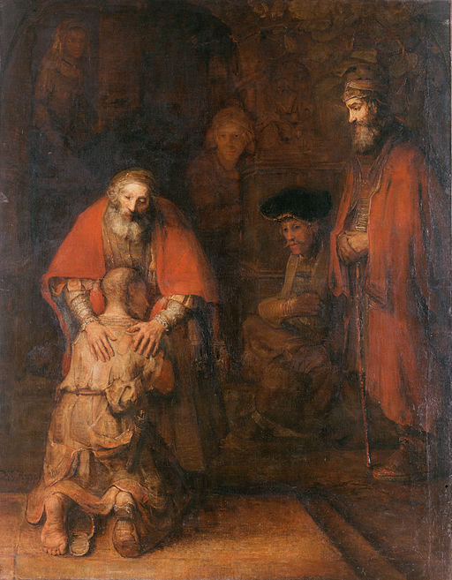
“The Return of the Prodigal Son” by Rembrandt
Painted by Rembrandt van Rijn, a Dutch painter who died 400 years ago.
You can see this painting at the Hermitage Museum in St. Petersburg, Russia.

Read Luke 15:11-32
- Why did the youngest son come home?
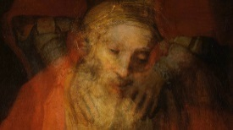
- How does the Father show his love for his youngest son?
- What is the eldest son’s problem with his father and his younger brother?

