Children’s Page
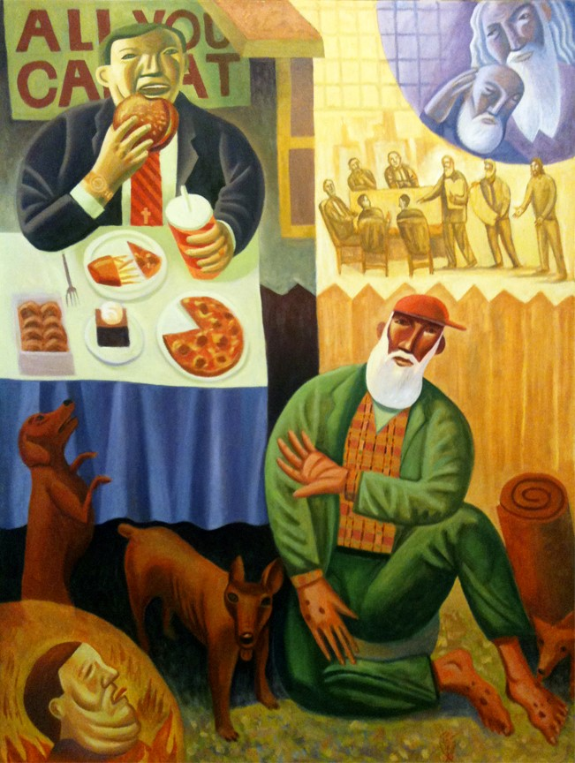
“The Rich Man and Lazarus” by James B. Janknegt
James B. Janknegt was born in Austin, Texas and currently lives in Elgin, Texas where he and his family have an ArtFarm. They grow artists, fruits, vegetables, chickens, goat, guinea hens, peacocks, and ducks. They also have two dogs. This picture can be found in his book, Lenten Meditations (available at http://www.bcartfarm.com/books_lent.html).

Read Luke 16:19-31

- Does the Rich Man have enough to share? Why do you think he doesn’t share?

- Why do you think Lazarus is poor? Do you think he wants to be begging?

- What do you think Jesus wanted us to learn from this story?

