Children’s Page
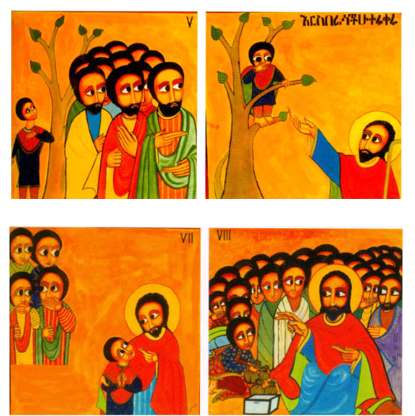
Die Geschichte von Jesus und Zachäus
(The Story of Jesus and Zacchaeus)
A portion of an Ethiopian hunger cloth written by Alemayehu Bizuneh in 1978
Read Luke 19:1-10
Using these four pictures, tell the story to someone.

