Children’s Page
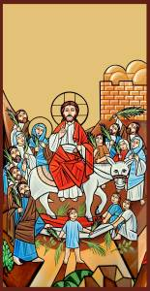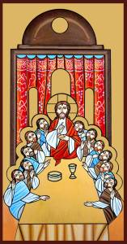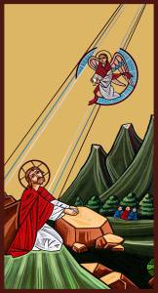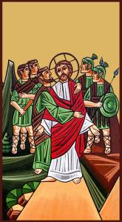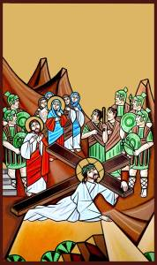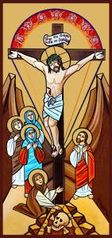

These icons were written by Mekhaiel Metias Rezkalla,
a Coptic artist who lives in Melbourne, Australia.

Today is Palm Sunday.
It is the first day of Holy Week.

On Sunday
- Jesus rode a donkey into Jerusalem.
On Thursday
- Jesus ate dinner with His friends.
- After dinner, Jesus goes to the Garden to pray.
- Some men come to take Jesus away.
On Friday
- Jesus carries a cross up the hill.
- Jesus dies on the cross. Darkness covers all the earth.
- Jesus’ body is laid in a tomb. A big stone is rolled against the door.
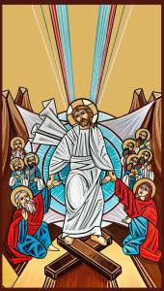
On Sunday
- Mary and some other women come to the tomb.
The big stone is rolled away! The tomb is empty!
Where is Jesus?
- He is risen!

