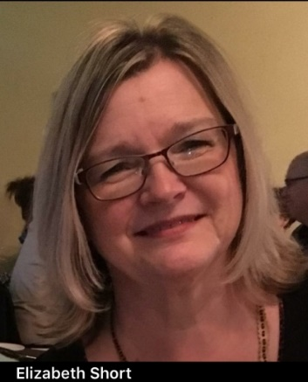

**Course Information**

**\***Sessions will meet for 6 consecutive weeks on “Zoom”.

**\*April 12 to May 24**

**10:00 – 11:30 am**

**7:00 – 8:30 pm**

**\*Register** by **email**, [elizabeth@en-courage.ca](mailto:elizabeth@en-courage.ca)

Or **phone**, 403-660-5636

You will be sent Zoom link.

**\*Fee** – No cost, but donations gratefully accepted for All Saints Parish House

**\***You are encouraged to **contact Elizabeth** with any questions *(see below)*

***Sponsored by All Saints Anglican Church, Cochrane.***



*using stories to*

*navigate our lives…*

403-660-5636

[elizabeth@en-courage.ca](mailto:elizabeth@en-courage.ca)

[www.en-courage.ca](http://www.en-courage.ca)

# Grief Support

for

Loss of a Loved One

With Facilitator, Deacon Elizabeth Short, MTS

Director of **En-Courage**

Six Sessions

Beginning April 12, 2021,

10:00 to 11:30 a.m. ***or*** 7:00 to 8:30 p.m.



**The loss of a Loved One** is one of life’s most difficult experiences. There is no right or wrong way to “do grief”. Nor is there a specific timeline to follow or on which to rely. Every individual is unique and it is to be expected that his or her journey of grief will be unique. It has been said that one cannot truly understand this experience unless he or she has gone through it. Strength and insight can be gained as people share their personal reflections of this shared experience.

**What can I expect?** The purpose of this group is to gather people together who have lost a loved one. Elizabeth creates an atmosphere of safety and confidentiality that allows you to share aspects of your grief. Elizabeth specializes in life transitions and grief will be examined from this context. Each week she will introduce an element of transition and will then facilitate conversation among the participants, encouraging them to share their insights with each other, so that they might support and be supported. Grief often creates situations and feelings of isolation and loneliness. Your journey through this difficult stage in life can be helped by sharing your story with others and listening to others’ stories. Not only will you realize you are not alone, but you will gain insight from the interactions in the group, learning from hearing their stories—and yours, as you tell it aloud.

**What will I take away?** You will learn 6 elements of transition, which will give you a context for your own experience. It is hoped, that through the insights and encouragement received from the process, you will begin to make sense of this difficult time in your life and begin to be reconciled with grief, moving from a place of loss to a new way of being.

## Company Name

Your business tag line here.