Using your parish email account
  - A guide to using Office 365 email accounts in your parish
[Document version 1.1, 15 October 2019]
Congratulations! Your parish is using Office 365 to provide secure email (and other useful services) and to comply with our diocesan data privacy and protection policies. This guide will help you set up and use your new email account in way that will make it as easy as possible for you to fulfil your role in your parish.
In the instructions that follow, the example internet address/domain of stmarysoakbay.ca will be used. Please substitute your own parish where appropriate.
Table of Contents
First Time: Use a Web Browser 2
Wardens only: Using the Shared Mailbox in a Web Browser 3
Wardens only: Sending as ‘Wardens’ using the Web Browser 4
Wardens only: Using the Shared Mailbox on a desktop/laptop Computer 4
Set up Outlook 2016 for Windows 10 5
Set up Outlook 2016 for MacOS 9
Wardens only: Using the Shared Mailbox on a mobile device 12
Wardens only: Using shared mailbox on Apple devices (with native Mail apps) 13

Still to do:
- Instructions to ‘Send as’ in Outlook for Windows or MacOS, and in mobile Outlook and native Mail
- Setup/test for native Windows Mail apps
- Setup/test for native Android/Windows Mobile Mail apps
- Setup signatures in all apps/platforms

First Time: Use a Web Browser
- Visit office.com, and choose ‘sign in’
- Your username is your official parish email address: e.g., [account]@stmarysoakbay.ca
- If this the first time you’ve used the account, you may be prompted to change your password. Do so at this point.
- When you’ve successfully signed in, you will be on the Microsoft Office Home Page, which will look something like this:
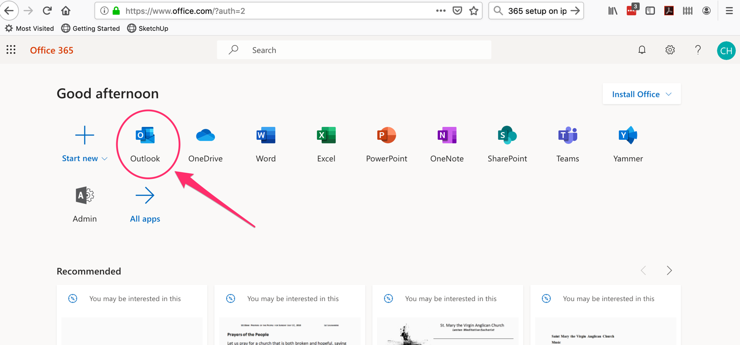

- Click on ‘Outlook’ (see above). You will then be at your own Inbox:
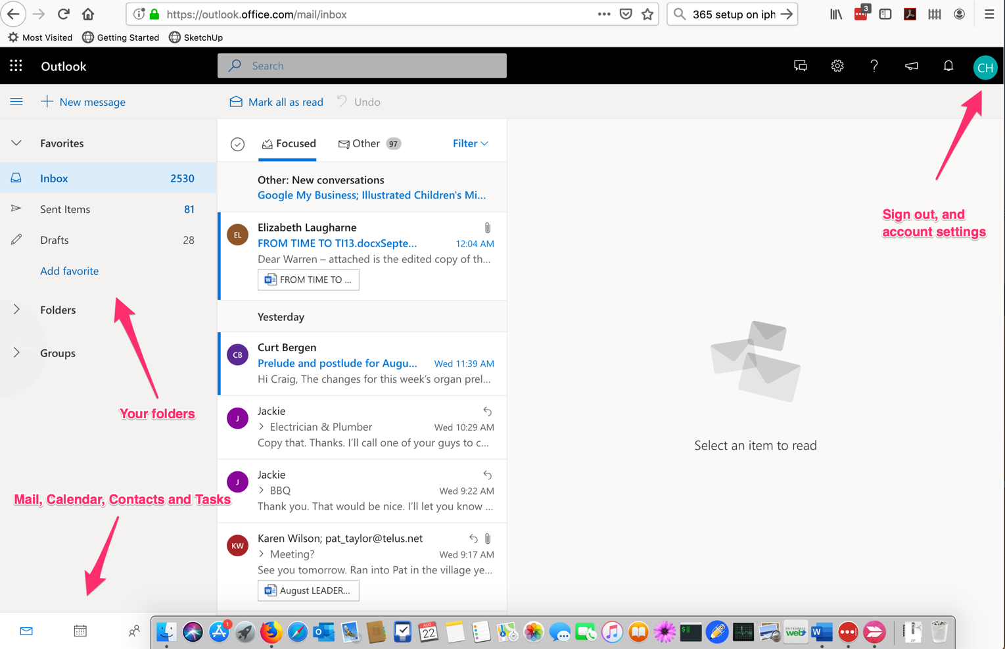

Wardens only: Using the Shared Mailbox in a Web Browser
As a Warden, you have your own email address (e.g., youraddress@stmarysoakbay.ca), but you are also part of a shared email address called wardens@stmarysoakbay.ca. This is the address that the Synod Office will use in order to contact all the wardens of the parish at once, and it’s also the address that we publish for people to contact the wardens. This means you need to check this ‘wardens’ shared mailbox regularly.
Here’s how to set this up in the Web Browser version of Microsoft Outlook:
- Sign in to your account in Outlook on the Web (see above).
- Right-click the word ‘Folders’ in the left navigation pane, and then choose Add shared folder.
- In the Add shared folder dialog box, type the name of the shared mailbox you are a member of, wardens@stmarysoakbay.ca.
- The shared Wardens mailbox will now appear in your Folder List in Outlook on the Web. You can expand or collapse the shared mailbox folders the same way can with your primary mailbox. You also can remove the shared mailbox from your Folder list. To remove it, right-click the shared mailbox, and then click Remove shared folder.

Wardens only: Sending as ‘Wardens’ using the Web Browser
As a Warden, you will now have the option of sending an email as yourself or on behalf of all the Wardens. The first time you reply to a message sent to the shared mailbox, you need to add the shared address to the From drop-down box. Here's how to do that:
- Open Outlook on the Web and go to your shared mailbox.
- Open a message that was sent to the shared address.
- Click Reply.
- At the top of the message, choose > Show From.
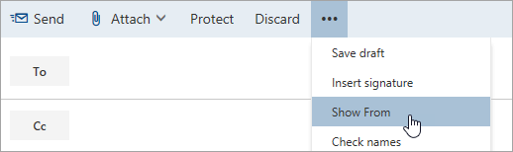
- Right-click the From address (which will default to your own address) and choose Remove.
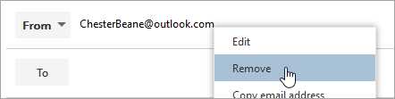
- Type the shared address wardens@stmarysoakbay.ca and send the message. The next time you reply from the shared mailbox, its address will appear as an option in the From drop-down list.

Wardens only: Using the Shared Mailbox on a desktop/laptop Computer
First things first: if you use your computer’s native mail app (Windows 10 Mail, or Apple Mail, for example), then, while it will be possible to set up your primary email address, it may be difficult or impossible to set up your shared [wardens@stmarysoakbay.ca] email mailbox.
If, however, you are using a recent version of Microsoft Outlook (part of the MS Office collection), then it is quite simple:

Set up Outlook 2016 for Windows 10
- Navigate to the File tab in Outlook. In the Info tab press Account settings->Account settings.
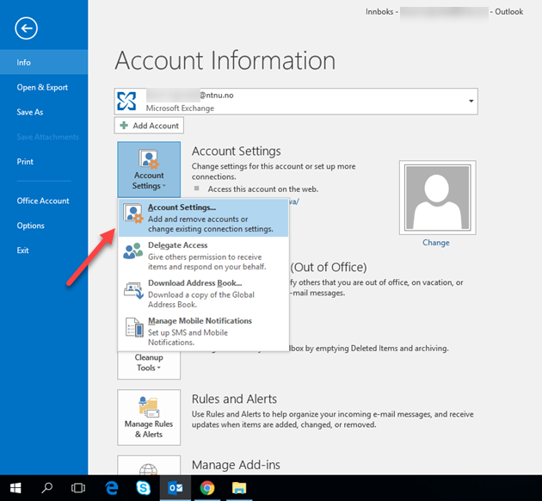
- Highlight the account with access to the shared mailbox and press Change.
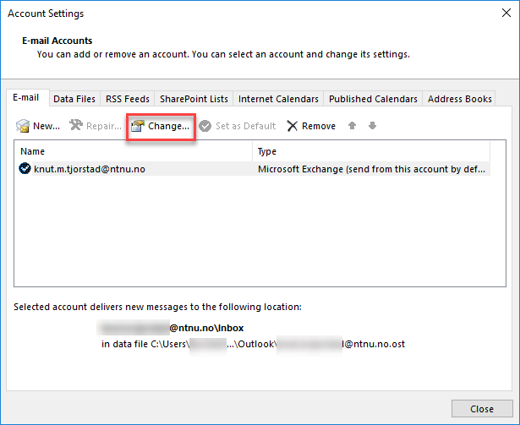
- Press More settings...
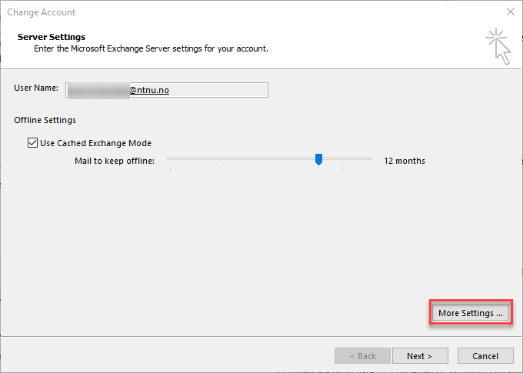

- Go to the Advanced tab and press Add...
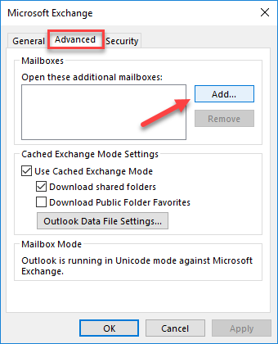
- Enter the name or address of the shared mailbox and press OK.
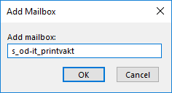
- Then press Apply->OK->Next->Finish and go back to your main Outlook window. You should now see the shared mailbox in the overview to the left of the Outlook window.
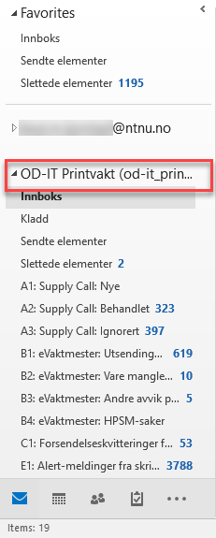

- Then press Apply->OK->Next->Finish and go back to your main Outlook window. You should now see the shared mailbox in the overview to the left of the Outlook window.

Set up Outlook 2016 for MacOS
When using Outlook on Mac, you have to set up the shared mailbox as a “delegate”.
- Navigate to the Tools tab and click Accounts.
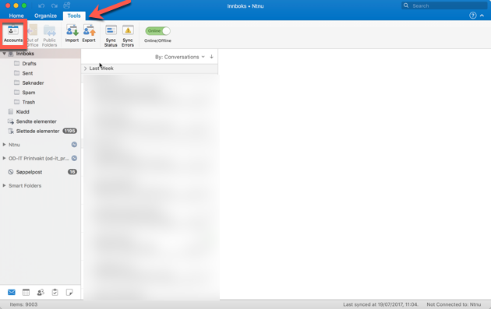
- Highlight the account which is going to access the shared mailbox and click Advanced.
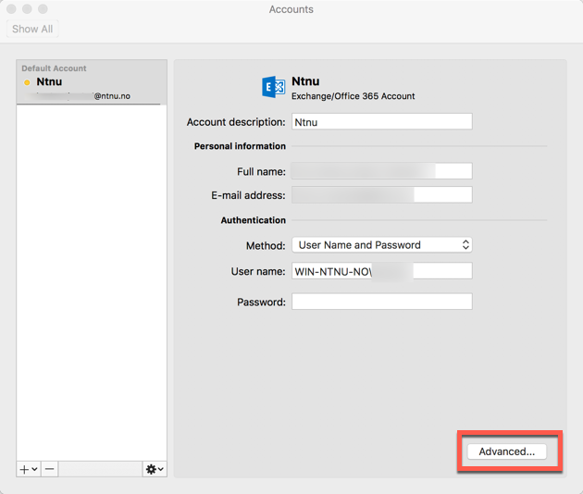
- Go to the Delegates tab and click the plus button in the field that says People I am a delegate for.
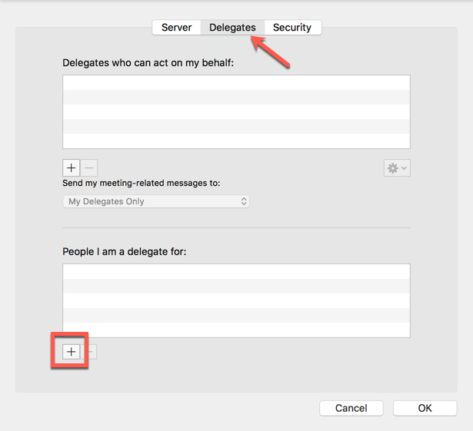
- Enter the name of the shared mailbox and click Add.
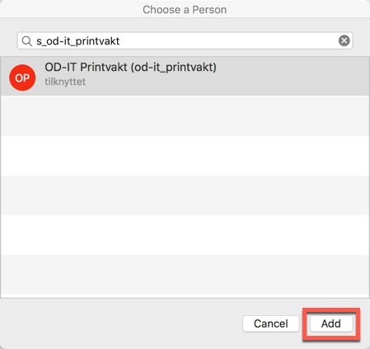
- Click OK and close the Accounts panel. The shared mailbox should appear in the list to the left of the Outlook window.
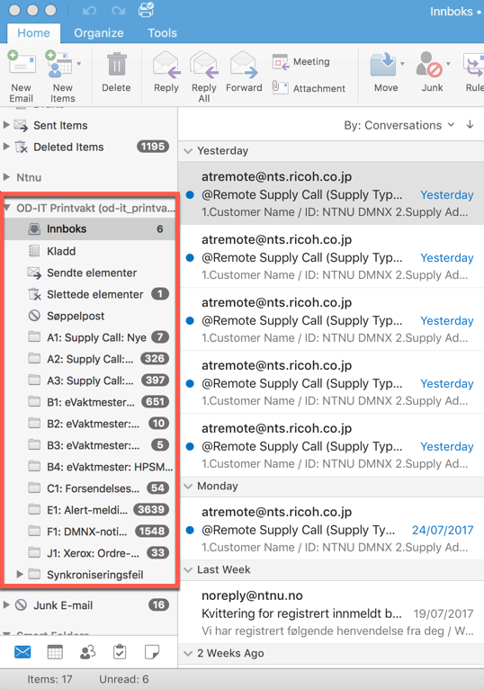

Wardens only: Using the Shared Mailbox on a mobile device
By far the easiest way to access all/both of your Office 365 email accounts on a mobile device is to use Microsoft’s Outlook for iOS or Outlook for Android app (available for free on the Android and Apple App Store or Android Play Store). The following example is from the iOS (Apple) version, but works exactly the same for the Android version:
- Sign in to your primary account in Outlook for iOS or Android.

- Tap the Add Account button in the left navigation pane, then tap Add a Shared Mailbox.
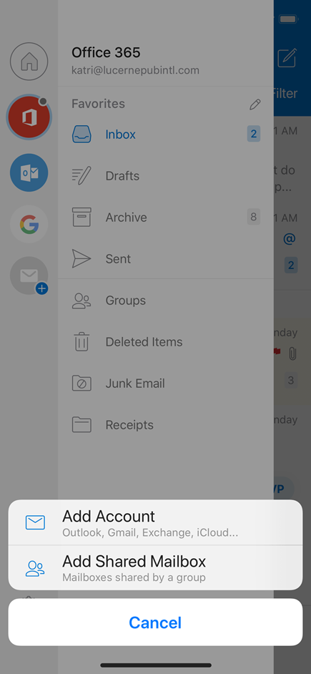
- If you have multiple accounts in Outlook Mobile, select the account that has permissions to access the shared mailbox.
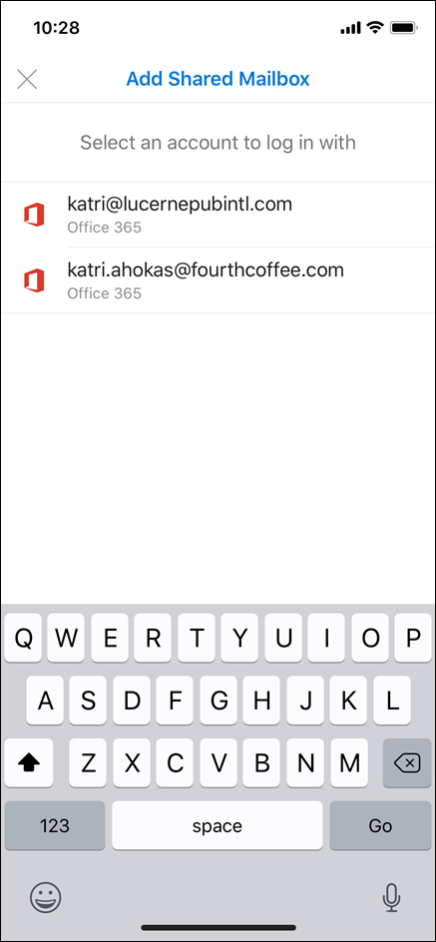

- After the account setup process completes, the shared mailbox will display in your account list in Outlook for iOS or Outlook for Android.
- To remove a shared mailbox, go to Settings > Accounts. Then tap on the shared mailbox and select Delete Account.

Wardens only: Using shared mailbox on Apple devices (with native Mail apps)
It is possible to add a shared mailbox to the standard, built-in mail app in
- With the Mail application active, click Mail in the menu bar then click Preferences
- Under the Accounts tab, locate the + button in the bottom left of the window and click it
- For the Choose a Mail account provider… select Other Mail Account… and click Continue
- Fill out the fields for the shared mailbox you’re adding but use your user account password, then click Sign In
- The authentication should fail, and you should see a message Unable to verify account name or password. This is okay and expected!
- You should now see some extra fields available to configure. Configure the fields as outlined here:
- Email Address: [the Office 365 shared mailbox address]
- Incoming Mail User Name if using a desktop or laptop Mac: [your Office 365 email address]
Incoming Mail User Name if using an iPad or iPhone: [your Office 365 email address]\[shared mailbox address]
- Outgoing Mail User Name: [your Office 365 email address]
- Password (both incoming and outgoing): [your Office 365 email password]
- Account Type: IMAP
- Incoming Mail Server: outlook.office365.com
- Outgoing Mail Server: smtp.office365.com
- Click Sign In to authenticate now, you should be prompted as to whether to also save and sync Notes with this shared mailbox account. Make a selection and click Done to proceed
- Close the Mail Preferences window and you should see the new Shared Mailbox listed on the left among your other configured accounts now.
You should now have access to the shared mailbox. If you’ve been granted the permissions you can also send as the shared mailbox itself, too.

